
Section: InaSAFE-Realtime
Module : Earthquake realtime


Browsing Earthquake Realtime

“The Earthquake section of the Realtime website allows you to browse and query recent and historical earthquake events”
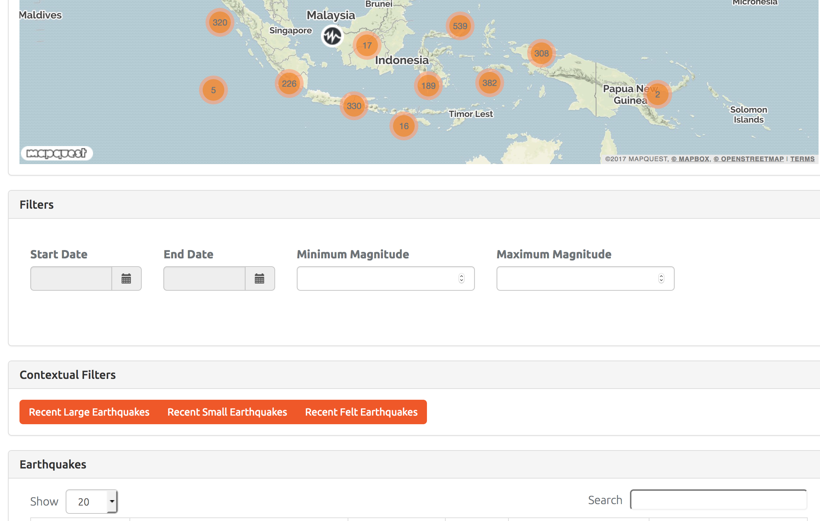
To find the earthquake events you are interested in, or merely to explore the data, you can explore the map and click on events; Apply a spatial filter in the map; Filter by date and magnitude; Apply predefined contextual filters; Sort records by multiple fields; and Search using keywords.
You try:
Goal: To explore and find earthquake events
1. What was the date and magnitude of the Pidie earthquake?
2. Zoom into the far eastern end of Seram Island and click on the single quake event you find there. What was the magnitude of that quake and how long ago did it occur? Zoom back to ‘Fit all’.
3. How many quakes occurred in the week of the Pidie quake and is there anything noteworthy about them?
4. How many quakes of magnitude 6 or greater are in the database?
5. What are the three biggest quakes in the database in descending order? Zoom to the biggest one.
Check your results:
Swap your list with the person next to you and see if they had any different answers.
Question | Clue
1 | Pidie is in Aceh

More about the earthquake realtime web page
This worksheet has taken you through some of the tools available to explore quakes or to query, sort and filter quakes for those you might be interested in. The primary function of the realtime system is to act as a near-realtime resource for shakes that have just happened, to assist with response. This is why the webpage defaults to showing the most recent quake. However, as you have discovered, there is a long time series of shake events that make a rich resource for research and analysis.
You can do more on this page, like download reports and data sets, but we’ll do that in other worksheets.


Check your knowledge:
- I want to find the ten deepest earthquakes. To do this I use the following functionality
- Explore the map and click on quake events.
- Sort on the depth field.
- Use the search field.
- I want to find the most recent felt earthquakes, so I
- Sort on the intensity field
- Search for ‘felt’
- Click on ‘Recent felt earthquakes’


Answers (to move to answer sheet)

You try

1. 7 December 2016. Magnitude 6.4. One way to have found it was to search for ‘Aceh’ and sort on the Magnitude field.

2. 6 years ago. Magnitude 5. Zoom and pan to the location in the map.

3. From 4 to 10 December there were 19 quakes with 11 clustered around the Pidie quake. Use the date filters.

4. 137 quakes >= magnitude 6 (as of 4/9/2017). Use the magnitude filter.

5. NAD (7.5); Maluku Tenggara Barat (7.4); Banda Sea (7.4). Sort the Magnitude column. Click on the magnifying glass icon under ‘Action’ to zoom to a quake.

Check your knowledge

1b

2c

