
Section: Data Providers
Module :Databases


Databases in Context
“ Spatial databases are enhanced for storage and fast retrieval of data that defines a geometric space. The data is stored as coordinates,lines,points,polygon and topology”
In this module we will look at spatialite databases and explore ways in which QGIS can interact with them. We will also learn about database syntaxt and how to do simple geoprocessing.

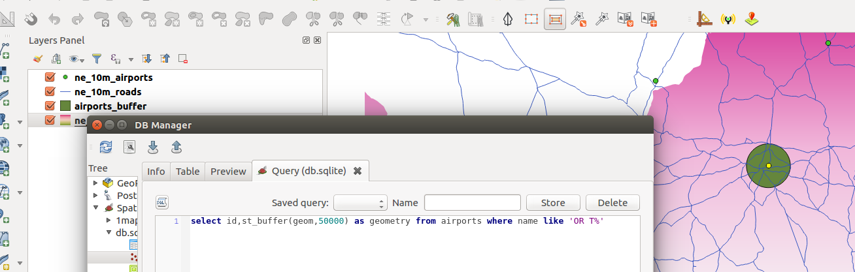
You try:
Goal: To learn how to create,populate databases and run simple queries
Problem: South African government wants to expand OR Tambo international airport by 50km. Visualise the extent of the new airport in QGIS and do all processing in the database
Data:ne_10m_airports,ne_10m_roads,ne_10m_admin_0_countries from natual earth
* Load the data into QGIS
* Create a spatialite database
* Filter the layers to show features visible in South Africa
* Load layers into the database using DB manager and reproject them using SRID
* Remove all layers from QGIS after loading them into database
* Load the layers from the database to appear in QGIS.
* In DB manager run the expression to calculate the buffer.
* Load the result of expression as a layer in QGIS.

Name | Value
TARGET SRID | EPSG:3857
GEOM | geom
Expression | select id,st_buffer(geom,50000) as geometry from airports where name like 'OR T%'

More about
Databases are very flexible in handling large ammounts of data. They offer many advantages over other data source and it is encouraged to use them as a data source. Spatial databases have started to be used also storing raster data and besides acting as a data store they can also be used for geoprocessing. The syntax that is used in the database is called SQL(Structured Query Language). This allows easy manipulation of the data and to derive new products using the same datasource.


Check your knowledge:
- A database is:
- A storage device where GIS activities will take place
- A GIS database representing vector features.
- A type of data store that is used to store geographic data and non geographic
- In which instance would you prefer a spatial database:
- When you have a a lot of csv or spreadsheet containing data for analysis
- When you need to do some advanced processing of the data.
- Almost all times, whenever I get hold of a data source I should load it into a spatial database.
- Buffers calculated in the database are identical to the ones in QGIS:
- True
- False
Answers: 1c, 2c, 3t


Further reading:
http://docs.qgis.org/2.14/en/docs/training_manual/databases/spatialite.html
http://www.bostongis.com/PrinterFriendly.aspx?content_name=spatialite_tut01
https://www.gaia-gis.it/spatialite-3.0.0-BETA/spatialite-sql-3.0.0.html

