
Section: Data discovery
Module : QGIS metadata


Capturing metadata for GeoNode in QGIS. Searching a GeoNode catalog from QGIS
Metadata is data about data. It describes the characteristics of the data e.g title, abstract, author, and keywords. GeoNode publishes spatial data and its metadata. Whilst GeoNode has the ability to generate metadata and tools for you to populate it, QGIS provides an interface where users can pre-generate full metadata and associate it with a layer during upload.

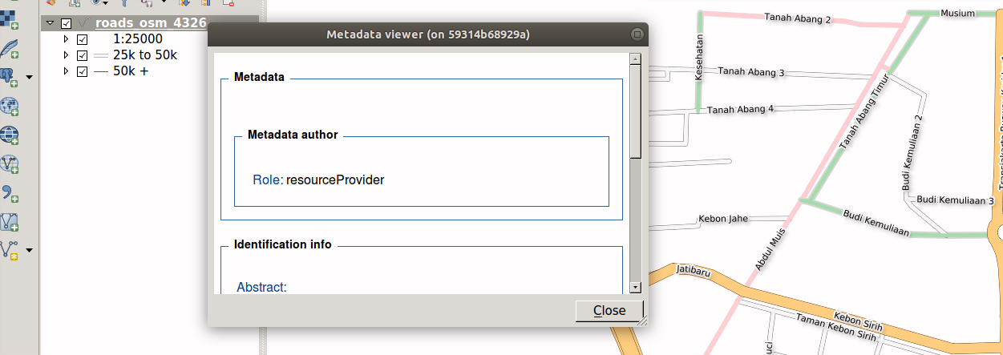
You try
Goal: To explore metadata capabilities in QGIS
* Load your Layers into QGIS
* Install or activate the Metadata tool
Instance 1
* Using the Keywords tool right click the layer.
* Select choose keywords and follow the onscreen prompts. The metadata file is saved next to the layer on disk.
Instance 2
* Use the Metadata tool.
* Using a loaded layer navigate to the Icon toolbar and select View Metadata. If the layer does not have metadata it will create a metadata document.
* Select Edit Metadata from the Icons and enter al records about the layer.
* Select Export Metadata from the icons and save the file on disk.
Instance 3
* Use the loaded layer and metadata from instance 1
* Using the Metadata tools select Import Metadata from the icons.
* Choose Edit Metadata and enter extra details.
* Choose Export Metadata and save the metadata file on disk
Instance 4
* Log into GeoNode
* Upload the Layer with the metadata you generated above
Browse GeoNode metadata in QGIS
* Install and open the metadata client
* Add a new service then explore the service
Name | Value
Layers | OGR or GDAL data layers
Metadata tool | MetaTools plugin
Keywords tool | InaSAFE plugin
Metadata file | .xml in ISO 19115 format
Metadata client | MetaSearch plugin
service | http://your.geonode/catalogue/csw
explore | Service info, GetCapabilities, try Search, add WMS / WFS / WCS layers to QGIS
Check your results
If using InaSAFE to generate metadata, the layer is not visible in the InaSAFE dock initially but after generating the keywords the layer will become selectable in the InaSAFE dock. Using other methods to generate metadata should result in a metadata file (.xml)

More about metadata with GeoNode and QGIS
When InaSAFE generates metadata it populates only a subset of the metadata fields, including adding the keywords to the Supplemental Data field. Utilising tools like MetaTools allows us to add extra detail to the metadata so that users can fully understand all elements of our data.

Richly populated metadata is important for many reasons, here are just a few:
- recording the provenance of the data
- recording the processing history
- noting the correct attribution
- providing details of any access constraints
- providing web service access urls
- providing contact information
- being interoperable with other ISO 19115 compliant metadata systems
- complying with regulations and policies. e.g. INSPIRE in Europe.


Check your knowledge
- what is the difference between generating metadata with InaSAFE and MetaTools?
- InaSAFE is used with hazard and exposure layers only and cannot generated metadata for other type of layers.
- InaSAFE produces a subset of the metadata.
- MetaTools is much more difficult to use.
- Metadata generated from InaSAFE and MetaTools can be ingested in GeoNode but they are produced with different tools. Why is that?
- The metadata contains Keywords and this allows them to be used in GeoNode.
- GeoNode does not care about the contents and structure as long as the metadata file has the extension (.xml)

- They all produce metadata that adhere to some common standard.

Further reading:
https://en.wikipedia.org/wiki/Metadata
https://inspire.ec.europa.eu/metadata/6541

