
Section: Advanced
Module : Management commands


GeoNode from the command line
GeoNode has an admin interface which is accessible on the browser if you have administrator rights. In addition to this, there are command-line options for doing various administrative tasks in GeoNode. The management commands are an extension of the admin interface as they allow user to do additional tasks that are not available in the admin interface.
In this module we explore the management interface from the command line.

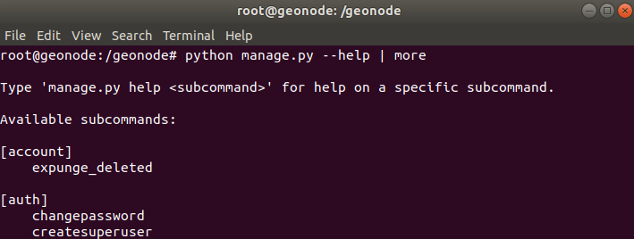
You try
Goal: To explore the some management commands
* Determine the install method for GeoNode (mainly done by sys admin)
* If the install method is Rancher, navigate to the rancher server or log in to the server using the server access method.
* Search for the Django container. If you are logged to the server run the docker lookup command. In Rancher navigate to the container list.
* Exec the Django container by right clicking the container and choose exec in rancher or by using the log-in command when logged on the server.
* When logged into the Django container execute the management command.
* You will be presented with a list of management options and a description of how they can be used.

Name | Value
Server | Geonode@192.168.2.12
Install method | Rancher, Docker-compose, Ansible
Rancher server | http://foo.bar
Server access | ssh
Docker lookup | Docker ps -a
Log in | docker exec it django bash
management | python manage.py --help
Check your results
When you are in the Django container you should be able to run a command without getting an error message. Execute python manage.py createsuperuser to ensure that you setup a master account on GeoNode.

More about GeoNode management commands
GeoNode is built with Django and Python with a backend of either Geoserver or QGIS server and a PostgreSQL database backend. Django has an admin interface which allows users to manipulate all the data and other related components relating to permissions for layers. The management command provides a set of management tools which extend the functionality of Django admin.

Example of management commands on the command-line. Assume all commands start with python manage.py $name of command. Where the $name of command could be
- createsuperuser
- importlayers
- updatelayers

For a full list of all the management commands execute python manage.py –help and choose each individual command to understand how it can be executed for example python manage.py importlayers –help

Probably the two main reasons you would need the management commands are:
- to upload and publish very large layers that time out through the web interface
- to publish layers that are available in the backend but not yet in GeoNode


Check your knowledge
- What components make up GeoNode ?
- QGIS Desktop,Django and Celery
- QGIS Server, Django,PostgreSQL
- Django,python3,QGIS Desktop
- Why would you want to use the command line management commands vs admin interface accessible on the browser?
- It does not make sense, the browser is much more friendly.
- The command-line should not be used because it is complex.
- The command-line allows a user to do more tasks in an automated way which the admin interface will not be able to achieve.
- The admin interface is simpler and easy to use and has more commands.
- How would you use the command line management tools?
- Yes, Only if you have installed management software like rancher.
- It is impossible, you need server access


Further reading:
http://docs.geonode.org/en/master/tutorials/admin/admin_mgmt_commands/

