
Section: Data discovery
Module : overview


Searching, browsing, federating GeoNode content
GeoNode is a spatial data infrastructure (SDI) that allows geospatial data and non-spatial data to be uploaded. The uploaded layers are available for searching, styling and processing and to generate maps that can be shared with other users. GeoNode has a permission model that enables users to manage access to data.

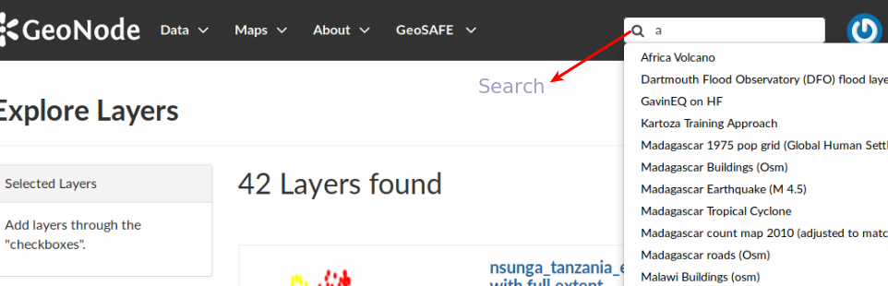
You try
Goal: To explore how to browse and filter GeoNode content
Instance 1
* Navigate to your GeoNode instance.
* For non logged users click on the Search
* Enter the name of the layer you need to access. As you type in the text representing the name of the layer, the search auto filters to show the available layers.
* Preview the layer you have searched.
Instance 2
* Log into GeoNode
* Navigate to the search and repeat the steps in Instance 1.
* Alternatively navigate to the left side of the layers page and choose from the Search Options.
* The layers are filtered based on the Search options.
* The Search options are heavily dependent on the metadata captured for the layers.
Instance 3
* On the data menu select Add Remote Service
* Enter the csw url and write the name of the service.
* Save the remote service.
* Navigate to the search and repeat the steps in Instance 1 or Instance 2

Name | Value
Search Options | Text, Categories, Type, Keywords, Date, Regions or Extent
csw url | http://foo.bar/catalog/csw
Check your results
After searching your layers you should see the layer or maps you have just selected and you can explore the properties of the layers and maps.

More about GeoNode data discovery
GeoNode uses the search engine elastic search which provides distributed, multitenant-capable full-text search engine with an HTTP web interface and schema-free JSON documents. GeoNode also provides for searching through Text, Categories, Type, Keywords, Date, Regions or Extent. The search method incorporates searches of Metadata.

By using remote services, you can federate content from multiple GeoNodes or other CSW compliant clearinghouses so that it becomes searchable and viewable from one central GeoNode.


Check your knowledge
- What is the difference between searching for layers when logged into GeoNode vs not logged in?
- When logged in there are more search options available.
- Searching for non logged users provides more options.
- Layers searched when non logged can not be downloaded.
- What is a remote service?
- A GeoNode instance that is setup on a different server to provide geospatial layers.
- Any OGC service that provides layers as WMS, WFS and WCS layer.
- Vector layers that can be accessed from the internet.
- Can you search for non-spatial content and maps in GeoNode?
- Yes
- No
- I do not know.


Further reading:
http://docs.geonode.org/en/master/tutorials/users/searching/
http://docs.geonode.org/en/latest/tutorials/overview_and_ref/user_features/import_and_manage.html

