
Section: Vector Analysis
Module : Symbology: Heatmaps

Heat maps in Context
“Heat map visualizes hotspots in the distribution of features on the map i.e. dense areas will be highlighted in a heat map, based on the parameters you use for processing it”
In this module we explore heat maps as a point symbolisation technique.
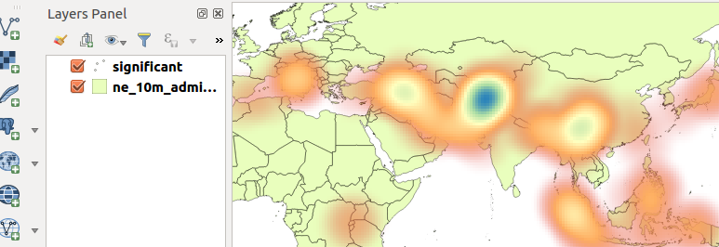
You try:
Goal: To learn creating heat map as a symbolisation technique
Data:appendix3-local-data/earthquake.csv
and ne_10m_admin_0_countries from natural earth

* Load the earthquake layer as a spatial layer.
* Load the ne_10m_admin layer
* Change the country layer transparency as specified
* Change the layer order to put the point layer on top
* Open the properties of the point layer and click the style tab.
* Change to the specified render type
* Choose the specified colour ramp
* Apply the changes and observer the map
* why does the whole map colour change ?
* Edit the colour ramp. Make colour 1 transparent.
* Apply the changes and observer.
* Open the properties of the point layer and change rendering quality to fastest. Observe the changes.
* Change the weight points by option to use the specified attribute.

NB: What can you infer about the intensity of the heat map in relation to deaths?
Name | Value
Render | Heat map
Country transparency | 70
Colour ramp | Spectral
Attribute | Deaths

More about
Heat maps use colour to communicate relationships between data values that would be difficult to understand if presented numerically in a spreadsheet or attribute table. A colour ramp helps to visualise a heat map with low values having colours at the bottom of the colour ramp and high intensity values corresponding to darker values on the colour ramp.

Check your knowledge:
- When would it be useful to use a colour ramp:
- To depict how a player was behaving during a soccer match.
- To show that the layer being represented is a vector layer.
- Heat maps can also be applied to raster data.
- Which statement is false:
- A colour ramp is used to show variation in a phenomena of interest
- Heat maps are extensively used by scientist
- Heat map points can be weighted by a discrete column.
- A colour ramp is a type of vector analysis:
- True
- False
Answers: 1a 2c, 3f

Further reading:
http://docs.qgis.org/2.14/en/docs/user_manual/plugins/plugins_heatmap.html
http://grindgis.com/software/heat-map-using-qgis

