
Section: Map Composition
Module : Map Composer Basics


The Map Composer in Context
“The QGIS Map Composer is the layout or reporting component of QGIS. You might do your work on the canvas, but you show it off or publish it with the Composer.”
You can user the composer to make a once-off map or to design and manage multiple map designs by means of templates. While you do your map styling and labelling in the main QGIS environment, the canvas, it is in the Composer that you add the rest of the map elements, do the layout and add the finishing touches.

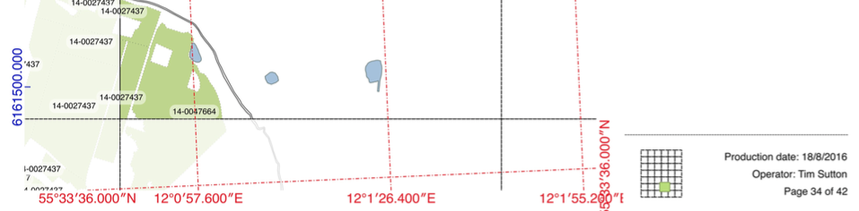
You try:
Goal: To produce a map with all the standard map elements.
- Open a few Natural Earth layers from the ne.sqlite database and do some quick styling and labelling, or use a project from a previous worksheet.
- Set your CRS to a projected CRS (maps must be projected!).
- Create a new ‘Print Composer’ and give it a useful name
- Look at the Composition settings and change your page settings if you like
- Find and click the Add a New Map tool and click-drag a rectangle where you want your map to go.
- Do the same for Image (once for a photo or logo and once for a North Arrow), Label (for your map title), Legend and Scale bar
- After adding each element or while it is active (with white handles), look through its Item properties and experiment with changing them.
- Move and resize the map elements to get a pleasing layout.
- Use the Move item content tool and the Map’s item properties Extents and Scale to set your map extent and scale just how you want it.
- Add a long/lat graticule (aka Grid) to your map.
- If you have time:
  - Add annotations with text boxes, shapes and arrows
  - Add an html frame and a table
  - Export your map as a pdf
  - Save the map as a template (.qpt file)

Name |   Value
CRS suggestions | Choose an appropriate CRS for the scale, shape and location of your map.
World map | 54032
Local | The local UTM zone
Graticule CRS | 4326

More about Composer
We’ve just touched on the composer. Hopefully you found it easy to slap together a fairly good looking map or report. There’s lots more to the composer that is covered in other worksheets. For example, you can add multiple maps to one layout and use some as overviews or popouts. Or you can create a series of maps automatically with the Atlas tool. Take time to explore and read about the functionality of the composer. Good cartography is a combination of what is in the map itself and how the map is presented in the final layout.

It takes a lot of effort to perfect a map layout. So, once you’ve done that back at work (or for yourself) then save the layout as a template that you can share and use in other projects, where all that changes is the map itself.


Check your knowledge:
- A ratio scale is a bad idea because:
- It’s hard to understand a ratio
- If the map size changes (e.g. enlarged in a photocopier) the scale becomes invalid
- It’s hard to get a ratio to a round number
- Why must the map be projected?
- The Earth is a globe and our map is flat
- Longitude and latitude are polar coordinates, so should not be plotted on a Cartesian plane
- Choosing the right projection helps convey the message of the map correctly
- So the scale can make sense
- All of the above
- None of the above


Further reading:
Inspiration: https://www.flickr.com/groups/qgis/pool/
http://docs.qgis.org/2.14/en/docs/gentle_gis_introduction/map_production.html
http://docs.qgis.org/2.14/en/docs/training_manual/map_composer/map_composer.html

