
Section:Map Composer
Module :Scale Bar

Scale Bar in Context
“A map is a measuring product. The functionality of maps is not limited to giving directions only; distances between two places can also be calculated on a map. A scale bar is labeled with its ground length, usually in multiples of map units, such as tens of kilometres or hundreds of miles.”
In this module we look at how to produce a map with an accurate scale that ensures distances can be correctly measured from the maps.
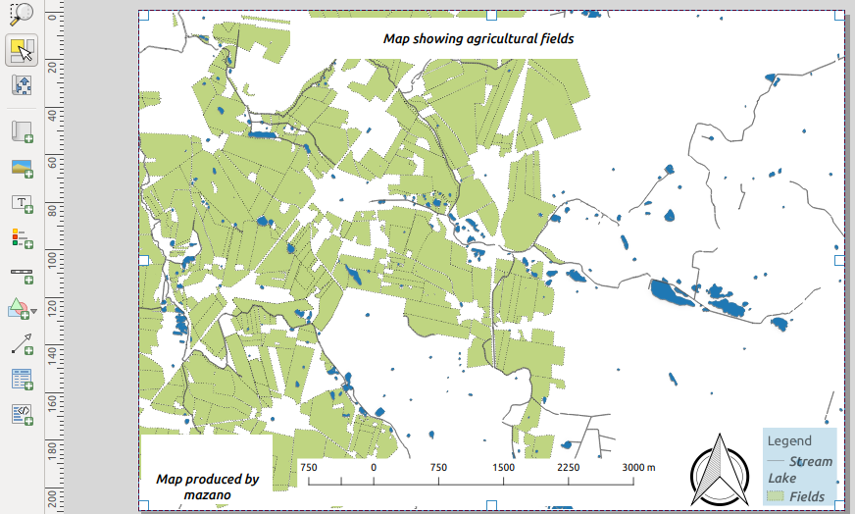
You try:
Goal: To produce a map from which measurements can be taken.
* Open the project scale_bar from appendix4-projects
* Add a map and Map legend.
* Add an image and choose search directories in the item properties. Select North Arrow.
* Add a grid using the Grid properties
* Add a label and insert map credits. To insert the name use Insert and expression and choose the Name_variable.
* Add a scale bar using the Map scale properties
Does the scale bar look correct, If not what is wrong ?
* Activate the map and change Cache to Render.
* Navigate to QGIS and change the CRS of the project to the specified CRS.
* In map composer click Update Preview.
Why does the map disappear. How do you get it centred again, Is the scale bar still correct ?
* Click set map to canvas extent. And set the scale to 25:000
* Change the scale bar from metres to km by using the Km scale.
* Why is it wrong to measure from the map where the scale is a ratio ?

Name | Value
CRS | 25832
Grid properties | Units:CM,X and Y = 5
Map label | Horizontal align: centre,Vertical align:middle, font size:16
Map legend: | Fonts sizes:16,Bg_colour:#a6cee3,Bg_Transp:40
Name variable | @user_full_name
Map scale | Style:Line ticks up
Km scale | Label multiplier: 1000,unit label:km

More about Scale bar
Maps are extensively used around the world for direction but many cartographers also use them for measuring distances between different places. The distance between two places is affected by the co ordinate reference system the map is produced in. Making a map for measuring distances should not be done in an unprojected co ordinate system like EPSG:4326.

Check your knowledge:
- What do you understand by the term projected data:
- Data that you have been given by a client as part of a project.
- Data that has been acquired from a GPS and used in a GIS.
- A GIS dataset that has units in metres.
- Why does a map not show when you change the map projection in composer:
- The GIS software becomes confused and there is no algorithm to edit that.
- The map extent changes between the different data sources and the scale will be wrong.
- The scale will be wrong and unusable in QGIS.
- Can a map be used as a measuring tool:
- True
- False
Answers: 1c, 2b, 3t

Further reading:
https://docs.qgis.org/2.14/en/docs/user_manual/print_composer/composer_items/composer_scale_bar.html
https://docs.qgis.org/2.14/en/docs/user_manual/print_composer/print_composer.html
https://docs.qgis.org/2.18/en/docs/user_manual/working_with_projections/working_with_projections.html

