
Section: Vector Analysis
Module : Topology Maintenance

Vector topology in Context
“Topology expresses the spatial relationships between connecting or adjacent vector features (points, polylines, and polygons) in a GIS. Vector data has to conform to the topological model e.g. two lines in a roads vector layer that intersect should be joined by the same node. Topology is necessary for carrying out some types of spatial analysis, such as network analysis.”
In this module, we will inspect vector data for topology errors and explore ways in which to clean the dataset so that it conforms to the vector topology model.
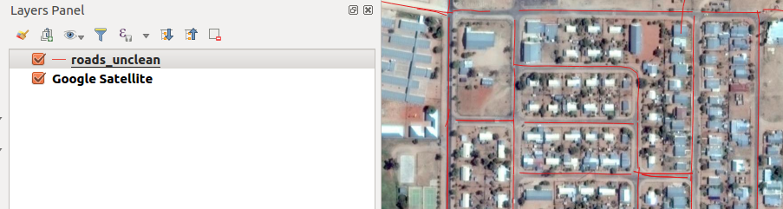
You try:
Goal: To learn how the basics of maintaining vector topology.
Data: roads_unclean and 2821AD_21_2014_747_RGB_RECT.tif from appendix3-local-data
* Open the named QGIS version and load the road layer in QGIS
* Check for topology errors using validity tools
* Use the processing toolbox to delete duplicates
What are duplicate ?
* Activate processing toolbox and use v.clean.snap.
What are the units are used in the algorithm ?
* Reproject the vector to the CRS.
* Activate the grass plugin. (Click on new mapset and follow the onscreen prompts, create a location with EPSG:3857)
* Select grass tools from Grass menu.
* Navigate to File management and choose import vector layer. Import the projected layer.
* Navigate to Vector then develop map and then toolset for cleaning topology.
* Choose a cleaning tool and visualise the result after running it.
* Repeat the cleaning procedure with different tools until you get satisfactory results.
* Load the results in QGIS each time and compare with the original roads_unclean layer.

Name | Value
Validity tools (Plugins) | Topology checker,Geometry validity
CRS | EPSG:3857
Cleaning tools | V.clean,v.clean.snap
QGIS version | QGIS with grass

More about
Vector topology maintenance is useful because it enhances spatial analysis and also allows us to explore the geographical relationship between feature example which roads are connected with which and which provinces are adjacent to each other. Vector GIS datasets need to be checked for any errors which include undershoots, slivers,overshoots,duplicates. GRASS GIS is a fully topological GIS package and using the GRASS plugin to check and clean data helps in generating clean vector data which can be used in an analysis.

Check your knowledge:
- A clean vector dataset is:
- A dataset that has been beautifully symbolized.
- A GIS vector dataset that can be used in spatial analysis without causing problems
- A GIS vector dataset that does not have any spelling mistakes
- Which type of data should be checked for topology errors:
- A satellite image that contains roads
- All layers in QGIS should checked
- A GIS vector dataset where each polygon represents a type of building
- GRASS is a type of a plugin:
- True
- False
Answers: 1b, 2c, 3f

Further reading:
http://docs.qgis.org/2.14/pl/docs/user_manual/plugins/plugins_topology_checker.html
https://docs.qgis.org/2.14/en/docs/gentle_gis_introduction/topology.html

