
Section: InaSAFE Realtime
Module : Volcanic ash data preparation

How volcanic ash data are prepared for InaSAFE Realtime
“In this module we will explain how ash fall data are taken from PVMBG ash fall products and prepared for use in InaSAFE Realtime.”
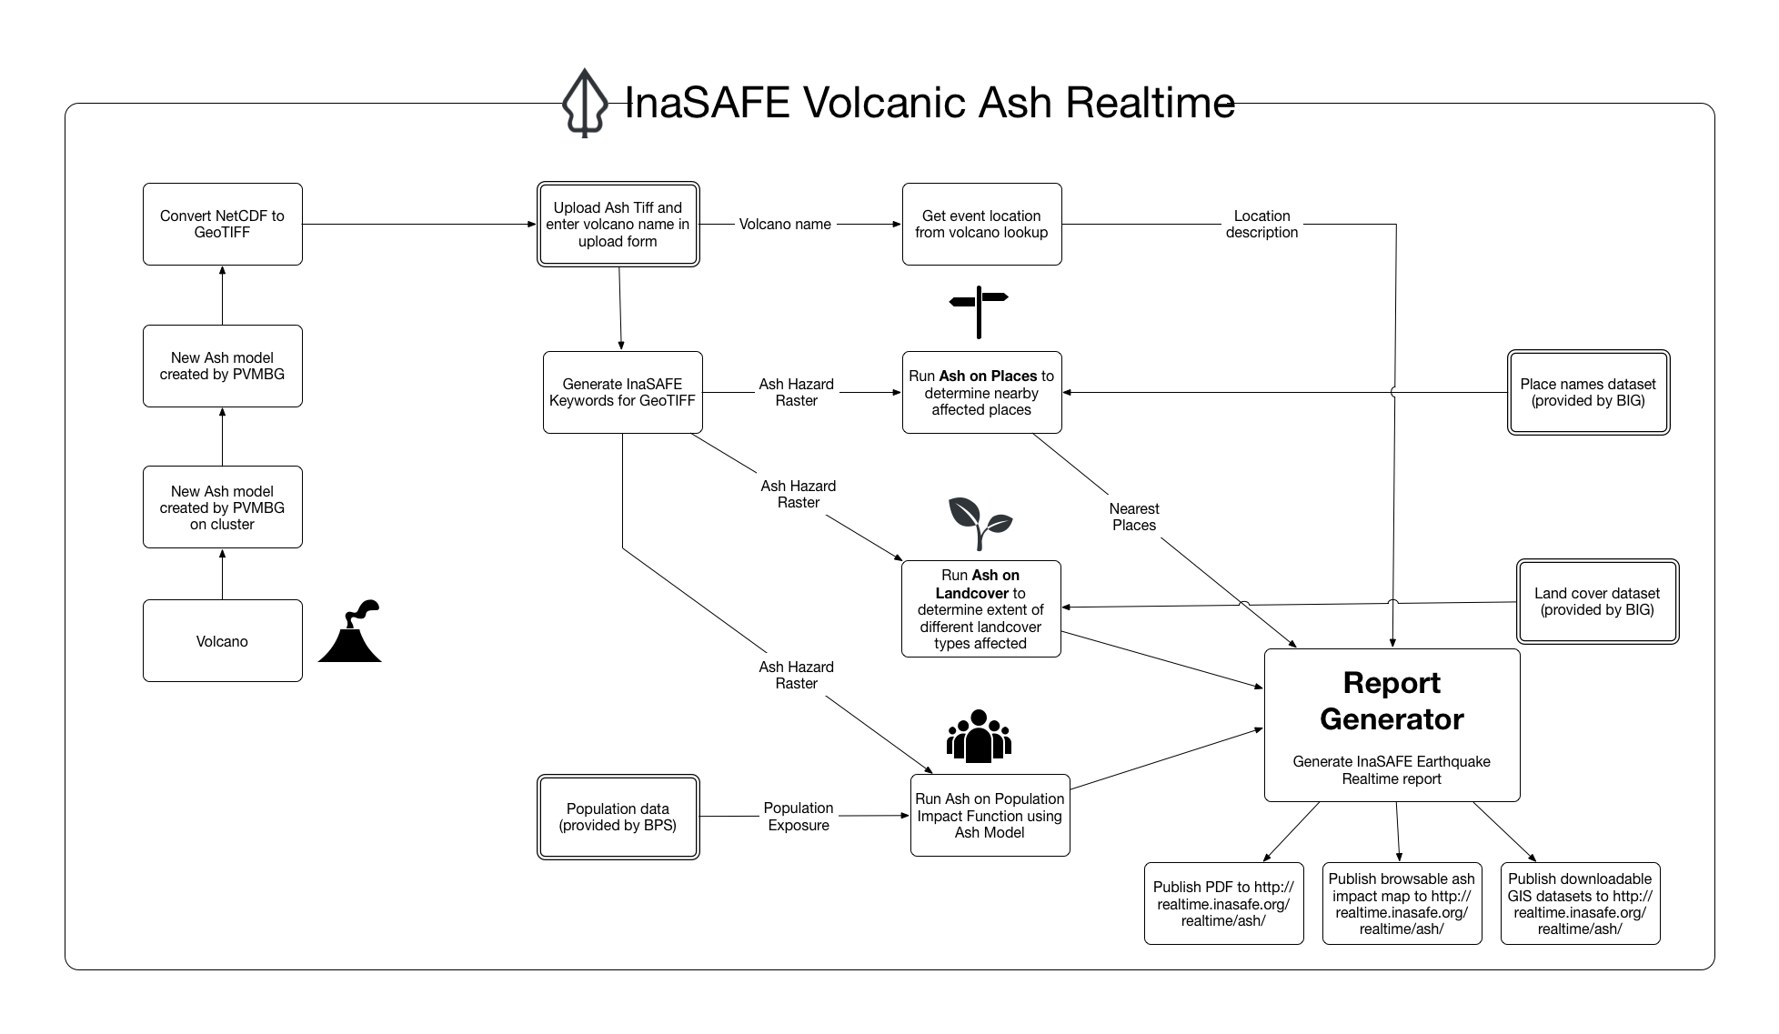
In the ash service we provide a file upload form that PVMBG can use to push modelled volcanic ash products for a volcanic eruption event. Once an ash dataset has been uploaded, InaSAFE will add appropriate keywords to the uploaded dataset and generate a number of products. This process is described in the diagram above. The various products are combined with standard exposure and contextual datasets to produce a report. The report is then published on the InaSAFE realtime web site but is not pushed to InaWARE.

Note: Ash realtime is still subject to sign off from PVMBG and thus you will not see it as part of the live realtime site.

More about the ash analysis
As you can see from the above diagram, there are three main analyses carried out in the ash analysis:

1) Calculation of ash on landcover. The deposit of volcanic ash on certain landcover classes is significant because the ash can kill crops and affect other land use related activities. For landcover, data from BIG is used. This calculation is used to produce the Land Cover Impact table in the PDF report.

2) Calculation of ash on places: This calculation is carried out using BIG places data and Open Airports data. InaSAFE does not make any assertions as to whether a place or airport will be operable given the ash load experienced. Rather InaSAFE estimates the effect of the modelled ash fallout level at ground level at a given place / airport, and tabulates the place name, number of people likely affected and the fallout level.

3) Calculation of ash on population: In this calculation, the number of people per ash fallout level is calculated for the reported event.

After the analysis has completed and the reports are generated, the report and data are made available on the realtime platform. In the future it would be possible to publish the report to InaWARE where it can be viewed by operations staff after the volcanic eruption.

Check your knowledge:
- InaSAFE Realtime ash is available for general use.
- true
- false
- Mark all the correct statements:
- Ash Realtime actually performs four InaSAFE impact functions during report creation.
- InaSAFE ash reports are not available immediately after an ash plume is emitted by a volcano since the ash spread and weight need to be modelled first.
- InaSAFE ash reports are based on modelled ash fall at ground level and can be used to plan mitigation activities.
- The ash fall reports also include pyroclastic flow reporting.

Further reading:
https://github.com/inasafe/inasafe/issues/2491 – the InaSAFE Issue tracker containing detailed design notes during creation of the ash reporting functionality.
https://github.com/inasafe/inasafe-django – main repository for InaSAFE Realtime Source Code

