
Section: InaSAFE
Module : Preparing an analysis from first principles

Understanding the process
“First principles: the fundamental concepts or assumptions on which a theory, system, or method is based.”
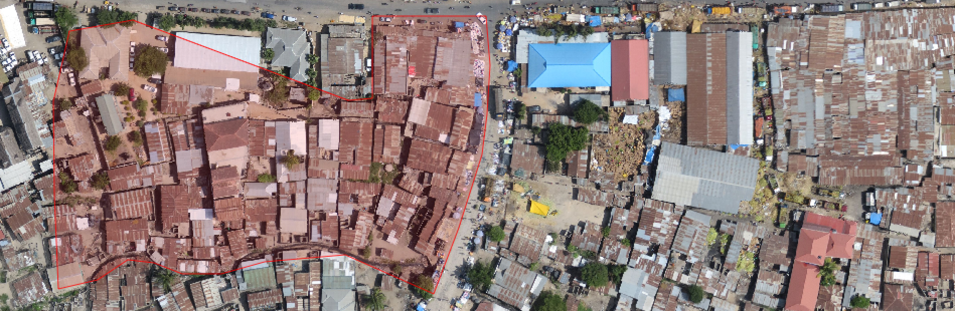
The purpose of this worksheet is to give you a small practical example of the workflows used in order to assemble the needed datasets to be used in InaSAFE. You will do some basic digitising activities, collaborate with your peer groups to exchange vital data needed to do the analysis and then perform two analyses in InaSAFE.
To start with you need to divide yourselves into groups of four people. Each group must take on one of these roles:
 | Building Mappers  (follow the building mapper’s guide)
 | Street Mappers  (follow the street mapper’s guide)
 | Flood Mappers  (follow the flood mapper’s guide)
 | Ward Mappers  (follow the ward mapper’s guide)

Now follow the worksheet relevant to your groups!

