
Section: InaSAFE
Module : Advanced Composer Substitution Variables

Customised reports in InaSAFE
“InaSAFE report templates can be overridden. You can place a template in your user directory and it will be used in preference to the standard templates we ship with InaSAFE.”
For InaSAFE you can prepare QGIS composer templates to be used in reporting. To modify a template you need to copy it to your home directory in:
<your home>\.qgis2\inasafe\<template name>
The following templates are customisable:
a4-landscape-blue.qpt
a4-portrait-blue.qpt
Note: In InaSAFE 4.2 we expect to change the standard template names – look out for the release changelog to see more information about this.
InaSAFE uses a ‘by convention’ based approach. Two conventions are supported:
Element ID's - InaSAFE looks for elements with specific id's on the composer page and replaces them with InaSAFE specific content.
Tokens within text elements - InaSAFE looks for text within a text item and tries to replace it. The text must be written in square brackets ‘[‘ and ‘]’.

Elements
Expected ID | Type | Purpose
safe-logo | Picture Item | If used, this will be replaced with the InaSAFE logo. Note: deprecated in 3.2, use black-inasafe-logo or white-inasafe-logo rather.
black-inasafe-logo | Picture Item | If used, this will be replaced with the BLACK InaSAFE logo. The logo is in SVG so you can scale it to any reasonable size. Note: added in 3.2
white-inasafe-logo | Picture Item | If used, this will be replaced with the WHITE InaSAFE logo. The logo is in SVG so you can scale it to any reasonable size. Note: added in 3.2
supporters-logo | Picture Item | If used this will be replaced with the 'supporters logo'. Note: added in 3.2
organisation-logo | Picture Item | If used this will be replaced with the organisation logo defined in InaSAFE options.
north-arrow | Picture Item | If used this will be replaced with a north arrow.
impact-map | Map Item | If used this will be replaced with a map that is centered on the impact area. Note that if you do not maintain a square aspect ratio for the map, it may be resized vertically by an arbitrary amount during print generation!
impact-legend | Legend Item | If used, this will be replaced by a legend generated by InaSAFE.
impact-report | *Label Item | If used, this will be replaced with the detailed impact report. The report may be quote long so should typically be on its own page.

Here is an example of using an element ID to place an organisation logo on the layout:
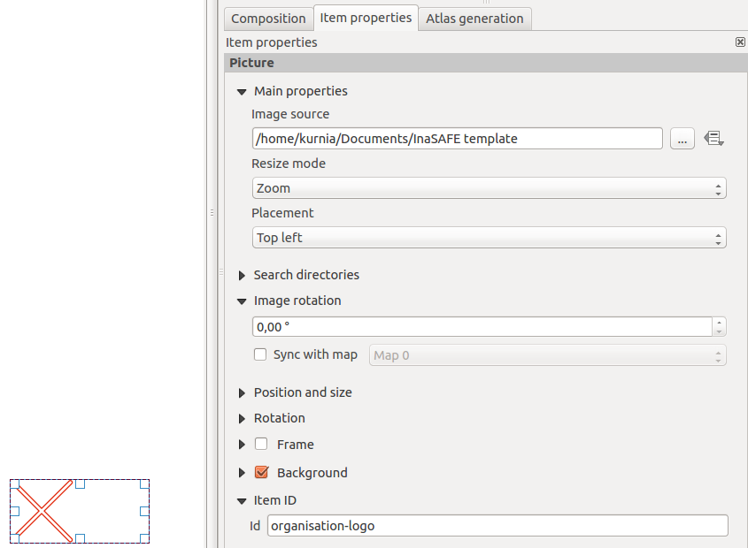

Replacement tokens
Token | Type | Purpose
[impact-title] | Label Item | Will insert the title for the impact map.
[disclaimer-title] | Label Item | Will insert the word 'Disclaimer' as localised text in place of this token. Note: Added in version 3.2
[disclaimer] | Label Item | Will insert InaSAFE's standard disclaimer paragraph.
[date-title] | Label Item | Will insert the word 'Disclaimer' as localised text in place of this token. Note: Added in version 3.2
[date] | Label Item | InaSAFE will insert the report date in place of this token.
[time-title] | Label Item | Will insert the word 'Time' as localised text in place of this token. Note: Added in version 3.2
[time] | Label Item | InaSAFE will insert the report time in place of this token.
[safe-version] | Label Item | InaSAFE will insert the version of InaSAFE used to generate the report. Note: Deprecated in 3.2 - use inasafe-version rather.
[version-title] | Label Item | Will insert the word 'Version' as localised text in place of this token. Note: Added in version 3.2
[inasafe-version] | Label Item | Will insert the version of InaSAFE used to generate the report. Note: Added in 3.2.
[caution-title] | Label Item | Will insert the word 'Note' as localised text in place of this token. Note: Added in version 3.2
[caution-text] | Label Item | Inserts the following localised text: 'This assessment is a guide - we strongly recommend that you ground truth the results shown here before deploying resources and / or personnel.'. Note: Added in 3.2
[version-text] | Label Item | Paragraph form of the version which will produced localised text similar to: 'Assessment carried out using InaSAFE release 3.2.0. Note: Added in 3.2
[legend-title] | Label Item | Inserts the word 'Legend' as localised text. Note: Added in 3.2
[information-title] | Label Item | Inserts the word 'Information' as localised text. Note: Added in 3.2
[supporters-title] | Label Item | Inserts the phrase 'Report produced by' as localised text. Note: Added in 3.2

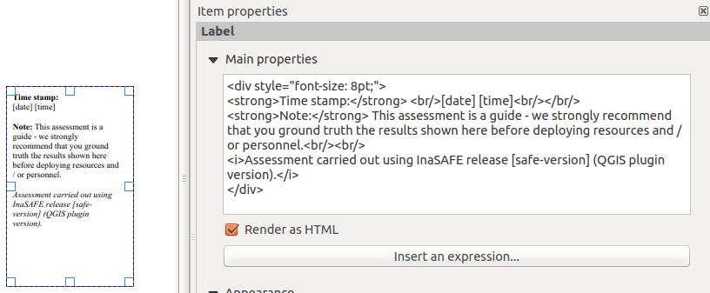

Using QGIS Variables to drive report behaviour

QGIS Variables (Settings -> Variables, Project properties -> Variables, etc.) Can also be used to manage certain elements in your template dynamically. For example if you set a heading background variable, you can use it on your template to determine the background colour, and then change it centrally for all reports.

Variable Name | Description
inasafe_report_heading_background | Background colour for the top heading

Now you try
Create a custom template using some of the elements above. Make sure to give the template the correct name and to place it in the correct location. Now run an InaSAFE analysis and verify that your template is being used.

More about the composer templating
All of the standard features of QGIS composer definition can be used to. You should take advantage of this to create reports that address the specific needs of your organisation. These customisations support also advanced features like QGIS variables. We plan to support atlas in the near future.
We would really appreciate it if you could include the InaSAFE logo in your reports – it will help to support the work we are doing and to promote the project to a wider audience.

Check your knowledge:
- All functionality of QGIS can be used in report design:
- true
- false
- Mark all the correct statements:
- You cannot use custom reports for InaSAFE.
- To edit your template, look in the InaSAFE source code and modify it there.
- Never acknowledge InaSAFE in your report.

Further reading:
Read about the InaSAFE wiki guide for templating:
https://github.com/inasafe/inasafe/wiki/Map-Composer-Templating

