
Section: InaSAFE
Module : Peta Bancana Downloader


Understanding the InaSAFE Peta Bencana Downloader
“InaSAFE includes a tool can download flood data from Peta Bencana and preprocess it so that it is ready for use in InaSAFE.”
The PetaBencana service is available at https://petabencana.id and is currently specific to select towns in Indonesia. From their web site: “PetaBencana.id is a project initiated by the Urban Risk Lab at MIT as a free, transparent platform for emergency response and disaster management in megacities in South and Southeast Asia.
The platform adopts a “people are the best sensors” paradigm, where confirmed reports are collected directly from the users at street level in a manner that removes expensive and time-consuming data processing. This framework creates accurate, real-time data which is immediately made available for users and first responders.”
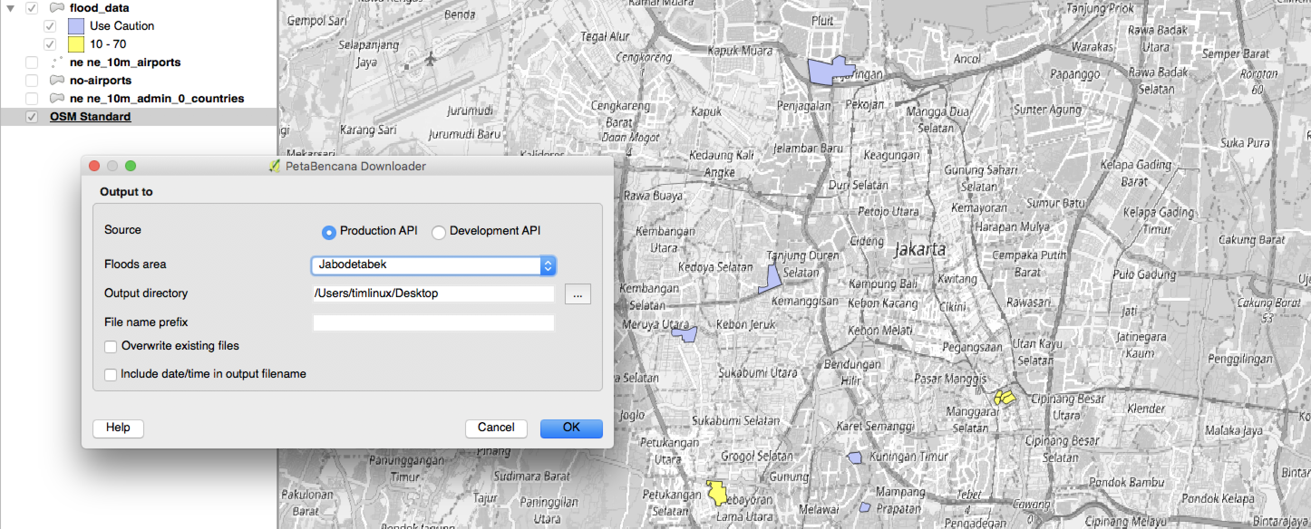

You try:
Goal: Understand the PetaBencana tool
Use the Plugins -> InaSAFE menu to find and run the PetaBencana downloader.
Run the tool are review the output. There are two possible outcomes:
1) There are no active floods in Jakarta in which case you will receive a prompt: “There are no floods data available on Jabodetabek at this time.”
2) There is an active flood in Jakarta and a new layer is added to QGIS with current floods for Jakarta

If you encounter situation 1 above, you can also fetch archive data from the InaSAFE realtime web site at: http://realtime.inasafe.org/realtime/flood/ but you will need to re-run the keyword wizard for the downloaded layer from the archive since the keywords provided there are for InaSAFE 3.5.
Finish this exercise by zooming in to one of the flooded areas, using the OSM downloader tool to get building data for the area and running a flood on buildings impact analysis.
Check your results:
Were you able to successfully complete the analysis?

More about the PetaBencana tool
The tool only fetches the current snapshot of flood data using the PetaBencana web API (application program interface). PetaBencana data is unverified but still provides a useful indication of where floods may be occurring. The platform underlying PetaBencana is open source and could be adopted in other places around the world too. The data provided be the system is ‘crowd sourced’ by watching various social media channels (Twitter, Qlue etc.) for mentions of specific keywords and then aggregating the report against administrative areas.
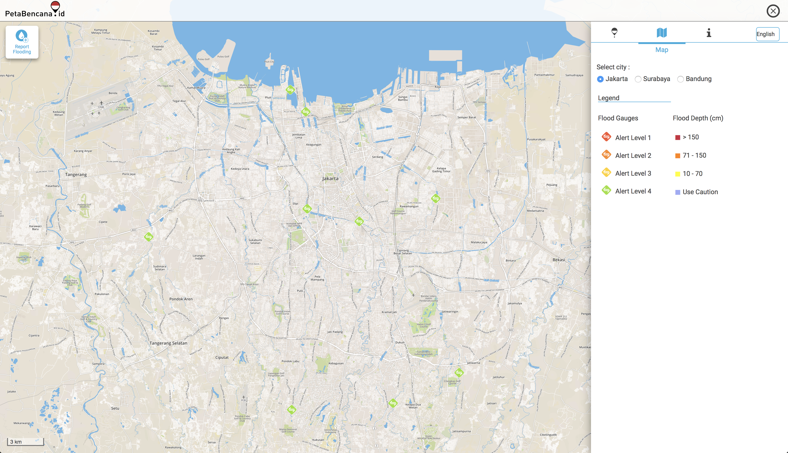
The InaSAFE Realtime system also uses PetaBencana for producing 6 hourly flood impact potential maps for Jakarta. In the process, InaSAFE realtime also stores the flood archive.


Check your knowledge:
- PetaBencana is a world wide flood reporting system:
- true
- false
- Mark all the correct statements:
- Archived data in PetaBencana can be used directly in InaSAFE Desktop.
- Archived data are available on the PetaBencana web site.
- PetaJakarta uses Twitter as a source of flood reporting data.



Further reading:
https://petabencana.id/map/jakarta

