
Section: Map Composer
Module : Multi page layouts

Map composer in Context
“Map composer allows you to add elements such as the QGIS map canvas, text labels, images, legends, scalebars, basic shapes, arrows, attribute tables and HTML frames. The basic elements of maps can be added on different pages of the same composer layout.”
In this module we look at how to produce a map with multiple pages. We will be looking at splitting the map on the image below so that it can appear on different pages.
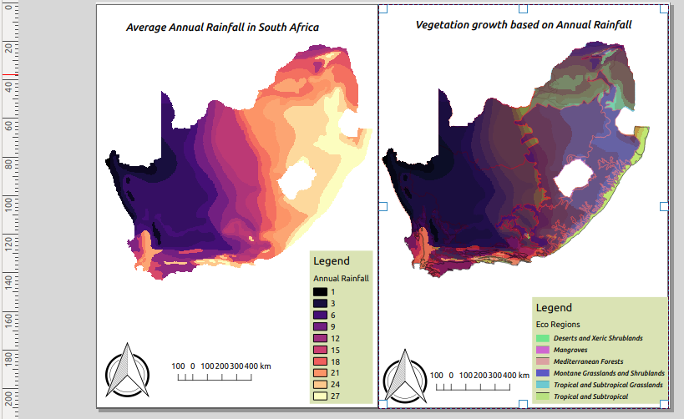
You try:
Goal: To produce maps that incoperates multiple page layouts.
* Load the Layers from appendix3-local-data
* Symbolise the raster layer using Raster style
* Arrange the layer and put the vector on top
* Symbolise the vector using Vector style.
* Toggle visibility of the vector layer to off.
* Open map composer and setup page settings
* Add a map on page 1 (map on the left in the image shown above)
* Add the scale bar,north arrow and map frame on page 1.
* Add the legend and put a background with color #dae3b4.
* Disable Auto Update on legend items and remove the vector from the legend. (Make the legend nice)
* Toggle lock layer, lock styles for map layers.
* Navigate to QGIS viewer and toggle visibilty on for all layers.
* Add a new map on second page(map on the right side in the image). Change the page background to #b2df8a
* Repeat the procedure for adding other map elements like you did for page 1.

Name | Value
Layers | South_Africa_annual_rain.tif ,sa_eco_regions.shp
Raster style | Color ramp:magma,Mode:Equal interval,class range:3
Vector style | Categorized,Column:WWF_MHTNAM,Layer transparency:30,belnding:multiply
Page settings | No pages:2

Check your results.

When you are done you should produce a map that consistof two pages and each page should have a map. The pages are part of the map but can be customised to include their own elements.

More about
Map composer allows users to add elements to a map based on the layers that exist in QGIS map canvas. Because of the ability to lock layer styles and map layers users are able to add multiple layouts with different layers on different pages. A map can have 1 or more pages and the only limitation is that the orientation of the pages should be identical. You can not mix between potrait and landscape between the different pages.

The advantage of having multiple pages in map composer is that it aids users who creates maps when other map elements overflow. It allows maps to be less cluttered.

Check your knowledge:
- What elements constitute a map:
- Layers with proprer catographic themes.
- Layers,scale bar,map titles and legends.
- Two or more map layouts and map titles.
- Why would you want to have to different map layouts using the same layer:
- To showcase the power of QGIS map composer.
- A monitor migration patterns of birds when using a bird layer.
- For the fun of it.
- What is the maximum number of map layout QGIS can handle:
- 1
- 2
- As many as you can fit on your pages
Answers: 1b, 2b, 3c

Further reading:
https://docs.qgis.org/2.18/en/docs/user_manual/print_composer/composer_items/composer_legend.html
https://docs.qgis.org/2.18/en/docs/user_manual/print_composer/composer_items/composer_legend.html

