
Section:Raster Analysis
Module : Clipping Rasters

Clipping rasters with QGIS
“QGIS provides various ways to clip a raster layer. In this worksheet we will look at one approach.”
If you have a raster that is larger than the area needed for your map or analysis, you can clip it to a smaller size using QGIS. In addition you can ‘mask’ the layer using a polygon in order to assign no data values to pixels outside of your target area.
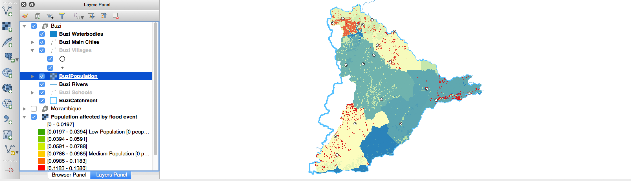
You try:
Goal: To clip a subset of raster data using a polygon

* Load the two datasets indicated in the table right.
* Select one district and use the ‘save as’ option to save just that district to a new shapefile.
* Remove the original districts layer.
* Use the Raster -> Extract -> Clip tool to clip the population dataset using the district.

Name | Value
Data | appendix3-local-data/kzn_pop_count
 | appendix3-local-data/districts

More about

Check your knowledge:
- Clipping rasters with QGIS is done either by rectangle or by a polygon layer:
- true
- false
- Which of these represents a derivative of a digital elevation model:
- A satellite image showing mountanous areas.
- A slope curvature map that is used by surveyors to determine the direction at which the sun shines
- A vector data that represents natural phenomen.
- Plugins are extensions in QGIS:
- True
- False

Further reading:

