
Section:VectorAnalysis
Module :Population Density


Population dot density in Context
“Population distribution describes a way in which people are spread across the earth surface. Population distribution is usually shown by a dot density map where each dot represent a certain number of people. ”
In this module we will learn how to create a dot density map.

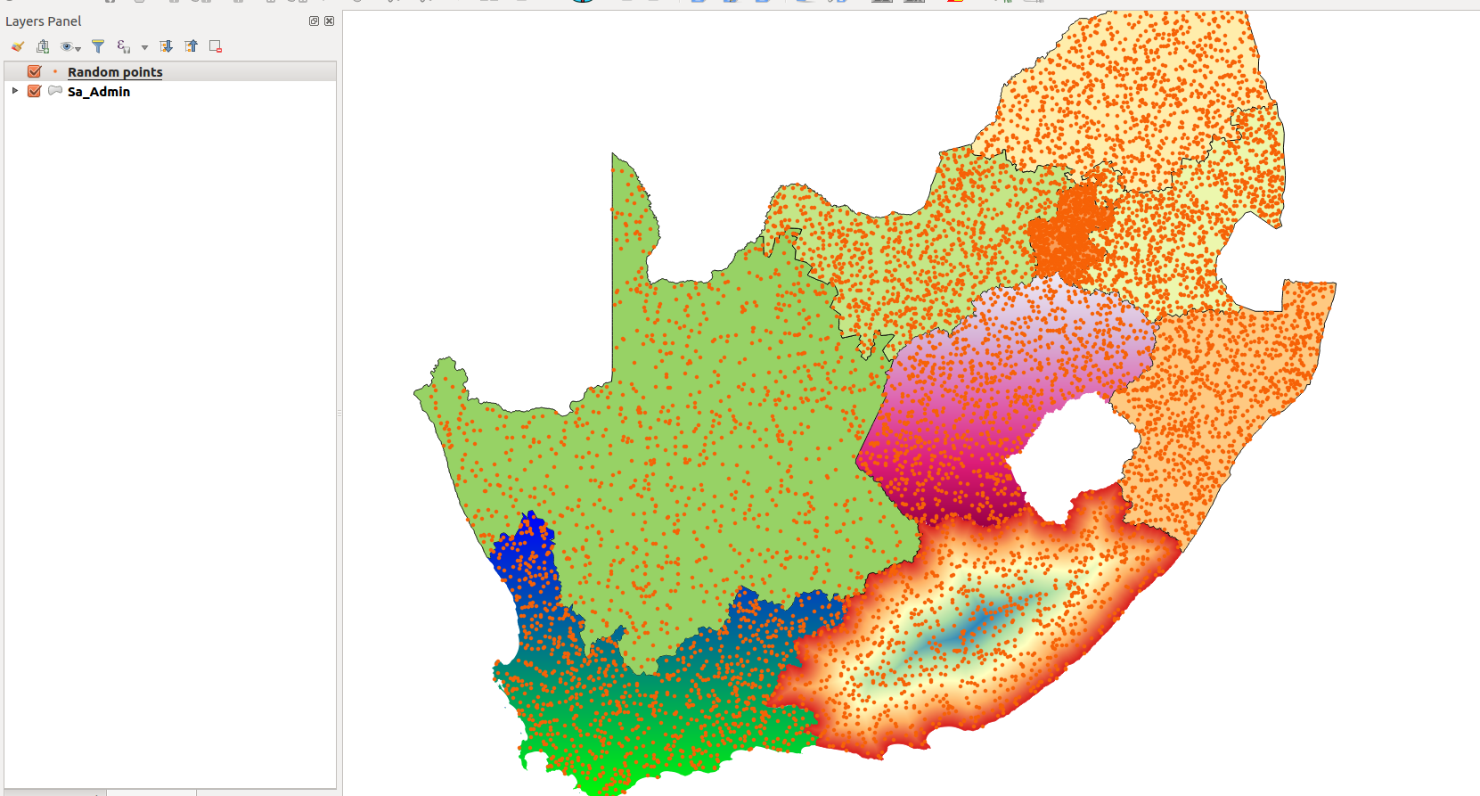
You try:.
Goal: Create a dot density map where 1 dot represents 1000 people.
Data: appendix3-local-data-district.shp,kzn_population.csv
* Load the layers into a new project.
* Right click on districts and choose properties.
* Select the join tab and create a join. Use the join field.
* Create a join using the specified join columns.
* Select which fields to join to. ( select area_km,population_2016,density)
* Activate custom field name prefix and give an appropriate name.
* Right click on district layer and choose ‘Save As`.
* Change the CRS to the specified one and proceed to save the layer. Make sure the name correspond to new layer.
* Use the spatial algorithm to create the random points using the district_hbk layer.
* Symbolise the resultant point layer and create a legend that shows your results.

Name | Value
CRS | South African CRS : HBK_NO_29
Join column | District:code
Spatial algorithm | Random Points
New layer | district_hbk

More about dot density maps
Dot density maps are effective at showing density variations on geographic landscapes.
Dot maps are advantageous when mapping phenomena that change smoothly over a space, as the dot maps will visually match the phenomena. There are mainly two type of dot density maps namely one-to-one and one-to-many dot maps.

Dot density maps can be used in conjunction with other thematic maps to understand phenomena that occurs across the earth surface.


Check your knowledge:
- What is it useful to know population distribution:
- Because it will interrupt human activity like a farming
- For planning purpose, resources use against people
- It does not matter as long as we know the population density
- What is population distribution and how is it represented in a GIS:
- A type of gis dataset that shows how people behave
- The spread of people across the terrain
- Spread of points in a vector layer
- Is population distribution a type of dataset:
- True
- False
Answers: 1b, 2b, 3f


Further reading:
http://docs.qgis.org/2.14/en/docs/user_manual/processing_algs/qgis/vector_creation_tools.html#random-points-inside-polygons-fixed
http://smsgis.co.za/qgis-population-density-tutorial/

