

Section: Analysis
Module : Troubleshooting


Troubleshooting GeoSAFE Analyses
Software troubleshooting is the process of scanning, identifying, diagnosing and resolving problems, errors and bugs in software. It is a systematic process that aims to filter out and resolve problems, and restore the software to normal operation.
In this module we will explore how to investigate issues encountered during the analysis workflow.

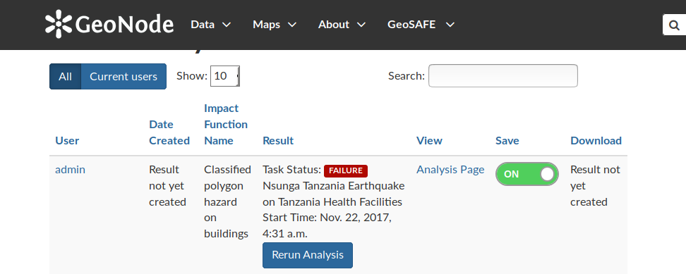
You try
Goal: To learn how to troubleshoot in GeoSAFE
* Log into GeoSAFE
* Navigate to the analysis list on the GeoSAFE menu.
* Navigate to the analysis that has failed to finish running.
* Clicking on Rerun will most likely result in failure.
* Navigate to the create analysis page and select the same hazard/exposure combination for the result that failed above.
* After selecting the Impact Function zoom in on the map area (This changes the analysis extent and a smaller area will run faster and the analysis will generally complete).
* Upload a layer with InaSAFE keywords into GeoNode.
* Navigate to the Create Analysis page in GeoSAFE.
* Search for the layer in the different Layer types.
* If the layer is not visible – Navigate to the homepage and select the layer.
* Click on Edit layer in the layer’s menu.
* Select upload metadata. (Make sure the metadata contains InaSAFE keywords)
* Navigate to analysis page and check if the layer now is visible.

Name | Value
GeoSAFE | http://geonode.kartoza.com/
Layer type | Exposure / Hazard
Check your results
After uploading a layer with InaSAFE keywords the layer should be visible in the create analysis page. After executing an analysis the reports and map should be available to download and the analysis should be listed on the analysis list showing that it sucessfully ran.

More about GeoSAFE
GeoSAFE is an open source project. GeoSAFE consist of GeoNode (Django,PostGIS),QGIS Server and InaSAFE. Most of the components that make up GeoSAFE are constantly being updated to bring in new changes which help optimise the software and make it run efficiently. GeoSAFE always uses the latest stable version of software from the various component parts. GeoSAFE has been tested extensively with sample data which in some cases is not real data and there exist a possibility of other data sets breaking the code and thus rendering some other functions unusable.

The problems users encountered with using GeoSAFE can be categorised as .
- User error. This is the inability of a user to follow the correct procedures from preparing the data to running and analysis.
- Data Issues. This results from data that has different encoding or a user failing to generate metadata properly before uploading it.
- Software problems – This occurs when the software does not do what it is expected to do or produce erroneous results on doing calculations.
A user is encouraged to identify a problem and categorize it. This will ensure that the problem is reported in the right channels or the user corrects himself.


Check your knowledge
- What is the most likely reason an analysis fails?
- Because my internet browser got overloaded with many tabs and crashed.
- The area I intended the analysis to cover was very big and this exited after some time.
- The data got corrupted during running the analysis.
- Which of the following statement is not true?
- The quality of data influence the GeoSAFE results.
- Two or more analysis cannot be run concurrently. It cause GeoSAFE to crash.
- You can change the extent of the analysis when you click the Rerun analysis.
- Metadata without InaSAFE keywords renders the layers inaccessible to GeoSAFE?
- True

- False

Further reading:
http://inasafe.org/
http://docs.inasafe.org/en/training/old-training/intermediate/qgis-inasafe/402-preparing-data-and-keywords-for-inasafe.html

