
Section: Vector Analysis
Module : Topology Maintenance


Vector topology in Context
“Topology expresses the spatial relationships between connecting or adjacent vector features (points, polylines and polygons) in a GIS. Topological or topology-based data are useful for detecting and correcting digitising errors (e.g. two lines in a roads vector layer that do not meet perfectly at an intersection). Topology is necessary for carrying out some types of spatial analysis, such as network analysis.”
In this module we will look at how to inspect a vector dataset to see if it is topologically clean and explore ways in which to clean the dataset so that it conforms to the vector topology model

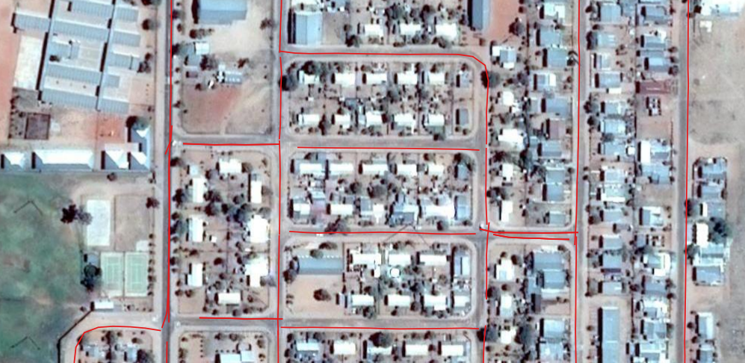
You try:
Goal: To learn how to check vector layer is topologically clean and methods of cleaning vector data
With the road layer given check for any errors.
To do:
* Load the vector layer
* Activate geometry validity plugin
* Use Processing provider / GRASS plugin to clean data
* Ensure the resultant dataset is clean
Name | Value
Validation tools | Topology checker,Geometry validity
Processing | Remove Duplicates
Plugins | Grass plugin
Processing framework | Grass, Saga.  V.clean
QGIS Algorithms | Geometry validation

More about
Vector topology maintenance is useful because it enhances spatial analysis and also allows us to explore geographical relationship between feature example which roads are connected with which and which provinces are adjacent to each other. Vector GIS datasets need to be checked for any errors which include undershoots,slivers,overshoots,duplicates. GRASS GIS is a fully topological GIS package and using the GRASS plugin to check and clean datasets helps in generating clean vector data which can be used in analysis.


Check your knowledge:
- A clean vector dataset is:
- A dataset that has been beautifully symbolized.
- A GIS vector dataset that can be used in spatial analysis without causing problems
- A GIS vector dataset that does not have any spelling mistakes
- Which type of data should be checked for topology errors:
- A satellite image that contains roads
- All layers in QGIS should checked
- A GIS vector dataset where each polygon represents a type of building
- GRASS is a type of a plugin:
- True
- False
Answers: 1b, 2c, 3f


Further reading:
http://docs.qgis.org/2.14/pl/docs/user_manual/plugins/plugins_topology_checker.html
https://docs.qgis.org/2.14/en/docs/gentle_gis_introduction/topology.html

