
Section: Layers
Module : Styles

Managing layer styles in GeoNode
QGIS has nice cartographic symbolisations which allow nice visualisation. Geonode has interchangable backends between Geoserver and QGIS server. Using a QGIS backend allows us to inherit the rich cartographic visualisation that is available in QGIS desktop in Geonode browser.
In this module we will look at how to manage Geonode layer styles for a Geonode using QGIS backend.
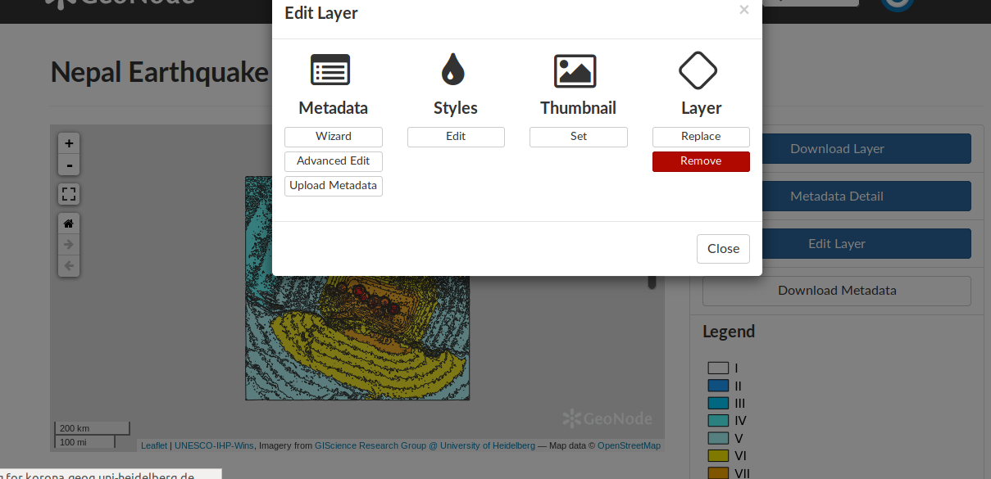
You try
Goal: To learn how to manage layer styles in Geonode

* Open QGIS and load the specified layer.
* Symbolize the layer. Use the style tab in the layer properties.
* Export the style from QGIS and save it on disk. Choose the option save as QGIS layer style.
* Navigate to Geonode instance and log in.
* Upload layer and browse to select the layer from disk. Also select the Style file
* Visualise the layer and the legend which is based on the Style file.
* In QGIS create another style that represents another theme you are interested in showing.
* Save the style file and give it another name.
* In Geonode select the layer you need to apply the symbology to.
* Choose edit layer and styles.
* Add a new name for the style and select the second style file you created.
* Upload the layer.
* You should be able to toggle between two styles for one layer.

Name | Value
Layer | Tandale.tif
Style file | .qml
Geonode | http://geonode.kartoza.com/
Check your results
Once you have finished you should be able to see two styles for the same layer. Toggling between the two styles will enable a user to visualise different themes for the same layer.

More about GeoNode
If a layer is uploaded without a style file (.qml) QGIS server assigns random colours and that symbology becomes the default style. When a user uploads a layer with a style file (.qml) the style becomes the default and a user can upload a new style file which will become an alternate style. When a layer has two or more styles the default style can easily be changed.

Symbols allow you to illustrate a unique difference between features, some difference in magnitude between features, or another characteristic. Symbolization can take on a range of functions on a map but should be clear, concise, and easily understood by the user.

Check your knowledge
- Why is it useful to upload two or more styles for one single layer?
- To showcase a user’s artistic skills.
- To potray different messages to the user using one single layer.
- So that if one style fails to draw the other one will be used as a backup.
- Map layer look better in QGIS than Geonode?
- Absolutely.
- No they look alike
- I am not sure
- Which of the following statement is true?
- The legend in Geonode is identical to the legend of the layer in QGIS.
- In order to update the units of the legend for a layer I update the metadata for the layer.
- An alternate style does not produce a legend. The legend is fixed with the default style.
- You can also upload style file that has an extension (.sld) when using QGIS backend.

Further reading:

http://docs.qgis.org/2.18/tr/docs/training_manual/basic_map/symbology.html

