
Section: InaSAFE
Module : Home assignment 2


InaSAFE Customised Report
“In this assignment you will integrate the various skills we have learned thus far to develop a custom flood report”

InaSAFE supports the creation and use of customised reports. This will let you decide exactly how the contents of your report appear. For this assignment we will give you a specification of a new report to create and list the elements that need to appear in the report. We will use flood on buildings as the example for this assignment. This is what the default report provided by InaSAFE looks like:
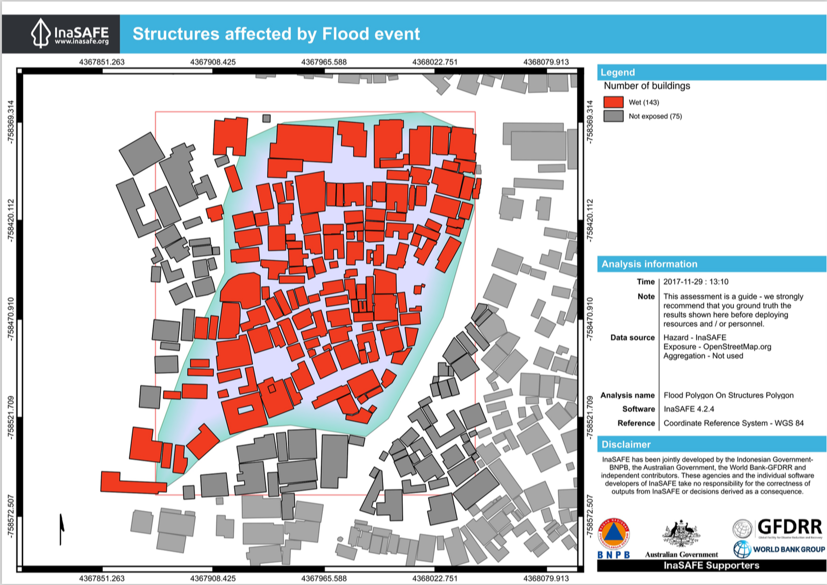
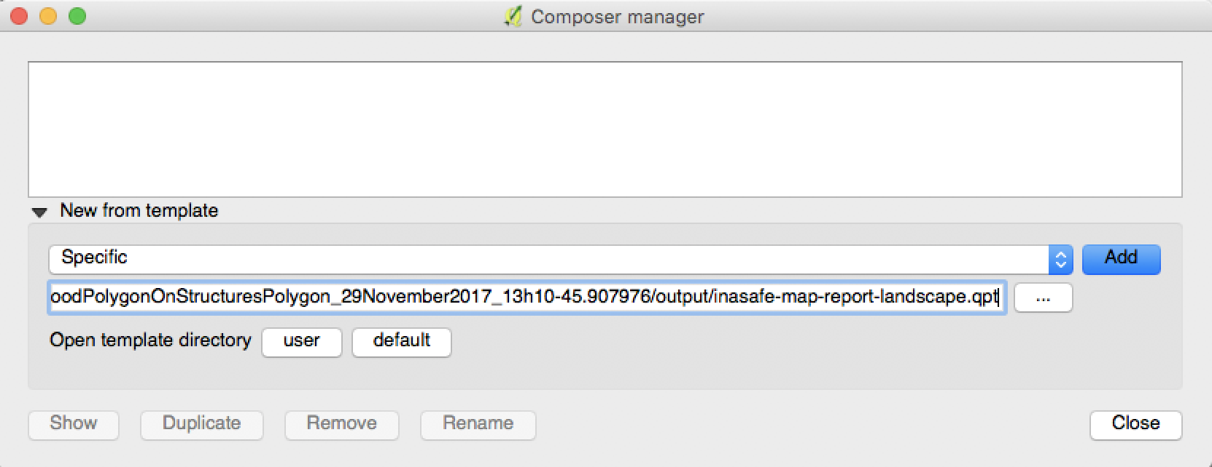
You try:
Goal: To make a custom report for flood on buildings.
* Run the tandale flood on OSM buildings analysis.
* Print the reports.
* Make a note of place where templates were saved as listed in the dock under ‘The generated qpts were saved as:’
* Open the landscape template as per the screenshot above.* Modify the template, adding elements, changing colours etc. to create something more in line with what your organisation would like to use.* Save the landscape template to your inasafe directory as indicated right.
* Name the template using the expected naming convention as indicated right.
* Run a new flood analysis and print the results.
Check your results:

* Verify that the outputs now include your custom template.

Name | Expectation
Place to save templates: | <your home directory>/.qgis2/inasafe/
Naming convention for templates: | <hazard>-<exposure>.qpt e.g. flood-structure.qpt

Things to try
Here are some ideas that you could incorporate into your layout:
- Add multiple pages – try adding more pages with extra content like explanatory text or a detailed legend.
- Try experimenting with different page sizes
- Add graphics and other elements that will support the reporting
- Try different colour schemes and other changes to make the report more consistent with those produced by your organisation.

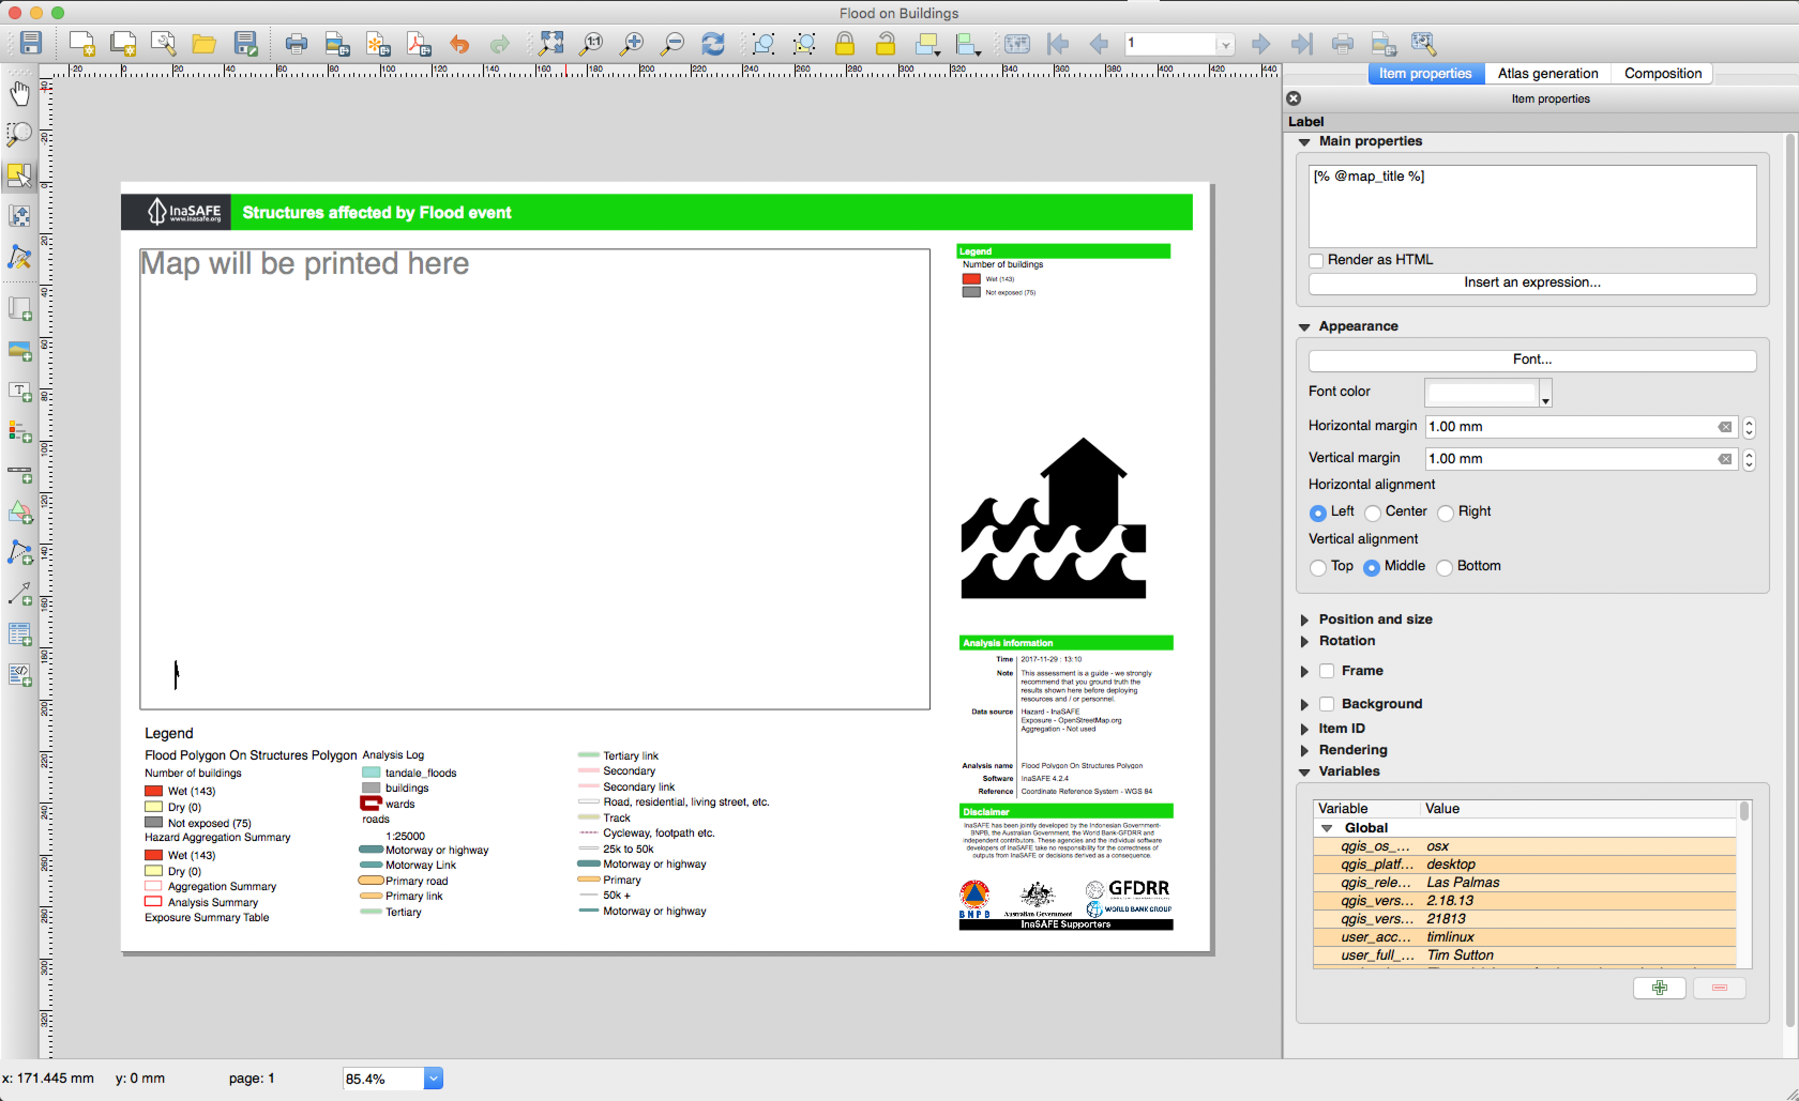

By the way, we will really appreciate it if you can keep the InaSAFE logo and url on your report so that the InaSAFE project can be supported.

Getting help

Please use the gitter.im chat room to ask for help. You can speak in your own language there if needed and we will translate.


Further reading:
http://docs.qgis.org/2.0/da/docs/training_manual/map_composer/map_composer.html

