
Section: Analysis
Module : Vector Digitising


Digitising in Context
“Digitising is a process of converting geographic data from a hard copy and scanned maps into vector data by tracing the features.”
In this module we will learn on how to create new datasets and how to populate the attribute tables. We will also look at how two or more features for line geometry can adhere to topology rules. We will look at how topology rules affect the digitising process for lines and polygon features. We will explain the concepts of topology rules that affect digitising.

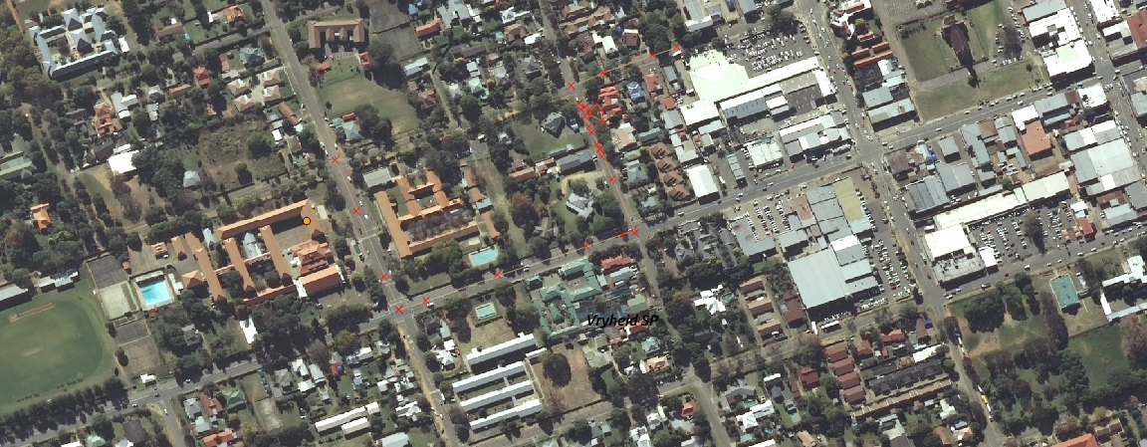
You try:
Problem:
You are a city official and need to undertake a study to find new roads,park and traffic lights in your town. Create a roads,traffic lights and parks asset register. Ensure that all digitised object adhere to topology rules.
Goal: To learn the basis of digitisation for point, lines and polygons. To understand the implications of snapping and topology rules.

* Load a raster layer covering your AOI
* Create new shapefiles for Line and Polygon features.
* Digitise two or more roads that cross an intersection into the Line layer.
* Activate snapping where lines cross each other.
* Digitise two or more adjacent polygons with and without snapping activated.
* Edit the line/polygon using the tools visible in the Digitising toolbox

Name | Value
Vector Layer | Multi line, Multi Polygon
Digitising | Advanced digitising toolbar
Topology | Snapping Options, Trace
AOI | Area of Interest

More about digitising
Digitising a point feature is creating a point representing an x, y coordinate. Digitising lines involves creating a line feature that consists of a node (start and end) and a series of vertices which indicate a change of direction along that line. Straight features require fewer vertices, curved/complex features require more vertices. Digitising a polygon involves creating three or more line segments that are joined. The start node of the line is also the end node of the line.

When digitising a layer snapping should be activated so that the new features created adhere to the topology rules. There are a variety of tools that can be activated to leverage digitising functionality and these tools’ usage varies based on the type of feature being created. Functionality can also differ based on the type of geometry a feature has etc. Multi-polygon, Multi-line string and Multi-point


Check your knowledge:
- What is the main use of snapping when digitising:
- To make roads layer look nice
- To ensure spatial relationship between datasets is maintained properly
- It is not necessary
- Which of the following can be a problem in manual digitising :
- Hand eye coordination
- Availability of suitable hardware and software
- Boredom
- Can digitising be used to create data from historical maps:
- True
- False
Answers: 1b, 2a, 3t


Further reading:
https://docs.qgis.org/2.14/en/docs/gentle_gis_introduction/topology.html
http://wiki.openstreetmap.org/wiki/Relation:multipolygon
http://wiki.openstreetmap.org/wiki/Relation:multilinestring

