
Section: Symbology
Module : Styling basics


Styling in Context
“If you think of GIS as having two major aspects, data and visualisation, then the visualisation is all about styling or symbology. Data does not look ‘pretty’ without a style. Geometry data has to be styled to be visualised.”
In this module we will find some entry points to styling spatial data in QGIS. Styling is a very broad and deep field, part art, part science. So most of this module is about exploring styles, freestyle.

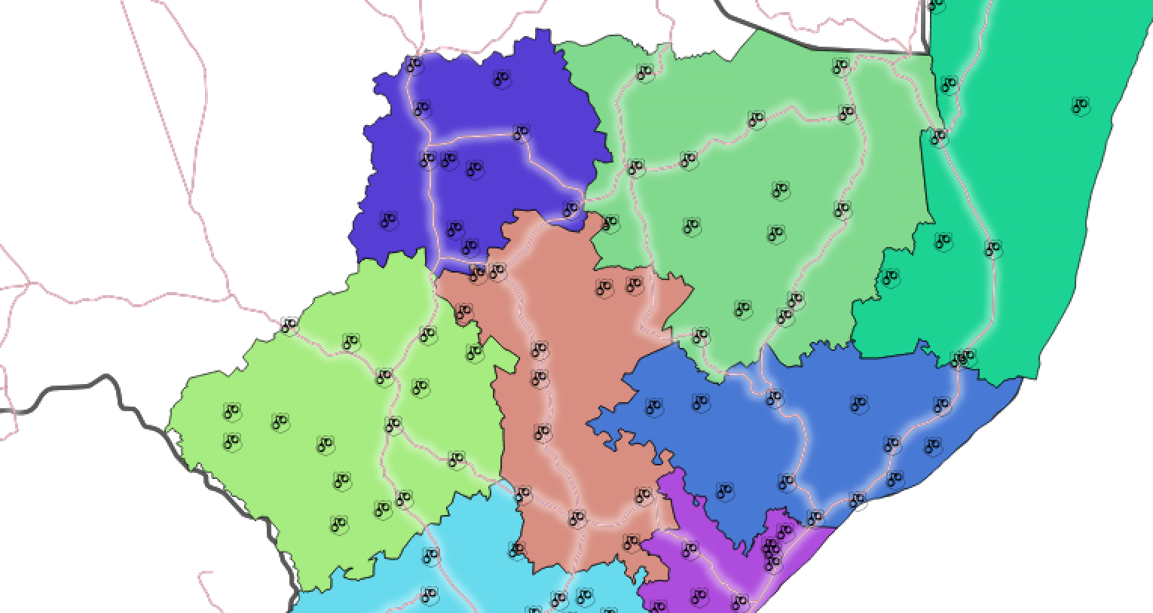
You try
Goal: Explore vector layer styles and make a pretty map.

* Load the Countries and Roads layers from Natural Earth
* Load the District and Police station shapefiles and zoom to the District layer.
* Open Countries’ Layer Properties and go to the Style tab. Choose options as per the table to the right.
* Look at Districts’ attributes and style it in a way you think is meaningful. Note the styling options available for polygons.
* Style Roads. Note the differences in Line styles.
* Style Police stations. Note the differences in Point styles.
* Compare your map with your neighbour’s

Name | Value
Countries layer | ne_10m_admin_0_countries in the ne.sqlite database in appendix1-naturalearth-data
Roads layer | ne_10m_roads
Districts and police stations | In appendix3-local-data
Country styles
Layer type | Simple fill
Fill style | No brush
Border colour | black

Check your results

Can you clearly see all four layers in your map?

Why is there a gap between the district and country boundaries? What could you do about it?
What message were you trying to convey with your map? Did your neighbour get the message?

Do your neighbour like your colour scheme as much as you did?

More about styles
When you open a layer in QGIS it will choose a fairly random default style so at least you can see the data. Usually that default style is no good for your final map so you will have to spend some time styling it to meet your objectives. Perhaps you or someone else already prepared a style and saved it as a default; in that case you are lucky and it will look good immediately.

Styles are all about communication. Very often that communication is scientific or statistical and therefore must represent the facts in an unbiased way. Or it could be topographical or navigational in which it should be clear and easy to understand. Or perhaps it purely artistic and just needs to look beautiful. The best maps combine all of these: accuracy, clarity and aesthetics. Effective styling applies the elements of good design.

Static maps are styled to look good at a specific scale. This can take a lot of work to achieve. Dynamic maps, such as interactive online maps (like OSM or Google), are styled to work at any scale. This is even harder to achieve since you need to style for multiple scales and also alter the data available for styling at each scale by filtering or generalising.

In a GIS a map is made up of several layers. It is quite an achievement to style and label one layer effectively and it can take a lot of time. To style and label many layers so that together they make a beautiful map is a real craft.


Check your knowledge
- What does layer blending do?
  - Stirs up the colours in your layer

  - Combines the layer’s colours with those in the layer below
  - Animates the features in your layer
- Can you use a gradient fill on a point layer? (Yes or no)
- Which is the best way to get complex styles (like a black road with a white border and a middle centre line)?
  - In the style library
  - By constructing them, by stacking styles on top of each other.
  - By uploading an image of the style you want

Further reading:
http://docs.qgis.org/2.14/en/docs/training_manual/basic_map/symbology.html

