
Section: InaSAFE
Module : User map

Add yourself to the user map!
“Adding yourself to the user map will help us understand where and who our users are.”
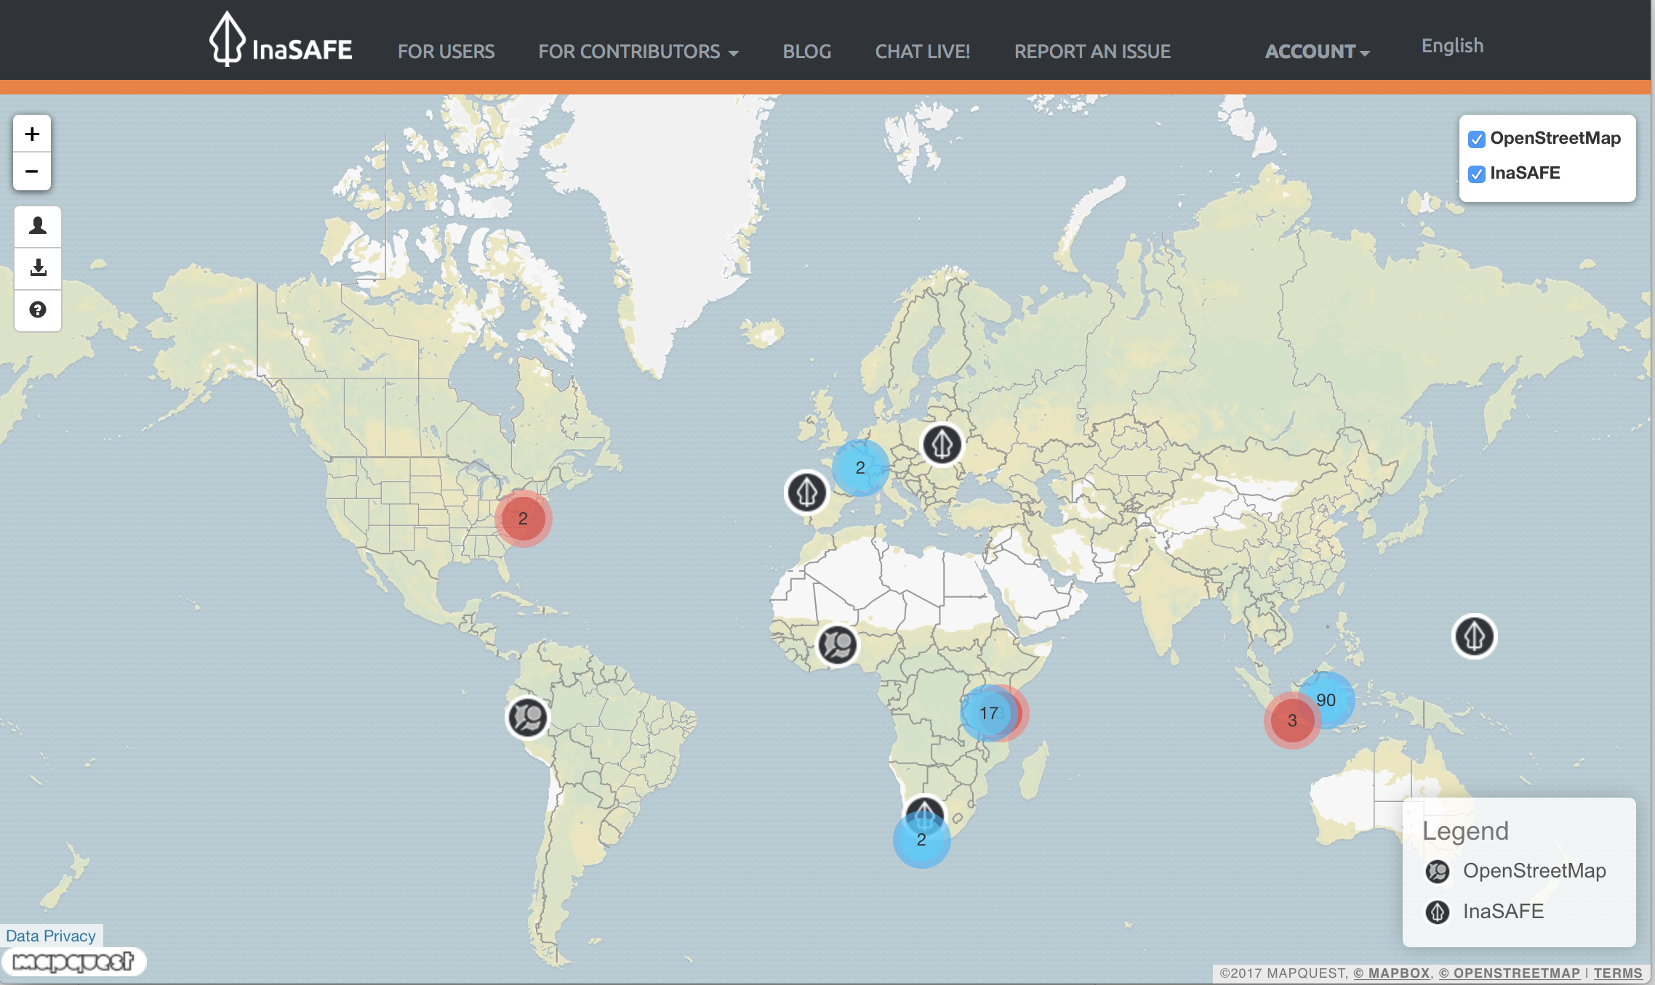

The InaSAFE user map (http://users.inasafe.org) is a community map that we are using to visualise and share where our users are. We would be very appreciative if you could add yourself to the map. To add yourself, simply navigate to the user map page and then use the add yourself icon:

Then fill out the form provided.

