
Section: Raster Analysis
Module : Symbology


Raster symbology in Context
“Raster symbology involves assigning colours to pixel values of an image so that they appear visible and you can easily differentiate between the pixel thus making it easy to interpret the meaning of each pixel.”
In this module we look at the various ways in which pixel values can be assigned colours . We will also look at other factors that affect raster and how we can blend rasters with different colours so that we highlight particular features.

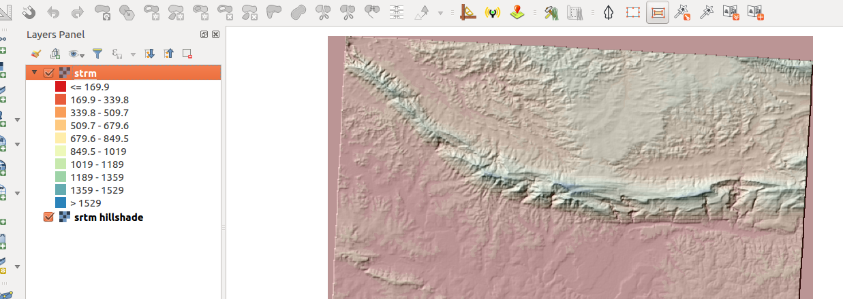
You try:
Goal: To learn to symbolise raster layers and derive by-products from DEMs. Learn how to overlay two or more rasters
* Load the layer twice into QGIS and rename them as srtm and srtm_hillshade
* Style srtm using pseudo-colour render
* Choose appropriate colour ramp
* Observe the results and change the render type back to single band. Observe what happens.
* Investigate why the colour does not revert
* Symbolise the srtm to a coloured raster
* Symbolise srtm_hillshade using Hillshade render
* Change the rendering order of the rasters. Put strm on top of srtm_hillshade.
* Change the transparency of srtm layer and observe features visible in the second raster

Name | Value
Render Type | Pseudo-colour
Colour | Colour ramps
Terrain analysis | Hillshade render
Layer | srtm_41_19

More about
When styling raster layers it is important to look at the range for the pixel values. Raster layers can be distinguished by the different number of bands and type of data being represented. RGB raster can not be symbolised as they consist of the bands red, green and blue which have been fused together. Single band images and two band images can be symbolised. It is also important to understand what kind of data is being represented by the raster so that you can allocate the correct colour ramp and choose the correct interpolation method and mode.


Check your knowledge:
- A Raster is:
- A type of musician that sings reggae.
- A type of GIS data where a pixel is used to represent a phenomenon on the earth surface
- A GIS data set that consists only of satellite images
- Styling a raster entails:
- Converting each individual pixel or group of pixels into a colour model
- Making the raster pretty
- Converting the pixel values into different categories
- Raster pixels range from 1 – 255 only:
- True
- False
Answers: 1b, 2a, 3f


Further reading:
https://docs.qgis.org/2.14/en/docs/training_manual/rasters/changing_symbology.html

