
Section:Analysis
Module : Vector Analysis


Vector Analysis in Context
“Vector analysis is defined as the heart of GIS. In analysis data we derive new datasets and useful information which can be used to answer questions. Vector analysis can be broadly grouped into two types attribute and spatial analysis.”
In this module we will look at joins , manipulation of the attribute table, creating charts, vector symbology and map generation.

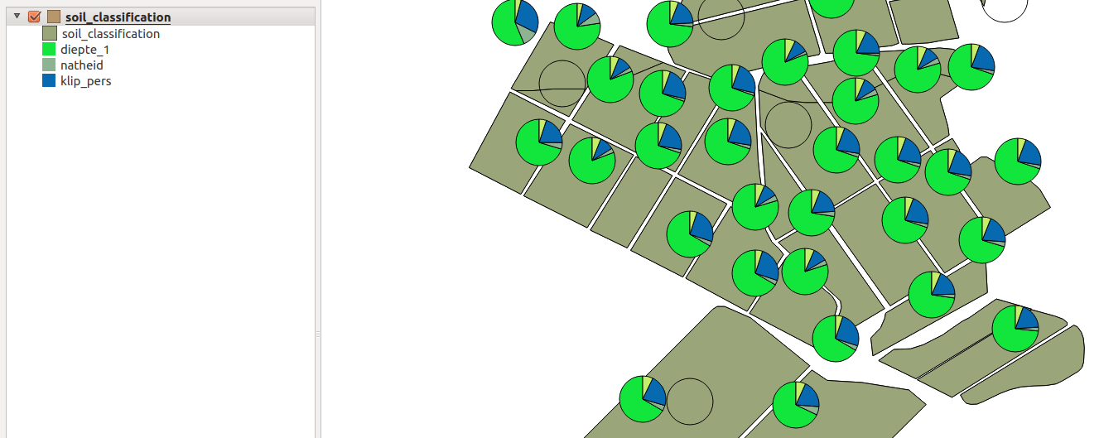
You try:
Problem: You are required to monitor the three main agricultural products produced in your country. Produce a map showing the distribution of the major three agricultural produce in your country.
Produce a second map showing the main agricultural produce per tonnes with proportional cirlces for each administrative regions.

Goal:
To learn the basis of map creation and generating charts.

Data: Load the administrative boundary for your country.
* Link the administrative boundary to the yield spreadsheet
* Create maps.

Name | Value
Vector Layer | Spreadsheet,Polygon
Attribute Analysis | Table joins
Symbology | Vector layers
Diagrams | Proportional circles

More about vector analysis
Vector analysis should always give us a better interpretation of our raw data. There are various forms of vector data that can be utilized within a GIS environment. Datasets can be non spatial and spatial. Spatial data is data that can be connected to a place on the earth surface. Example of datasets include excel,open office spreadsheets and csv files that can be combined with existing datasets to infer useful information. Vector analysis incoperates combining these two forms of data.


Check your knowledge:
- What is an attribute join:
- When two vector layers share a common value that can be used to link them
- A csv file that has longitude and latitude and has been imported into QGIS
- Two datasets that are from the same geographical area
- What is the use of proportional cirlces:
- For cartographic visualisation.
- To show the relationship between products/columns in a dataset.
- To depict that datasets have no relationship
- Can QGIS open an speadsheet from execel,open office:
- True
- False
Answers: 1a, 2b, 3t


Further reading:
https://docs.qgis.org/2.14/en/docs/user_manual/working_with_vector/vector_properties.html#joins-menu
https://docs.qgis.org/2.14/en/docs/user_manual/working_with_vector/vector_properties.html#diagrams-menu
http://darrencope.com/2011/11/01/qgis-diagrams-pie-charts-for-symbols/

