
Section: Analysis
Module : Vector Analysis


Spatial analysis in Context
“Spatial analysis is the process of analysis the relationship between locations,attributes,
and the relationship of features through analytical techniques. Spatial analysis defines the relationship between features based on the topology,geometric and geographic properties of the features.”
In this module looks at a variety of spatial analysis techniques that can be used to answer geographic questions.

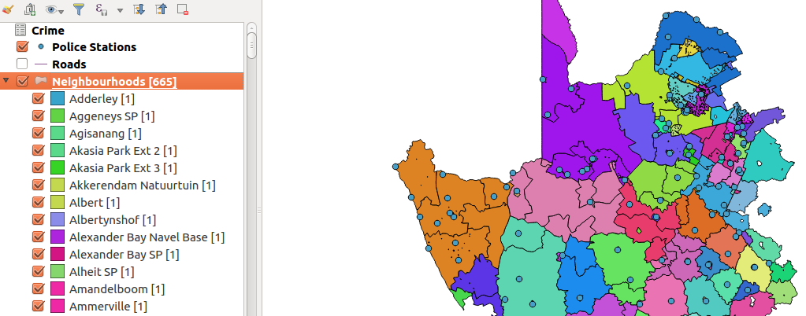
You try:
Problem: You are a resident of a neighbourhood and have been provided with crime data and police stations data. Use the datasets to answer interesting questions about your area.
Data: crime statistics,police stations,roads,neighbourhoods
Questions:
* How many police stations occur within the each neighbourhood.
* What is the length of each road segment that occur in the neighbourhood
* what is the total length of all roads in each neighbourhood
* Rank the police stations based on proximity to a road in each administrative region
* Using the crime statistics show how each crime category has varied of over the years.
* Determine the safest neighbourhood based on crimes recorded at each station

Name | Value
Spatial Operation | Points In polygon,  Sum line
Processing | Grass,Modeller
Data provider | Virtual Layer,Database
Attribute Table | Diagrams

More about
In spatial analysis all layers have to be projected to the same CRS. Spatial analysis is the heart of GIS and it allows creating new derived data that can answer geographic questions. A lot of geometric processes can be done in QGIS and also spatial databases help in solving other problems better. Determining which tool to use to answer a particular question if fundamental


Check your knowledge:
- What is the use of spatial analysis:
- To create new data
- To interpret problems and provide useful information
- Viewing raster data and symbolize it
- Which of these is an example of spatial operation:
- Assigning colour symbols to a vector layer
- Assigning colour symbols to a raster layer
- An administrative polygon that has been clipped to show a subset of the data
- Is a csv a type raster data:
- True
- False
Answers: 1c, 2c, 3f


Further reading:
https://grass.osgeo.org/grass70/manuals/v.distance.html
https://docs.qgis.org/2.14/en/docs/user_manual/processing_algs/qgis/vector_analysis_tools.html#sum-line-lengths
https://docs.qgis.org/2.14/en/docs/user_manual/working_with_vector/virtual_layers.html

