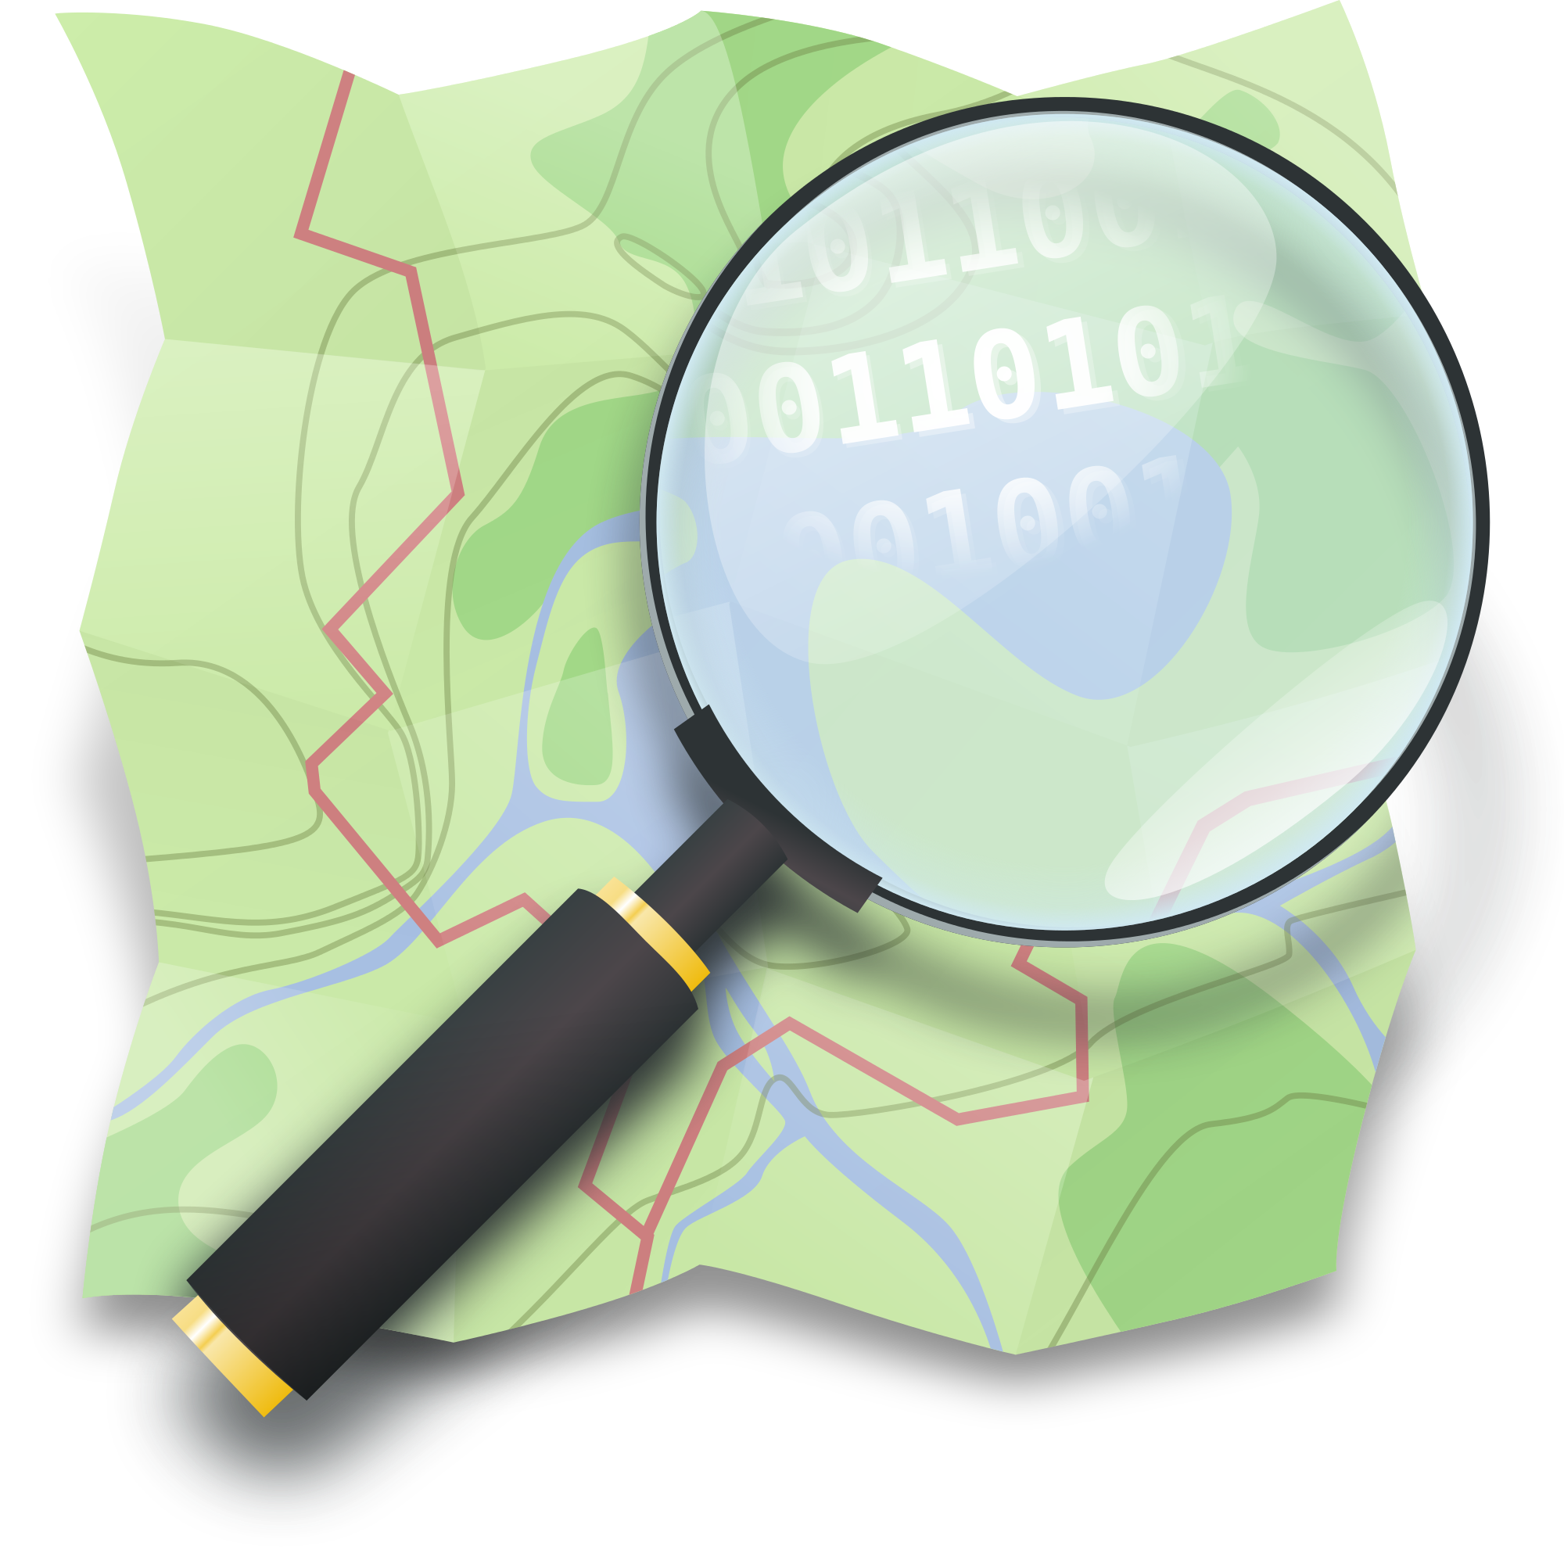
Section: OpenStreetMap
Module :Quality Assurance


Quality Assurance in Context
Contributing to OpenStreetMap is an important thing, but using OpenStreetMap data is another entire subject. As there is no reviewer in OSM, how can you be sure about the quality of the data that you would like to use? Some tools exist to do some Quality Assurance of OSM data.
In this module we will look at some QA tools that will improve the OSM database quality.

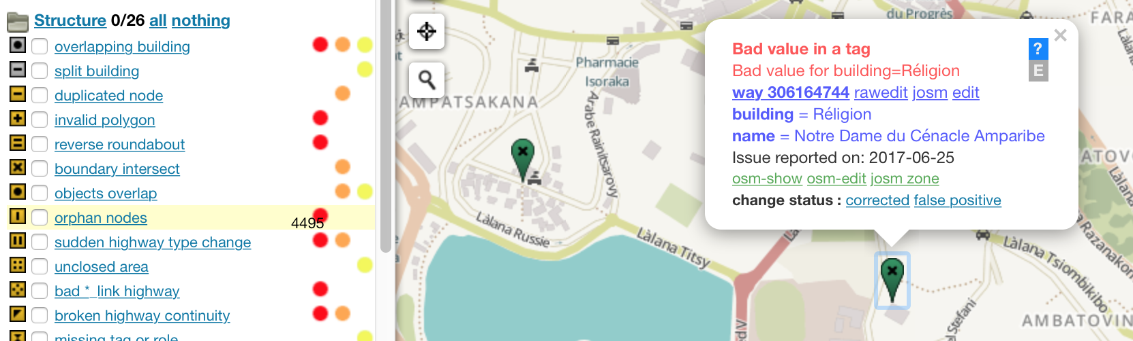
You try:
Goal: Notice some problems with OSM data and try to fix them.
Problem: Before using OSM data in your project or for an InaSAFE analysis, you need to check that data are correctly formatted.
Data: raw_osm_buildings in Kampala

* Load the data into QGIS
* With Processing, check all unique values in the attribute table for the “building” column.
* Check what we can improve in these results.
* Use the website Osmose to check OSM data in your area.
* Get familiar with the Osmose user interface
* Fix some easy mistakes in the “Structure” section.
* Check your own issues by filtering by username.
* Check all the issues in your country listed in the table by using the “statistics” page.
Name | Value
QGIS Algorithm | Unique values
Field | building
Website | http://osmose.openstreetmap.fr

More about
There are numerous QA Tools for OSM. Some are online such as Osmose, KeepRight and OSM Inspector. Some are integrated into JOSM, like the Validator. They all have their pros and cons, try them out and choose the one you like. Online applications amongst these download OSM data and execute a bunch of queries to detect potential errors on a regular basis. Then the tool displays these errors on a map to warn users. Some errors might be false positives -- you can flag them to hide them from the user interface. Don’t forget to flag “Fixed” to avoid duplicate efforts between users. There many kinds of potential errors; they can be either in the geometry or in the attribute table. For instance, some tools will detect invalid tags or will detect ways that are a dead-end and one-way at the same time.
In your OSM community, try to make a challenge every month by choosing one specific kind of mistake and try to fix them as much as possible and enjoy the graph associated with your error to notice the progress!


Check your knowledge:
- A Quality Assurance tool is:
- Used for exporting OSM data to a GIS format.
- Used to help users fix problems in OSM.
- A program that fixes OSM errors automatically.

- When do you need to use a Quality Assurance tool:
- When you have contributed to OSM to check potential mistakes you could have made.
- When you are using OSM data for an analysis.
- When you have some spare time on OSM and you don’t know what to do.

- Quality Assurance tools are always right:
- True
- False



Further reading:
http://wiki.openstreetmap.org/wiki/Quality_assurance
http://osmose.openstreetmap.fr/
http://tools.geofabrik.de/osmi/
https://www.keepright.at

