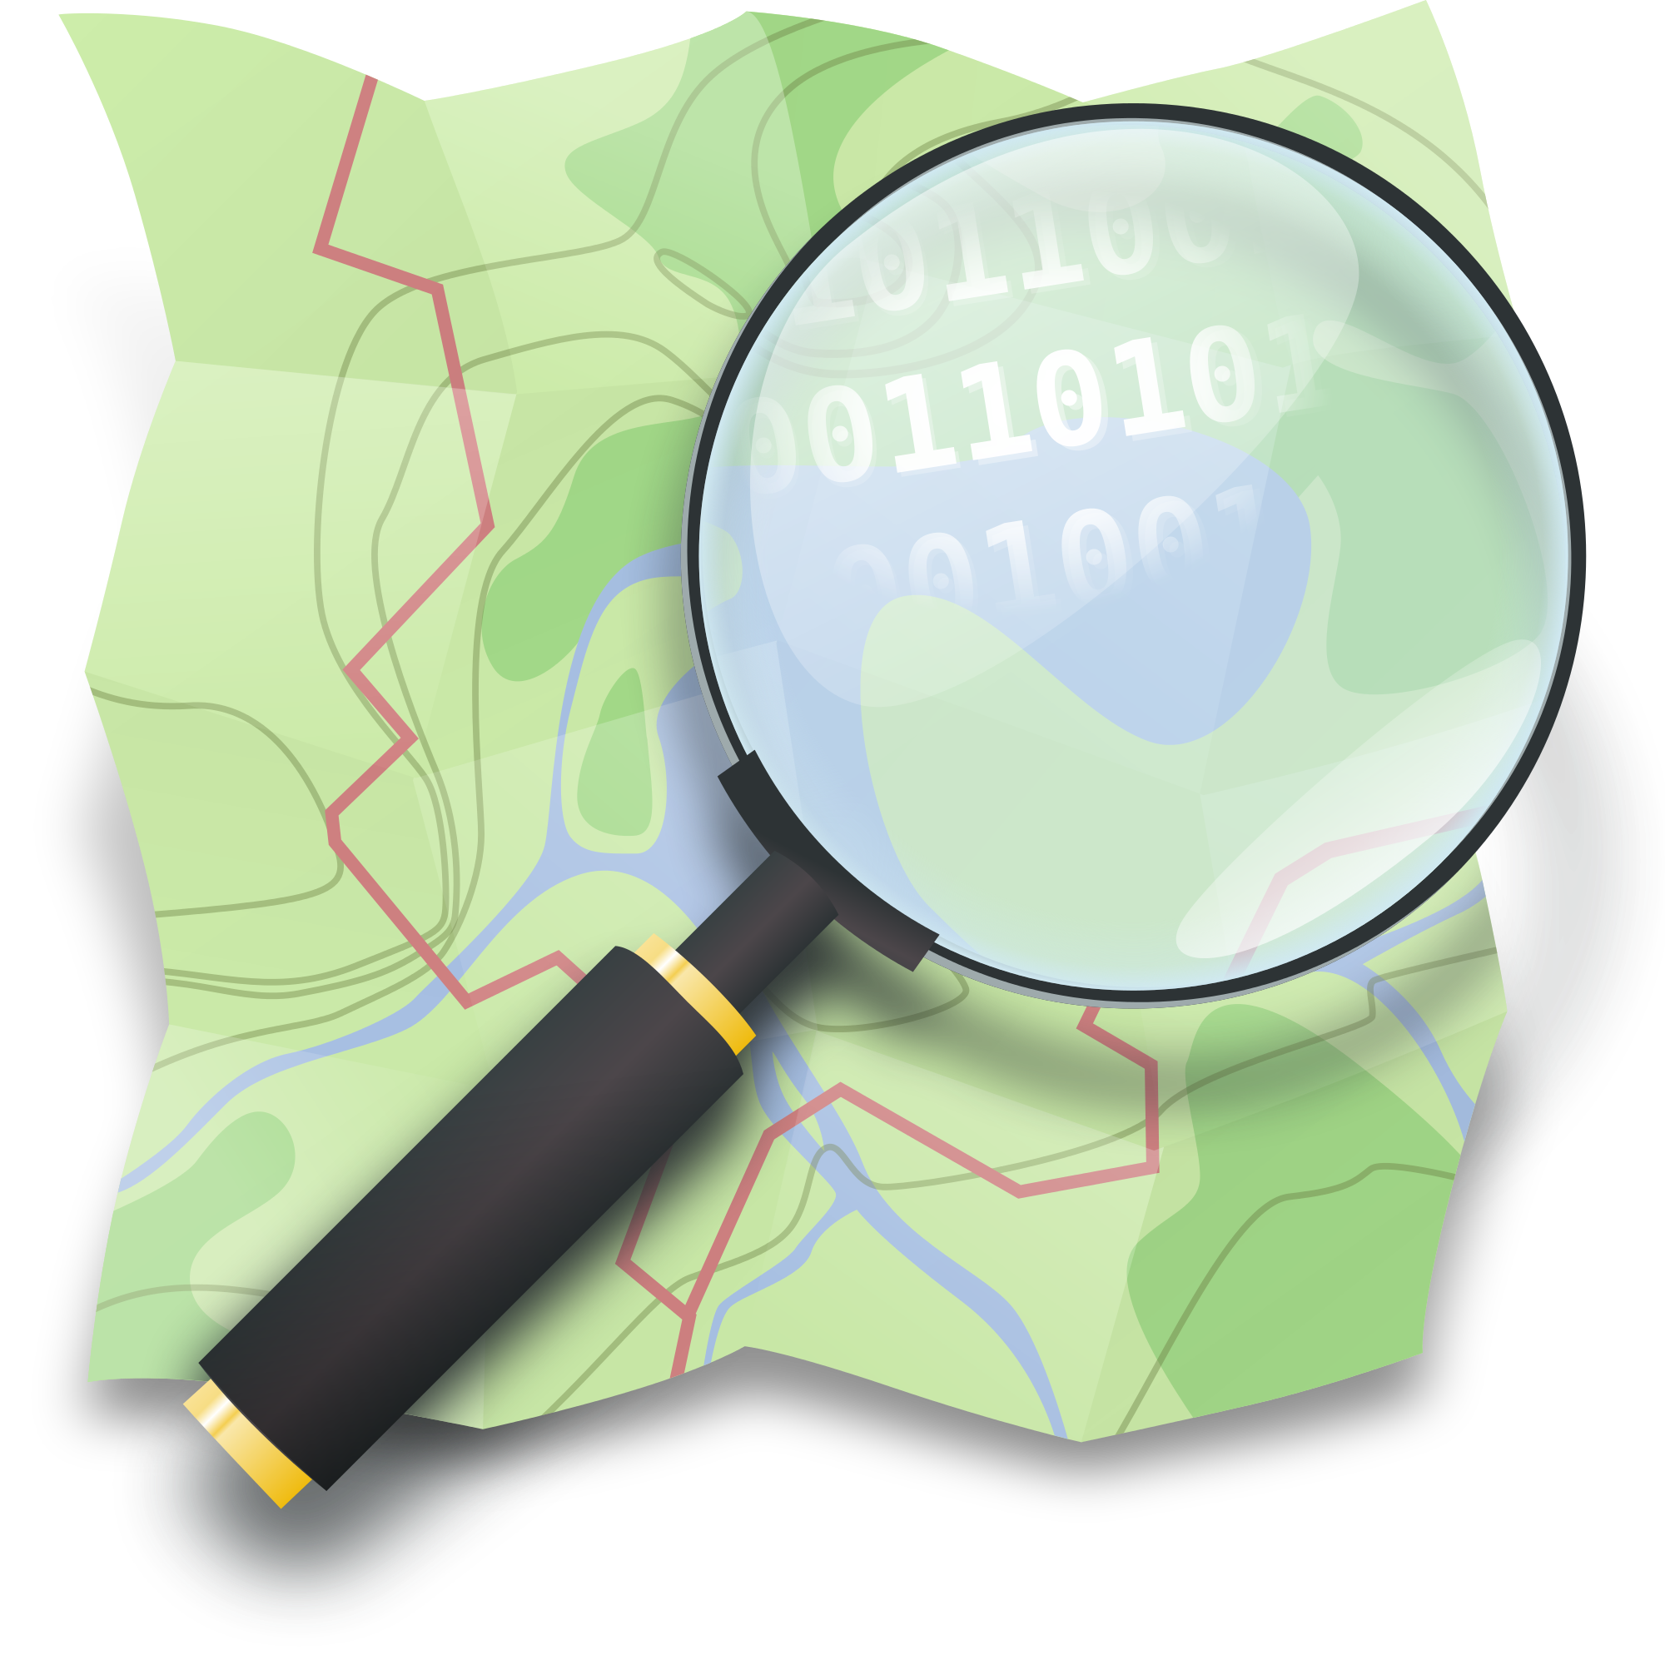
Section: OpenStreetMap
Module : Editing with the JOSM editor


Contributing to OpenStreetMap with JOSM
iD is a very nice first editor to use to contribute to OSM. But you might need a more powerful editor. In this module we show you how to create and edit OSM data with the JSOM Editor.
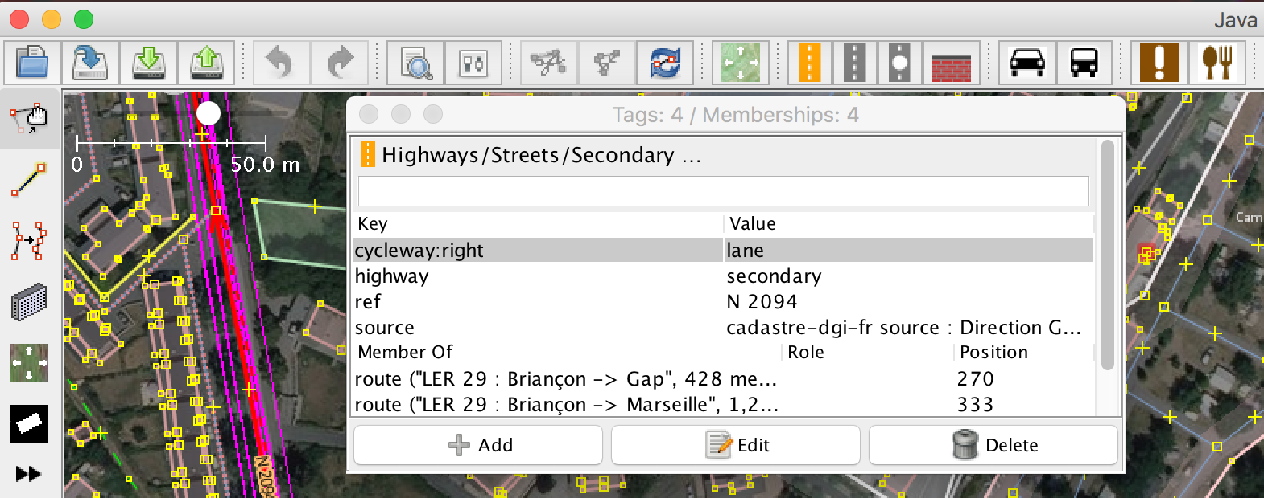
JOSM is a powerful OSM editor software. But it’s also a more complex tool to use. You need to install Java and then the software itself. JOSM is an offline editor, it means you need to download locally an OSM dataset, edit it and then upload it again to OSM. One advice, don’t wait too long (one day) to push your updates, or you might have some conflicts with some others contributors. JOSM is very complex editor, but when you know how to use it, it’s really worth it !

You try:
Goal: Use the JOSM editor.

* Install Java and JOSM on your machine.
* Download a dataset and look for tags when you have selected an area.
* By switching to “draw” mode, add a missing road and press F3 and look for residential for instance.
* Don’t forget the topology when you add roads.
* Use the special tool “building” to add new buildings. What do you notice?
* They are some shortcuts to create some predefined shapes. Look in the “Tools” and try to create a perfect circle. Hint, you need to draw the diameter first.

Check your results:
After uploading, refresh the main map on osm.org, can you see your new buildings and roads?

Name | Value
Software | Java, JOSM
Download OSM data | 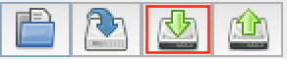
Add Bing Imagery | Imagery -> Bing Aerial Imagery
Switch between modes | 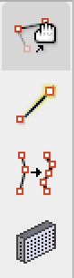
Look for tags | F3 when you have a selected feature.
Push your updates | 