
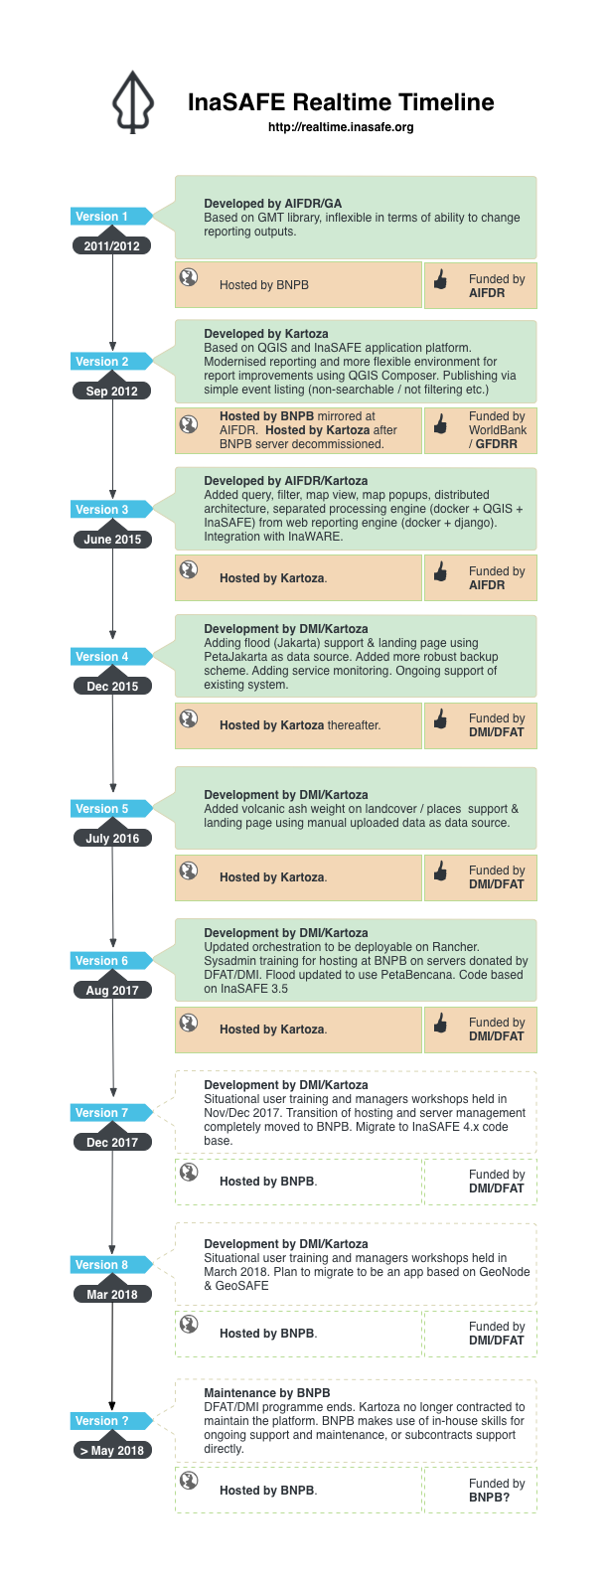
Section: InaSAFE
Module : Introducing InaSAFE Realtime

The InaSAFE Realtime project
“Before we start training you to use InaSAFE Realtime, let’s make sure you understand the purpose of the software!”
The InaSAFE project (http://inasafe.org) was started to provide a tool for disaster managers who want to understand what the potential impacts of a disaster will be. InaSAFE Realtime is software that is based on the same code base as InaSAFE Desktop for the analysis part, and a custom codebase that provides a web application. The purpose of the web application is to wait for events (Earthquake, Flood, Volcanic Ash) and then automatically process the hazard data from that event and produce a report using InaSAFE.

InaSAFE is supported by the Government of Australia, the World Bank / GFDRR and BNPB, the National Disaster Management Agency in Indonesia.
History
The InaSAFE Realtime project was started in 2011 and implemented as a simple proof of concept to show that we could produce near realtime reports on the estimated impact on population following an earthquake in the Indonesian territorial region.

Successive versions of InaSAFE Realtime have added support for additional hazard (flood in Jakarta, ash fall), and moved from a simple script that produces static files to a web application that stores a searchable database of previous events and publishes reports to InaWARE.

The approach taken by InaSAFE Realtime
Near realtime: Despite the name ‘realtime’ it would be more accurate to describe the system as ‘near realtime’. Our goal is to produce reports in a timely manner after or during an event but this relies on data availability and other factors that make it impossible to produce the report at the exact moment the event occurs.

Open Source: The software behind InaSAFE is Open Source, and can be freely viewed, downloaded, modified and adapted to your specific needs.

Funding and Partners: InaSAFE Realtime has been funded by the Australian Government, World Bank/GFDRR; and has been developed in collaboration with partner agencies from the government of Indonesia: BNPB, BPBD DKI Jakarta, BMKG, BIG, PVMBG; and with non governmental support from the Humanitarian OpenStreetMap Team (HOT), PetaBencana, the Pacific Disaster Centre and Kartoza.

Usage context: InaSAFE Realtime is intended to be used in the response and recovery phases of a disaster to increase situational awareness.
Key Features:
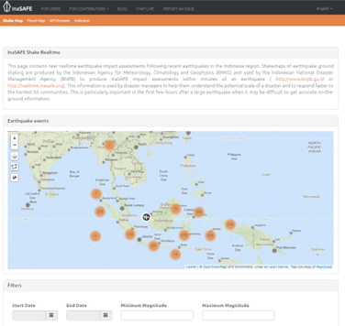
- Support for earthquake, flood (in Jakarta) and Ash fall (not live)
- Map and list of events
- Filter and zoom tools
- Open reports in PDF format
- Download reports and data
- Publish reports to InaWARE (EQ only)
- Automated processing chains

Links:

http://realtime.inasafe.org
http://inasafe.org
http://inasafe.bnpb.go.id (not online yet at time of writing – will be BNPB hosted version of the web site)

