
Section:Vector Analysis
Module : Network Analysis

Network Analysis in Context
“ A network is a set of connected lines. The networks are usually used to delineate rivers, road network. Network analysis studies the relationship between connected lines in terms of distance and time. ”
In this module we look at how we can use QGIS to plan a route based on the shortest distance or the shortest time it takes to travel between two connected lines
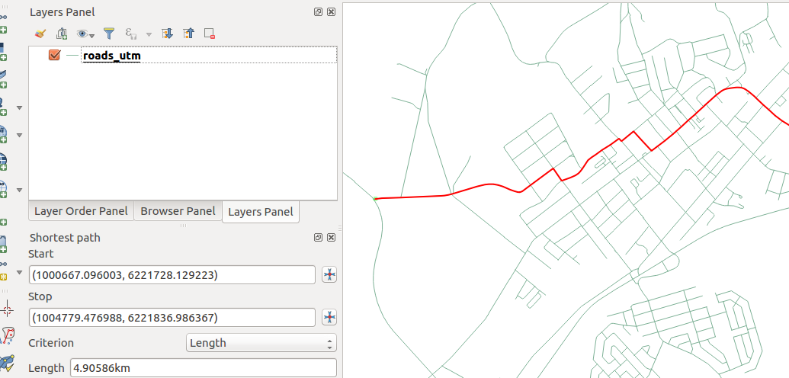
You try:
Goal: To learn how to use the road graph plugin to calculate routes between two places.
Data: appendix3-local-data
* Open a new project and load the network layer.
* Activate the Road Graph Plugin.
* Project the network layer to the specified CRS (name the resultant layer roads_utm_33s)
* Navigate to the vector menu and choose Road graph settings
* Click on the default tab and choose the speed
* Click on a start in the Road graph panel and choose a starting point on the network (Use the projected layer)
* Choose stop and activate it on the network
* Choose the either of the criterion.
* Repeat the procedure using a different criteria.
NB: Explain your results in terms of distance and time

Name | Value
Speed | 60 km/hr
network layer | roads_osm.shp
CRS | UTM 33S WGS 84
Criterion | Length/time

More about
Network analysis aims to establish if you can move from A to B and from B to C and is it possible to move from A to C. Network analysis is a type of connectivity analysis. Network analysis varies from simple analysis to complex analysis. Complexity is achieved by analysis the network and checking for features which gives resistance to a route. Example of features that bring resistance are number of traffic lights,terrain and this affects determining the shortest path between two points in a network. Travelling cost also vary because of these factors.

Check your knowledge:
- Which of the following statements is true:
- A network should be uni directional. All roads should be travelling in the same direction
- A road network can be bidirectional. A road that goes in both direction
- A vector layer that has units as decimal degrees can be used when estimating distances.
- Can a river be described as a network in the same way a road is:
- No we cannot determine the shortest path between two points because people do not travel in a river.
- Yes, a river is a network and all operations done on roads can be done here.
- A river is a GIS data depicting natural phenomenon so it cannot be used.
- Plugins are only installed when online:
- True
- False
Answers: 1c, 2b, 3f

Further reading:
https://docs.qgis.org/2.14/en/docs/training_manual/vector_analysis/network_analysis.html
https://grasswiki.osgeo.org/wiki/Vector_network_analysis
https://grass.osgeo.org/grass73/manuals/wxGUI.vnet.html

