
Section: InaSAFE
Module : Contingency Plans


Contingency Plans

“We introduce the idea of a contingency plan and why it is useful.”
In the context of disaster management, the expected ‘normal’ situation is that there is no disaster in progress and people are going about their normal daily lives. Disaster managers need to plan for the occasions when the ‘normal’ situation has been changed by a disaster and people can no longer go about their normal daily lives. This is called contingency planning. In order to prepare for such situations, disaster managers need to have a basic understanding of questions like:

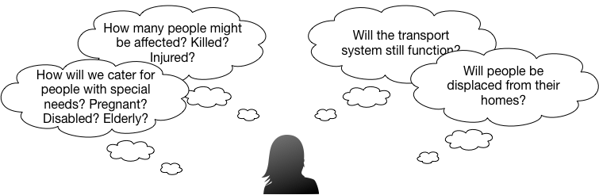
You try:
Goal: Imagine there is a big flood in your region:
Use the table on the right to list some key things you would include in a contingency plan. For example you might want to stockpile tents or shelters so that displaced people can be given temporary shelter until the disaster has passed.

Just put keywords down in the table, don’t try to write long text. If you work in or with a disaster agency, feel free to draw on your own knowledge and experience to note key things that should be part of the contingency plan. Use a notepad if you need more space.
Check your results:
Swap your list with a neighbouring group and see if they had any ideas in their lists that were missing in yours.
Category | Notes
Shelters | We should stockpile enough tents to shelter 1% of the population

The approach taken by InaSAFE

Knowing the likely answers to these questions can be immensely helpful to disaster managers. For example if you are aware of how many people live in flood prone areas you can estimate how many temporary shelters might be needed in the event of a disaster, how many provisions should be stockpiled in order to provide for the daily needs of affected people and so on. Having demographic breakdowns for the people are likely to be affected, can help disaster managers include things like special dietary requirements for lactating women in their contingency plans.
A contingency plan might also take into account expected impacts on infrastructure - for example by planning to have sufficient rescue boats should all the local roads be flooded.
- can be adapted for use in many different countries and scenarios
- supports disaster preparedness and to a more limited extent disaster response activities.

One of the goals of InaSAFE is to support disaster managers in the development of contingency plans. Remember though that InaSAFE scenarios are typically based on past or hypothetical scenarios – you should apply your own knowledge and insight to make sure that the numbers used are a good representation of the exposed communities and infrastructure.


Check your knowledge:.
- When should a contingency plan be developed:
- before a disaster
- during a disaster
- after a disaster
- other (specify)
- Mark all the correct statements:
- InaSAFE will automatically generate a contingency plan for you
- The estimates produced by InaSAFE will always closely match those of a real incident
- It does not matter if you have no or poor data, InaSAFE will compensate for this through the use of smart algorithms
Answers:


Further reading:
A very nice overview of contingency plans produced by the IFRC: http://www.ifrc.org/PageFiles/40825/1220900-CPG%202012-EN-LR.pdf

