
Section: Introduction
Module : Navigating map data

GIS in Context
“QGIS can open or connect to many different data sources. These include various vector and raster file formats, databases and web services. You can browse these in the QGIS Browser, add them to your QGIS desktop canvas or refer to them in processing tools. Once a layer is in the Table of Contents of your canvas, you can Zoom and Pan, Identify features, switch layers on and off and change the drawing order of layers.”
In this module we will go through the essential steps to start working in a desktop GIS: finding, viewing, exploring and otherwise navigating your data!
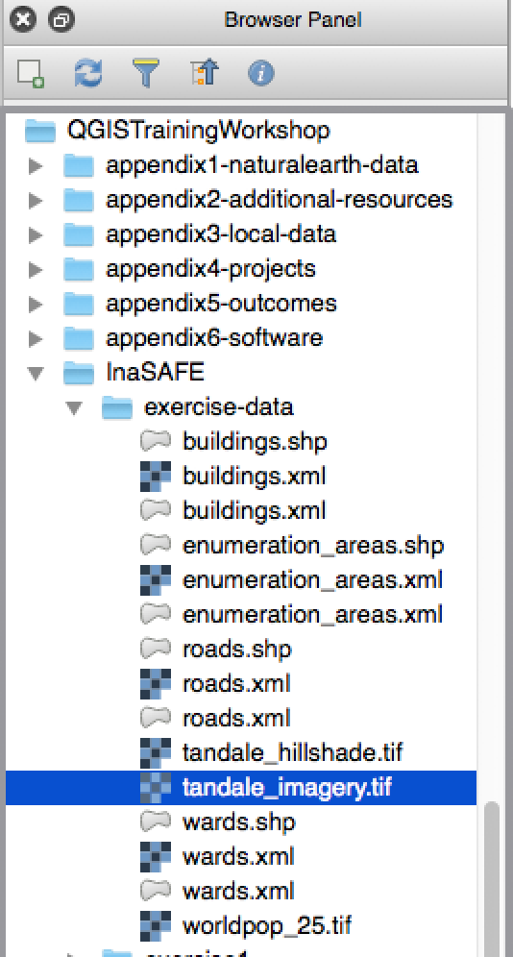
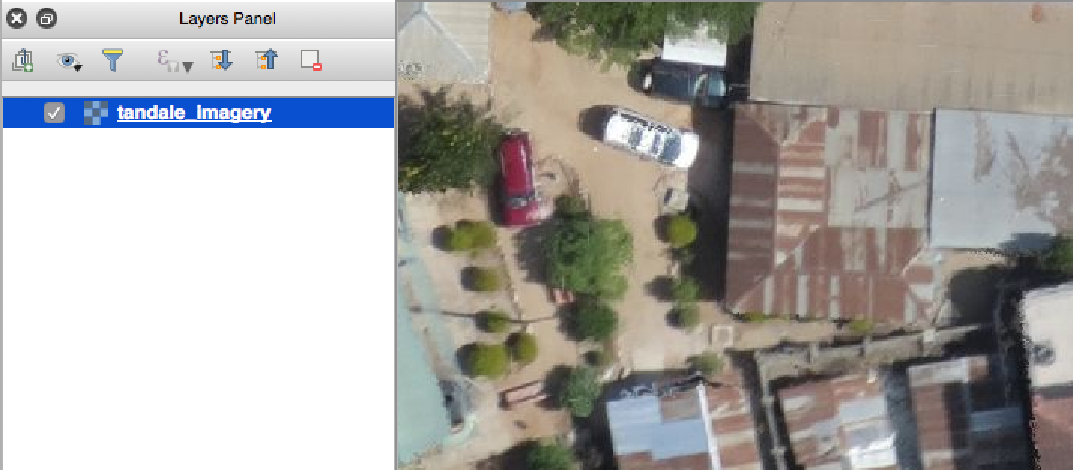
You try
Goal: Find and open some vector and raster layers and perform some basic operations on them
- Find the Tandale raster layer in the Browser panel.
- Load the Tandale raster layer by dragging it onto the canvas and zoom to its extent.
- Load some of the Natural Earth layers by navigating to the ne.sqlite file with the ‘Open vector layer’ menu item or tool.
- Zoom in and out; pan around
- Zoom to the full extent of all drawn layers.
- Make a layer active and zoom to its extent.
- Use identify button to see the details of a feature in the active layer.
- Drag layers so that you have points on top, then lines, then polygons.
- Try switching layers on and off.
- If you are online, try adding a layer with the OpenLayers or QuickMapServices plugin.
Name | Value
Find layer | Zoom to layer extent
Vector data | appendix1-naturalearth-data/ne.sqlite
Raster data | InaSAFE/appendix2-tandale-data/tandale_imagery.tif

Check your results:
- Did you figure out how to go back and forth between extents?
- With the data you loaded, do you think you can make a map with the Tandale aerial imagery and the Natural Earth layers together? Why did you give that answer?
- Did you find where you can switch all layers on or off at once?

More about navigating the map in a desktop GIS
QGIS, like a typical desktop GIS package, uses the concept of layers drawn on top of each other to make a map. The most common data types for these layers are vector and raster.

You can use the ‘Add Layer’ tools or menu items to find and load layers or you can browse to them in the Browser panel and drag them into your map.

Then you can use various tools to pan and zoom around your map and explore your data.

Check your knowledge:
- You added layers to QGIS but you can’t see all of them. Why?
  - Your view extent does not coincide with the layer extent
  - It’s the data provider’s fault
  - Your layer ordering has resulted in some layers obscuring other layers
  - There is a bug in QGIS
- If you zoom in close to the Natural Earth data it doesn’t look good nor correct. Why is this?
  - It was poorly digitised
  - It has been corrupted
  - I was intended for a smaller scale
  - It is simplified
- I click on the map with the identify tool but either no attributes or the wrong attributes come up. Why?
  - The data was captured incorrectly
  - The layer I want to query is not active
  - The layer I want to query has no attribute fields
  - All of the above
  - None of the above

Further reading:
http://docs.qgis.org/2.14/en/docs/gentle_gis_introduction/index.html
http://docs.qgis.org/2.14/en/docs/training_manual/introduction/preparation.html

