
Section:Raster Analysis
Module :Stream catchment delineation

Stream catchment delineation Context
“DEM(digital elevation models) represents raster data where each cell value depicts elevation. From DEM we generate useful by products which can help us understand the terrain. Example of products generated from DEM’s are slope, aspects map”
In this module, we explore how to derive drainage maps and delineate a catchment area from the DEM.
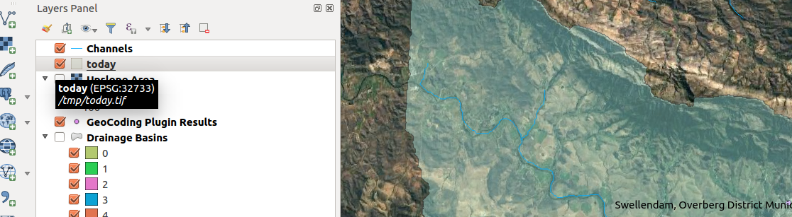
You try:
Goal: To determine the streams and catchment area for swellendam.
NB: You need the mentioned plugins
Data:appendix3-local-data/SRTM/
* Load the DEM
* Run the fill sinks algorithm (save the filled dem and flow direction only)
* Apply the flow style to flow direction layer
* Run the strahler alg and use the filled dem as input.
* Use raster calc to create a bolean raster (use rast calc expression and input raster is from strahler alg)
* Apply the bolean style on the bolean raster
* Add an aditional no-data value 0 on the bolean raster
* Run chanels alg with Filled Dem as the input. Set the threshold to 8. (save channels and drainage basins only)
* Activate plugins
* Search Swellendam using geocode plugin
* Zoom to a river near the point added by geocode plugin.
* Use co ord capture plugin to capture a point along the vector river.
* Use the slope alg. Substitute x,y for values in the coordinate capture. Use values representing correct CRS of the raw raster layer.
* Proceed to generate the catchment and streams as vector layer.

Name | Value
Fill sinks algorithm | Fill sinks (wang and liu)
Flow style | d8_flow_directions.qml
Strahler alg | Strahler order
Raster calc | "strahler@1" >= 7
Bolean style | strahler_bolean.qml
Channels alg | Channel network and drainage basins
plugins | Coordinate capture,geocoding
Slope alg | Upslope area

More about
Raster data is pixel based and it includes aerial and satellite imagery. Raster data can be classified as continuous and discrete. Population density represents discrete raster while elevation and temperature represents continuous data.

Digital elevation represents a thematic raster where each cell values depicts the height above sea level. Raster datasets can be processed to derive other products eg slope,aspect map from DEM. For satellite raster users can process the layer to derive land cover maps and land use maps.

Geoprocessing analysis is performed to recondition the digital elevation model and generate data on flow direction, flow accumulation, streams, stream segments, and watersheds. These data are then be used to develop a vector representation of catchments and drainage lines from selected points that can then be used in network analysis

Check your knowledge:
- DEM is an abbreviation for:
- Data emission problems.
- Digital elevation Movie
- Digital elevation model
- Which of these represents a derivative of a digital elevation model:
- A satellite image showing mountainous areas.
- A slope curvature map that is used by surveyors to determine the direction at which the sun shines
- A vector data that represents natural phenomena.
- Plugins are extensions in QGIS:
- True
- False
Answers: 1c, 2b, 3t

Further reading:
http://docs.qgis.org/2.14/en/docs/user_manual/processing_algs/taudem/basic_grid_analysis_tools.html
http://docs.qgis.org/2.14/en/docs/user_manual/processing_algs/saga/terrain_analysis_channels.html
http://docs.qgis.org/2.14/en/docs/user_manual/processing_algs/saga/terrain_analysis_hydrology.html#upslope-area

