
Section: Processing
Module :Graphical Model


Graphical Modeller in Context
““GIS work flow typically consist of running multiple steps before reaching a solution. This is cumbersome in situations where you have to do it over again. The graphical modeller is useful for defining work flows and running it multiple times with different parameters.””
In this module we will redo the exercise qgis-site_suitability_analysis from section 8 using the graphical model.

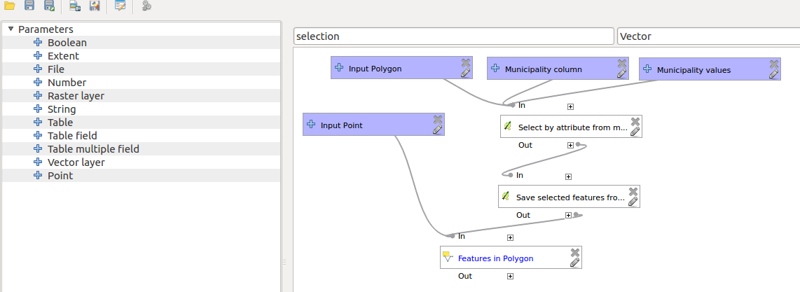
You try:
Goal: To learn how to automate running task in QGIS.
1. Revisit the workflow you did in qgis-site_suitability_analysis.
2. Open processing and choose graphical modeller.
3. Create module that solved the site suitability analysis.
NB: Do not save intermeditary results

Check your results:
Once you are done you should have a module that can be run with all the parameters.

Name | Value
Inputs | Vector layer
Processing | Buffer,select by location, Advanced field calculator

More about
Models are very powerful as they allow GIS task to be easily automated. When creating models it is important to parametrize most things so that the algorithm can be generic and be run in multiple scenarios. Models can also be run as single algorithm or can be executed as a batch processed which allows multiple scenarios to be executed at the same time.


Check your knowledge:
- Which of the following statements is true:
- A layer needs to be loaded in QGIS before it can be used with the graphical modeler.
- Graphica model can also be used as scripts.
- Models are designed for running only vector analysis.
- How can a model be made to be generic:
- Allowing users to have choose inputs like buffer when running the models.
- By specifying the buffer distance in the model.
- A model cannot be made generic. One should have a unique one for each case.
- Are there any functions available in QGIS that cannot be accessed using model:
- True
- False
Answers: 1b, 2a, 3f


Further reading:
http://docs.qgis.org/2.14/en/docs/user_manual/processing/modeler.html
http://docs.qgis.org/2.14/en/docs/user_manual/processing/index.html

