
Section: Data Providers
Module :Databases


Databases in Context
“Spatial databases are enhanced for storage and fast retrieval of data that defines a geometric space. The data is stored as coordinates, lines, points, polygon and topology”
In this module we will look at Spatialite databases and explore ways in which QGIS can interact with them. We will also learn about database syntax and how to do simple geoprocessing.

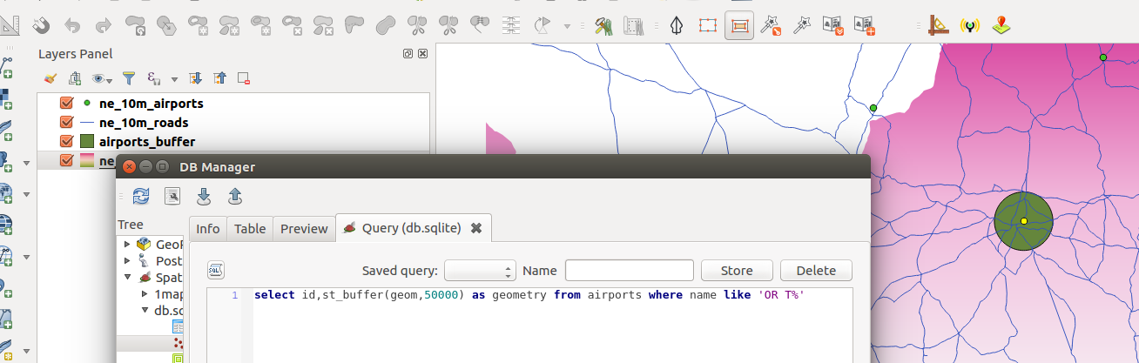
You try:
Goal: To learn how to create and populate databases and run SQL queries.
Problem: The government wants to expand OR Tambo international airport by a radius of 50km. Visualise the extent of the new airport do all processing in the database
Data:ne_10m_airports,ne_10m_urban_areas,ne_10m_admin_0_countries from natural earth
* Load the data into QGIS
* Create a spatialite database
* Filter the countries layer using the SA_filter
* Select features that are within South Africa from the urban areas and airports layers.
* Load layers into the database using DB manager.(Use the import options specified and name the layers as countries,airports and urban_areas respectively)
* Open the SQL window in DB Manager.
* Create a table `buffer` using the expression and load the resultant table in QGIS.
* Calculate the total urban area that will be affected by the airport expansion. Create a table `urban_precinct` using the affected_area expression.
* In QGIS add a column `area` to the `urban_precinct` layer and calculate the affected area.

Name | Value
TARGET SRID | EPSG:3857
AFFECTED AREA | select a.id,st_union(st_intersection(a.geom,b.geom)) as geom from buffer as a join  urban_areas as b where st_intersects(a.geom,b.geom)
Expression | select id,st_buffer(geom,50000) as geometry from airports where name like 'OR T%'
SA_filter | "sov_a3" = 'ZAF'
Import Options | Toggle import selected, create spatial index,geom, Reproject to target SRID

More about
Databases are very flexible in handling large amounts of data. They offer many advantages over other data sources and it is encouraged to use them as a data source. Spatial databases have started to be used also storing raster data and besides acting as a data store they can also be used for geoprocessing. The syntax that is used in the database is called SQL (Structured Query Language). This allows easy manipulation of the data and derivation of new products using the same datasource.


Check your knowledge:
- A database is:
- A storage device where GIS activities will take place
- A GIS database representing vector features.
- A type of data store that is used to store geographic data and non geographic
- In which instance would you prefer a spatial database:
- When you have a a lot of csv or spreadsheet containing data for analysis
- When you need to do some advanced processing of the data.
- Almost all times, whenever I get hold of a data source I should load it into a spatial database.
- Buffers calculated in the database are identical to the ones in QGIS:
- True
- False
Answers: 1c, 2c, 3t


Further reading:
http://docs.qgis.org/2.14/en/docs/training_manual/databases/spatialite.html
http://www.bostongis.com/PrinterFriendly.aspx?content_name=spatialite_tut01
https://www.gaia-gis.it/spatialite-3.0.0-BETA/spatialite-sql-3.0.0.html

