
Section: Analysis
Module : Statistical Analysis


Spatial analysis in Context
“Spatial analysis is the process of analyzing the relationship between locations, attributes, and the relationship of features through analytical techniques. Spatial analysis defines the relationship between features based on the topology, geometric and geographic properties of the features.”

In this module looks at a variety of spatial analysis techniques that can be used to answer geographic questions.

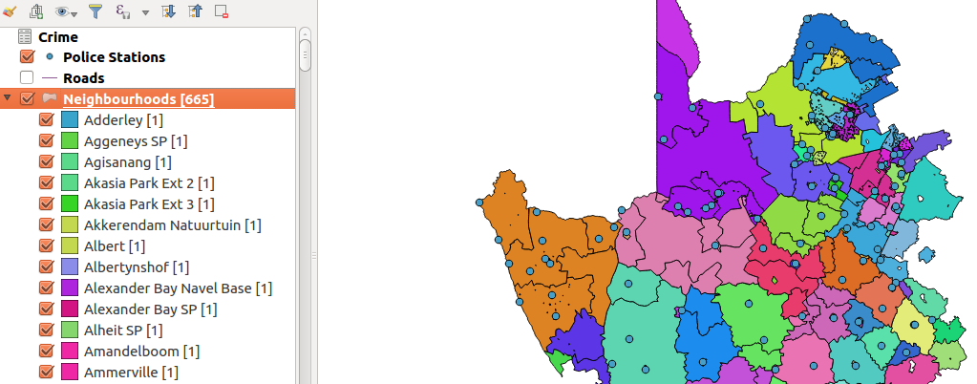

You try:
Problem: You are a resident of a neighbourhood and have been provided with crime data and police stations data. Use the datasets to answer interesting questions about your area.
Data: crime.csv,police_stations.shp, districts.shp from appendix3-local-data and ne_10m_roads from natural earth
* Load the data provided. Add crime.csv using the add vector menu. (this allows you to edit the layer)
* Filter the layers to show features that within the districts layer. (Use select by location and save the selected features as new layers for roads and police stations)
* Update the crime layer. Use field calculator to update the name column using the expression.
Questions:
* How many police stations occur within the each district. Use the count algorithm.
* What is the length of each road. Use a suitable length expression based on CRS of layer.
* what is the total length of all roads in each district. (Sum algorithm)
* Using the crime statistics show how each crime category has varied of over the years. (create a virtual layer between the roads and crime layer.)
* Which district is the safest according to each type of crime.

Name | Value
Count Algorithm | Points In polygon
Sum Algorithm | Sum line lengths
length expression | $length or length($geometry)
Diagram | Bar Chart
Expression | Upper("name" )
Virtual layer | select a.*,b.geometry from crime as a join police_station as b  on a.name = b.name

More about
When doing spatial analysis, all layers have to be projected to the same CRS. Spatial analysis is the heart of GIS and it allows deriving new data that can answer specific questions with relation to location. QGIS is geared for doing most GIS analysis but in some instances it makes sense to perform analysis in the database using SQL.


Check your knowledge:
- What is the use of spatial analysis:
- To create new data
- To interpret problems and provide useful information
- Viewing raster data and symbolize it
- Which of these is an example of spatial operation:
- Assigning colour symbols to a vector layer
- Assigning colour symbols to a raster layer
- An administrative polygon that has been clipped to show a subset of the data
- Is a csv a type raster data:
- True
- False
Answers: 1c, 2c, 3f


Further reading:
https://docs.qgis.org/2.14/en/docs/user_manual/processing_algs/qgis/vector_analysis_tools.html#sum-line-lengths
https://docs.qgis.org/2.14/en/docs/user_manual/working_with_vector/virtual_layers.html

