
Section: Analysis
Module : Site Suitability Analysis


Spatial Analysis in Context
“Spatial analysis is the process of examining the locations, attributes, and relationships of features in spatial data through overlay and other analytical techniques in order to address a question or gain useful knowledge. Spatial analysis extracts or creates new information from spatial data.”
In this module we will try explore various techniques that are used when solving a geographical problem.

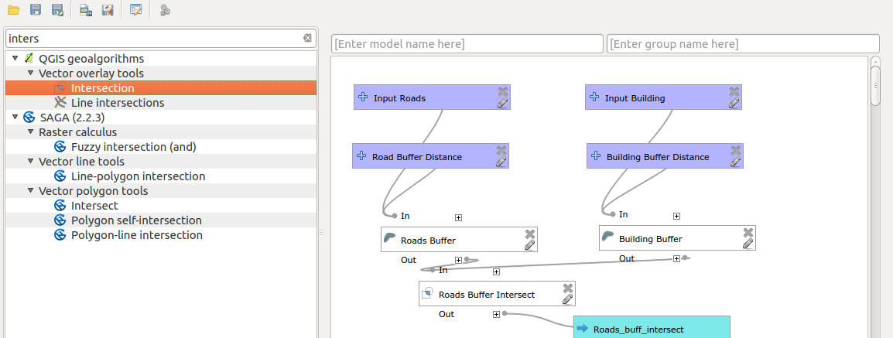
You try:
Problem: You are a salesperson in your local town and you have clients who are interested in buying houses in a town.
The following is the criterion:
a). It needs to be in Swellendam.
b). It must be within reasonable driving distance of a school (say 1km).
c). It must be more than 100m squared in size.
d) Closer than 50m to main road
e) Closer than 500m to a restaurant

Data: Download osm data representing the town you stay eg. Swellendam using Open Street map downloader or OSMDownloader plugin.

1. Filter the OSM layer for buildings,restaurants and main road. Use the amenity column to filter for restaurants and schools.
2. Use the provided main road filter and filter for buildings using the building columns
3. Run the analysis using the tools mentioned

Goal: To find houses that satisfy the conditions.
NB: Spatial analysis require that data be projected first. Use the specified CRS when projecting the data.

Name | Value
CRS | EPSG:3857
Buffer | Fixed Distance Bufer
Spatial Operations | Clip, Intersect,select by location
Dissolve Buffer | Yes
Main road filter | "highway" is not NULL AND "highway" not in ( ’unclassified’,  'track' , 'path' ,'footway')

More about
Spatial analysis ranges from performing simple analysis using simple geoprocessing algorithms to performing complex work flow. Knowing the CRS of a layer is important before undertaking spatial operations. Spatial analysis should always be done in a projected coordinate reference system. The order in which operations are done is also critical as it affects how the results will appear.


Check your knowledge:
- What is spatial analysis:
- Producing a pretty map.
- Adding a csv layer into QGIS.
- A GIS dataset that has been significantly altered by an algorithm to add columns and rows in which useful information can be deduced.
- Which of these represent a spatial operation:
- A GIS vector dataset that has been projected to another CRS.
- Finding features that occur within a geographic entity.
- Deleting columns from an attribute table.
- GIS can be used to solve real life problems:
- True
- False
Answers: 1c, 2b, 3t


Further reading:
https://infogeoblog.wordpress.com/2013/01/08/geo-processing-in-qgis/
http://gracilis.carleton.ca/CUOSGwiki/index.php/Automating_Vector_and_Raster_Workflows_using_the_Graphical_Modeler_in_QGIS
https://docs.qgis.org/2.14/en/docs/training_manual/processing/modeler_twi.html

