

Section: Preparation
Module : Keywords and metadata

InaSAFE keywords and metadata for GeoSAFE
GeoSAFE layers need InaSAFE keywords and additional metadata. You need to prepare these in QGIS with the InaSAFE plugin.
In this section we will look at how to generate metadata and keywords for InaSAFE which can be used in GeoSAFE. You might have prepared keywords in an InaSAFE module before – in that case treat this as a refresher.
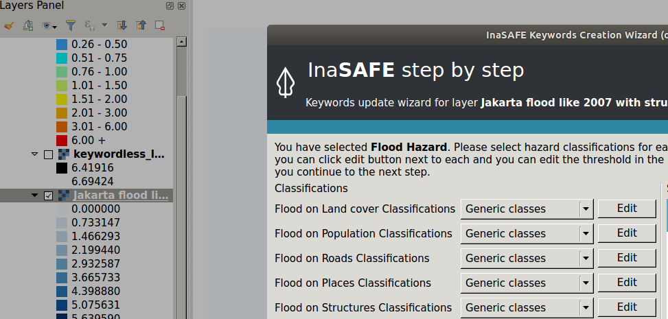
You try
Goal: To generate hazard/Exposure keywords.
* Load your sample data into QGIS.
* Activate InaSAFE from the plugin menu and InaSAFE dock.
* Right click on the layer type and choose keywords creation.
* Click through the options in the Keyword creation wizard.
NB: If the layer type is a hazard, generate keywords for each hazard combination.

The keywords generated are of the version specified.
* Populate all metadata fields in the keywords creation dock and save the results.

Name | Value
Layer type | Exposure / Hazard
Keywords Version | 4.0 or higher

Check your results
When you have finished creating the layer keywords the layer should be visible in the InaSAFE dock.

More about GeoSAFE
Geosafe is a web-based service running InaSAFE on the web server. It gives users the ability to run analysis using layers that can be loaded into Geonode with InaSAFE keywords. Additional metadata can also be appended to the metadata produced by InaSAFE in QGIS and uploaded into Geonode.

Check your knowledge
- What is the difference a hazard and an exposure layer?
- There is no difference , they are both types of layers used in QGIS.
- A hazard is a type of layer that depicts the occurrence of natural disasters.
- An exposure is a type of layer that depicts the occurrence of natural disasters.
- Which of the following statement is true?
- InaSAFE is a disaster modelling tool which can be used to predict the occurrence of natural disasters such as fires.
- InaSAFE can be used before or after the occurrence of disasters and helps disaster managers to prepare for future disasters.
- InaSAFE is a tool that is used to can only be used with raster layers.
- Exposure layers can only be vector layers?
- True
- False
- I do not know.

Further reading:
http://docs.inasafe.org/en/user-docs/application-help/keywords_wizard.html
http://docs.inasafe.org/en/training/old-training/intermediate/qgis-inasafe/402-preparing-data-and-keywords-for-inasafe.html

