
Section: Symbology
Module :Symbol Levels


Symbol levels in Context
“Symbol levels allow you to fine tune the rendering of symbols on map layers. Symbol levels allows us to specify the rendering order of each symbol and its position relative to other symbols which define the feature”
In this module we will look at how symbol levels can be used to control the rendering of feature symbology and how symbols can be ordered to control rendering.

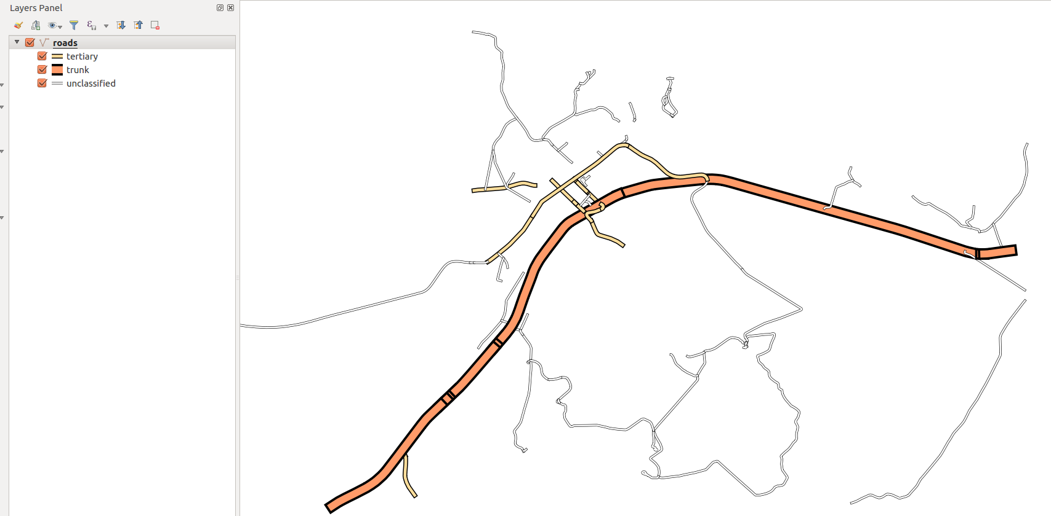
You try:
Goal: To symbolise osm roads using symbols levels so that all features which consist of more that 1 symbol type are visually asthetic and catrographically correct.
DATA: appendix3-local-data
* Add the osm roads from data folder or download osm roads using osm vector menu or quick osm plugin
* Apply the style (Load the .qml file)
* Select Advanced option and choose symbol levels.
* Enable symbol levels.
* Change the symbol levels so that your layer looks nice and obeys cartography rules.
NB: The symbol you need to be rendered first should have a value lower eg (0) that the one to be rendered on top (eg 1) .
Check your results:
When you are done roads should flow into each other

Name | Value
STYLE | roads_osm_symbols.qml
Vector layer | roads_osm

More about
When choosing to symbolise a vector layer you have to decide whether a single symbol will adequately represent the feature properly or more symbols can be used. In cases when you have used more symbol you then need to specify the hierarchy or rendering order of each symbol so that you have symbology that looks nice and blends with the rest of your map layers. Example of features that can have multiple symbols are railways and roads.


Check your knowledge:
- Symbol levels depict:
- Two or more symbols that are used to represent a class or group of features in a vector layer.
- A type of vector layer that can be used in a GIS
- A type of vector analysis technique
- Which of these statement is True :
- A symbol layer is applicable when the category used to style the layer is rule based.
- A symbol layer can be applied to any rule category. Examples Categorised or graduated.
- Symbol layer types can be classified as a spatial operation.
- Symbol levels can be applied to raster layers:
- True
- False
Answers: 1a, 2b, 3f


Further reading:
http://docs.qgis.org/2.14/en/docs/training_manual/basic_map/symbology.html

