
Section: Raster Analysis
Module :Raster calculator


Raster calculator in Context
“ Raster consists of pixels which are organised in rows and columns. Each pixel has got a values which represents a specific phenomenon on the earth surface. Because raster are based on pixel we can do arithmetic calculations on each pixel and derive new datasets that can be interpreted”
In this module we will look at how raster can be manipulated by using arithmetic operation. Raster data is very useful as it gives us information over a large scale and we can then derive new datasets from these. Lets dig in and explore the raster calculator.

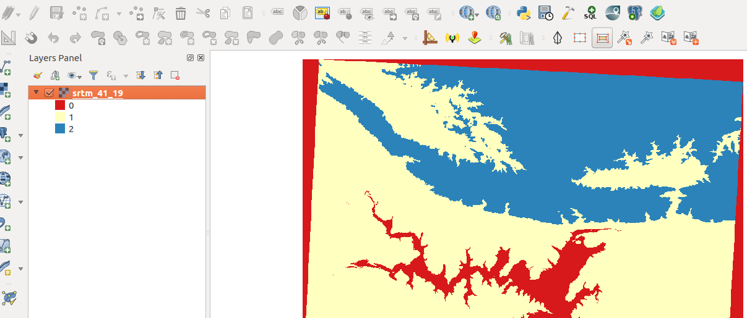
You try:
Goal: To learn how to reclassify raster pixel values into 3 categories and calculate total area for each category
Check your results:
You should have reclassified raster and total area of each class.

* Load the raster layer into QGIS
* Open raster calculator
* Use the sample expression to create a binary raster with all pixel < 200 being given a value 1 and other pixels a value 0
* Create a final raster with your own custom expression with the following ranges
Pixel_value < 200 = 0
Pixel_value > 200 and < 1000 = 1
Pixel_value >1000 = 2
* Calculate the area of each class.

Name | Value
Raster Layer | srtm_41_19
Operation | Arithmetic
Expression | ("srtm_41_19@1" < 200) * 1
Area | $Area

More about
The raster calculator is very useful in helping derive new datasets. The raster calculator is usually used as a pre processing step for any data source. It can be for example when someone needs to know the total area for pixels greater than a specific value where a user can reclassify the values and then calculate the area afterwards. It is important to understand the syntax for the operation that are applied with the raster calculator. By using the raster calculator we can perform complex operations on raster for example zonal,focal and local operations on the raster.


Check your knowledge:
- Raster calculator allows:
- Rasters to be overlaid together
- To reclassify raster pixel values into different categories using specific formula
- To clip a raster into smaller pieces
- Which of these datasets can we apply arithmetic operations on:
- A GIS raster dataset where each pixel represents the depth of a flood
- A GIS vector dataset where each polygon represents an area of high, medium or low flood depth
- A GIS vector dataset where each polygon represents a building with high, medium or low occupancy rate
- Raster calculator can be used with Digital elevation models:
- True
- False
Answers: 1b, 2a, 3t


Further reading:
https://docs.qgis.org/2.14/en/docs/user_manual/working_with_raster/raster_calculator.html
http://nates-intro-to-qgis.readthedocs.io/en/latest/rasters.html
http://gisgeography.com/map-algebra-global-zonal-focal-local/

