
Section: InaSAFE
Module : First steps – practical example


A practical example using InaSAFE
“We are going to walk you through the process of running through an InaSAFE analysis in a very simple way. As part of the process you will add hazard, exposure and aggregation data to QGIS, assign keywords to an exposure layer, run an analysis and then view the analysis products.”
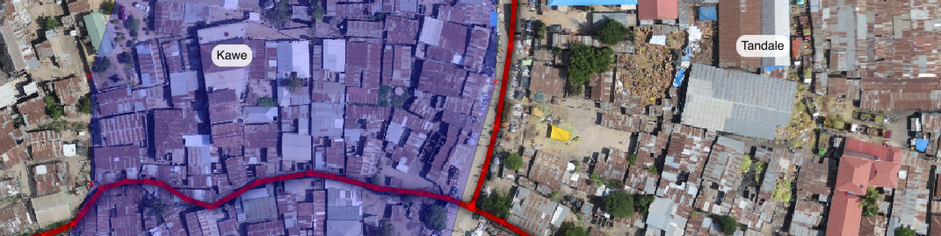
The analysis workflow in InaSAFE is similar regardless of which hazard and exposure types you have: Add your Hazard, Exposure and optionally Aggregation layers to QGIS, ensure they have their InaSAFE Keywords defined, then run the analysis. At the end of the analysis, InaSAFE will add a layer group to the layers panel, which will contain the GIS analysis results. InaSAFE will also generate PDF reports containing both maps and summary tables. We use a fictitious flood layer for this example.

You try:
Goal: To be able to run a simple analysis in InaSAFE.
First load the data layers as indicated in the ‘load data’ requirements.
Next use the InaSAFE Keywords Creation Wizard to define keywords for the population layer. Select the layer first in the legend, then click the InaSAFE “Keywords Creation Wizard” icon in the InaSAFE toolbar (use the tooltips to ensure you click the right icon). Use the Exposure keywords shown in the ‘exposure keywords’ requirements.
Finally run the InaSAFE ‘Impact Function Centric Wizard’, reading the instructions on each step carefully and make the most sensible choices (bearing in mind that all the data are already loaded in QGIS).
Check your results:
How many people were affected by the flood? Do the results match your expectations?
Requirements
Load data | Use the QGIS Browser panel to add the following datasets to your QGIS project. From the appendix2-tandale-data folder:  wards.shp,  worldpop_25.tif, tandale_imagery.tif  From the exercise1 folder: tandale_floods.shp
Exposure keywords | Title Worldpop resampled 25m  Purpose exposure  Exposure population  Geometry raster  Data type continuous  Units count  Source WorldPop  Url http://worldpop.org.uk  Date15 Jan 2015  Keyword version 4.1  Reference system EPSG:4326  Layer source .... worldpop_25.tif

More about the analysis
In this exercise we have really simple datasets with only a few features so that we can easily understand all the results generated. We also pre-generated the keywords for the aggregation and hazard layers for you (we will cover these in detail in subsequent worksheets). So what happened when we ran the analysis? InaSAFE performed a sequence of spatial operations on the data, converting rasters to vector data, unioning each vector layer with all the others and assigning hazard and aggregation classes to each resulting feature. The analysis results are then used to generate a number of reports using the InaSAFE reporting engine and the QGIS composer. The exact nature and sequence of operations will vary according to the input datasets; continuous raster data are reclassified then polygonised, vector attributes are remapped into standard exposure concepts and so on. For the report generation, InaSAFE rounds population numbers so you may notice that the sum of the results may seem inconsistent – this is not a mistake since we round up the results for each report element separately.
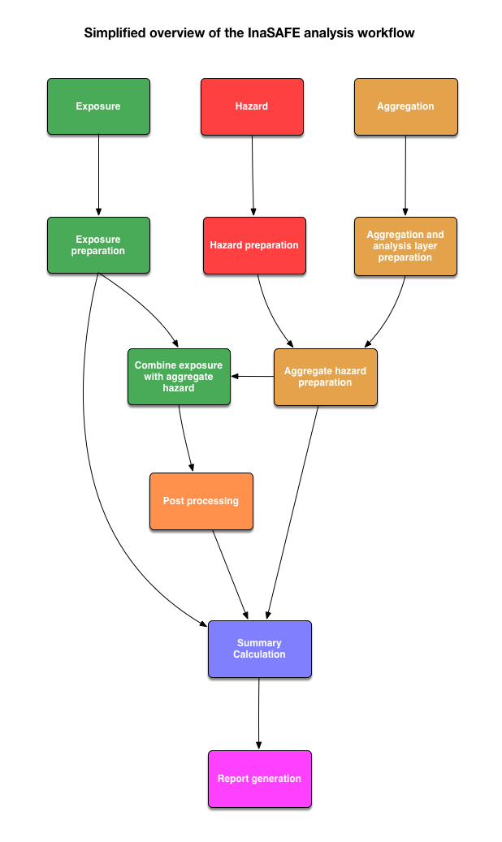


Check your knowledge:
- Why did you not define keywords for the hazard and aggregation layers?
- InaSAFE automatically generates the keywords when needed.
- Keywords were already defined for the hazard and aggregation in this exercise.
- Keywords are only needed for the exposure layer.
- What is the main geometric operation used during the analysis:
- Intersection of all features in hazard, exposure and aggregation
- Union of all features in hazard, exposure and aggregation
- Deletion of all features in hazard, exposure and aggregation


Further reading:
See the InaSAFE documentation at: http://docs.inasafe.org

