

Section: Preparation
Module : Additional Keywords and metadata


InaSAFE keywords and metadata for GeoSAFE
GeoSAFE layers need InaSAFE keywords and ideally should also have additional metadata. You prepared the InaSAFE keywords in a previous module.
In this module we will explore ways in which to add more metadata to layers that already have InaSAFE keywords.

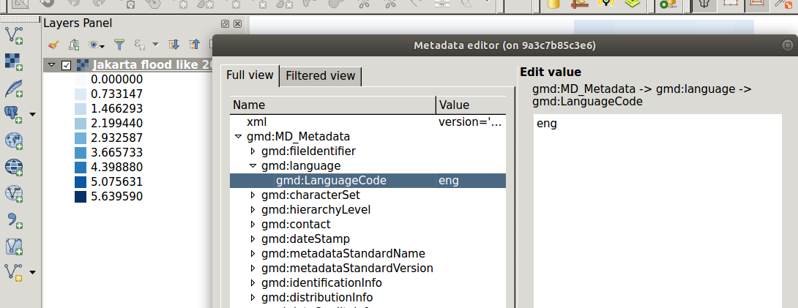
You try
Goal: To learn how to fully populate additional metadata records.

* Install and activate the plugin
* Add the layer into QGIS.
* Go to plugin and choose the plugin and select the specified metadata operation.
* Navigate to the source of the loaded layer and choose the metadata file (.xml)
* Go to the plugin and choose the edit operation.
* In the window that opens up choose the elements you need to edit and enter data and save.
* Using the plugin export the metadata and overwrite the metadata for the current layer

Name | Value
Plugin | Metatools
Layer | Exposure/Hazard with 3.5 keywords
Metadata operation | Import metadata
Edit operation | Edit metadata
Check your results
Once you are finished, check that the layer contains additional metadata fields.

More about Metadata
GeoSAFE uses metadata with keywords from InaSAFE version 3.5. When InaSAFE generates metadata it populates only a subset of the metadata fields, including add the keywords to the Supplemental Data field. Utilising tools like MetaTools allows us to add extra detail to the metadata so that users can fully understand all elements of our data.

Richly populated metadata is important for many reasons, here are just a few:
- recording the provenance of the data
- recording the processing history
- noting the correct attribution
- providing details of any access constraints
- providing web service access urls
- providing contact information
- being interoperable with other ISO 19115 compliant metadata systems
- complying with regulations and policies. e.g. INSPIRE in Europe.


Check your knowledge
- What is metadata?
- A document generated by InaSAFE
- A document containing data about data. Contains information like where and when the data was collected.
- A special type of document that is specific to InaSAFE and GeoSAFE.
- Which statement is true?
- Metadata is generic for any type of GIS data.
- Hazard and Exposure layers are the only two type of layers that can have metadata.
- InaSAFE invented metadata and have exclusive rights to it.
- Metadata generated by InaSAFE can be used in other programs ?
- False
- True


Further reading:

http://docs.inasafe.org/en/user-docs/application-help/keywords_wizard.html

http://docs.geonode.org/en/master/tutorials/admin/admin_panel/base.html

https://www.fgdc.gov/metadata/iso-standards

