
Section: InaSAFE-Realtime
Module : Earthquake realtime


Reading a Realtime Earthquake Report

“The Realtime Earthquake report graphically shows the location of the earthquake, the areas affected and the number and location of people affected. It also shows estimated fatalities.”
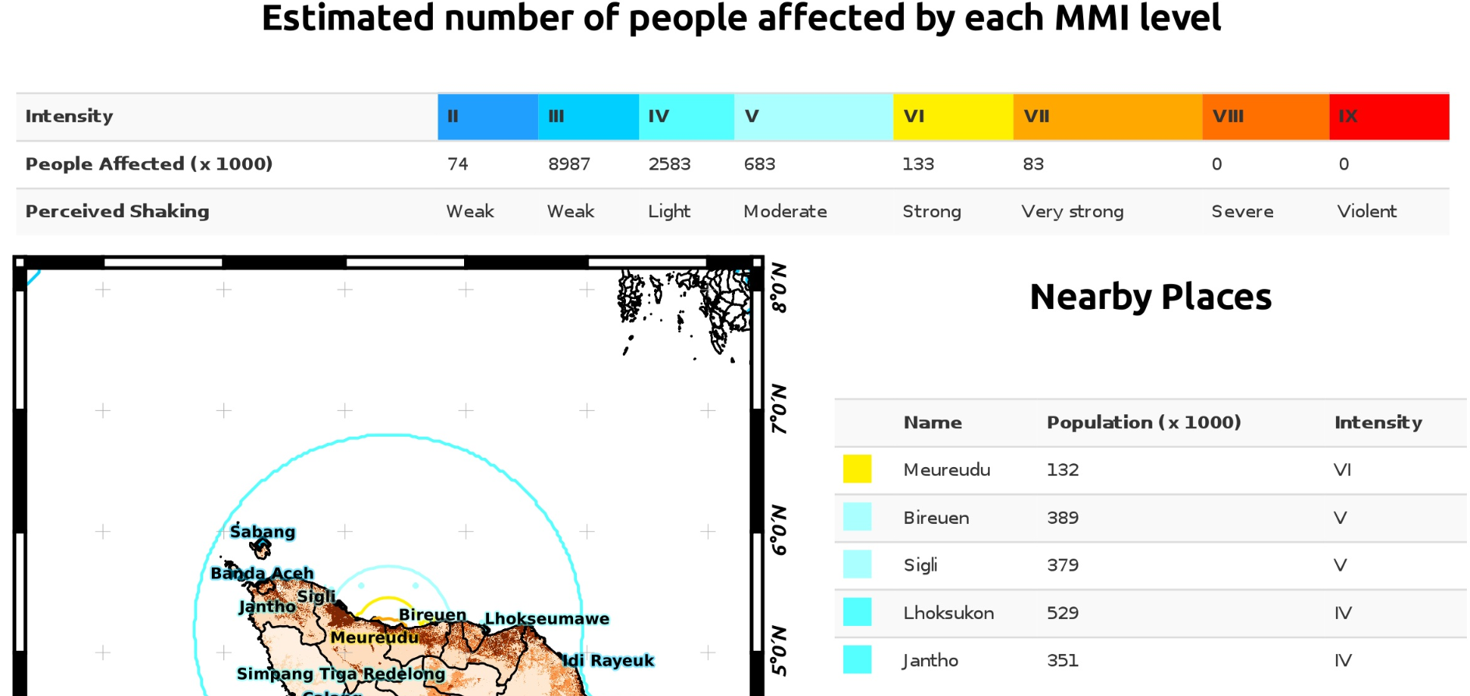
When a shakemap arrives in the realtime system, it runs an InaSAFE ‘earthquake on population’ analysis and publishes the result to the realtime website as a viewable pdf. You can view the report for any earthquake on the system by clicking on the report icon in map popups or the Action column.
You try:
Goal: To interpret an InaSAFE realtime earthquake report
1. Find the Pidie earthquake
2. View and read through the Pidie earthquake report
3. What is the closest settlement to the epicentre?
4. How many people were subjected to level 6 or greater intensity shaking?
5. Is the information shown in the report 100% accurate?
Check your results:
Swap your list with the person next to you and see if they had any different answers.
Question | Clue
1 | Pidie is in Aceh

More about the earthquake realtime report
Just to be sure you found the icons where you can view a report – they are the document icon in the Shake Event popup in the map and in the Action column in the Earthquakes table. If you hover over them you will see ‘Open Report’ or ‘Report’.
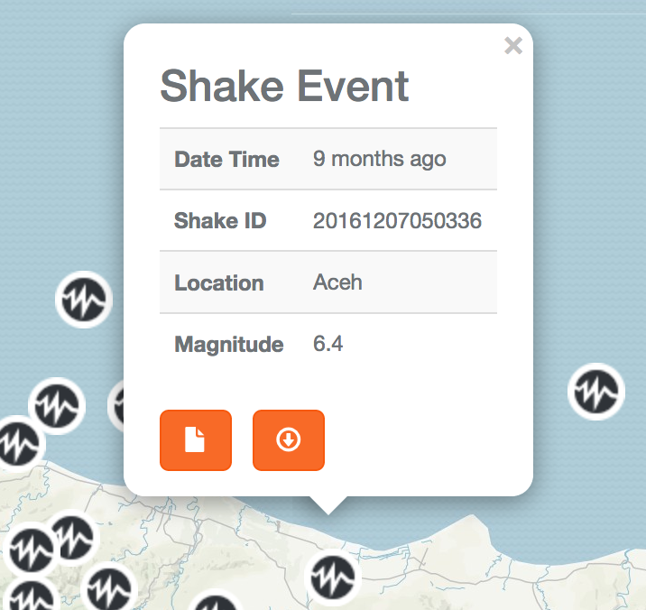

The report is generated by a slightly customised version of InaSAFE, the same software that runs in desktop QGIS. When you do more training or work with QGIS and InaSAFE you will do similar analyses manually. The main differences are that this analysis happens automatically, it works on a set exposure layer and the report contains some extra information.


Check your knowledge:
- The Pidie report puts estimated fatalities at 0-100. This means
- There will be no deaths
- There will be lots of deaths
- Prepare for the possibility of some deaths
- What can I conclude from the information that 132 000 people in Meureudu were affected?
- 132 000 people’s houses have been damaged
- A proportion of 132 000 people may have had their houses damaged or be without food or water.
- 132 000 people will be without food and water


Answers (to move to answer sheet)

You try

3. Meureudu.

4. 133 000 + 83 000 = 216 000

5. Not necessarily. It is subject to input data errors and omissions as explained in the disclaimer.

Check your knowledge

1c

2b

