
QGIS - Beyond the Basics
Tim Sutton (tim@kartoza.com)
Thu 18, Fri 20 August, 2016

About your presenter:

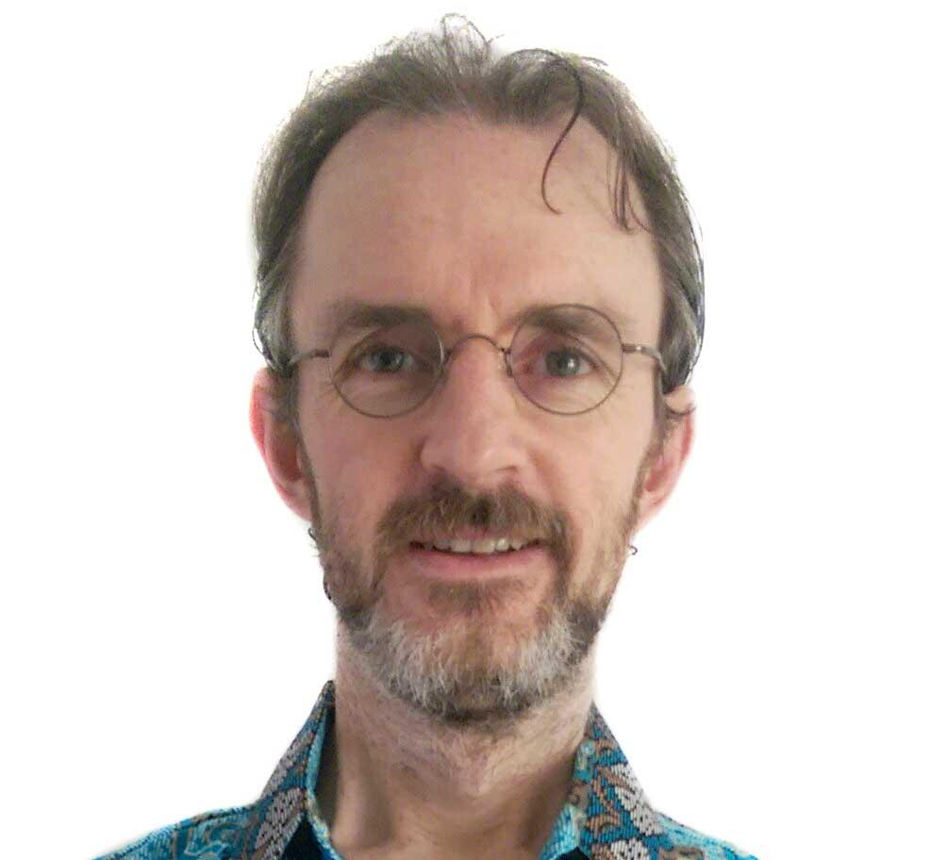 | Based in Cape Town, South Africa, Tim has nearly 20 years experience in the use of GIS. Originally trained as a Nature Conservationist, Tim became involved in GIS through his work at the provincial conservation agency in the Western Province of South Africa. Tim joined the QGIS project in December 2002 and has been actively involved in the project ever since. Tim currently serves as the QGIS project chairman.  Goal in life? Tim’s goal is is to put the tools for informed spatial decision making into the hands of everyone on earth.  @timlinux on Twitter

Requirements for the course:
- Your own laptop / computer running a recent version of your favourite operating system
- QGIS 2.14 LTR installed on your laptop. You will probably be ok if you have a newer version of QGIS, you might struggle if you have an older version.
- A working internet connection will be useful, though for most exercises is not required.
- Your concentration, and attention - we will cover a lot of material in a short space of time, so get a good night’s sleep and come ready to learn!
- We expect that you already understand basic concepts in QGIS such as adding layers, basic symbology, saving projects, etc.

Day 1:
Part 1:

- A short (30 minute) presentation describing the QGIS project.
- I explain the approach that we will follow over the next two days
Part 2:

  - Writing expressions in QGIS
  - Virtual layers
  - Rule based symbology
  - 2.5D symbology
  - Working with colour ramps

Day 2:

Worksheets

  - Masking with the inverse polygon renderer
  - Labelling vector layers
  - Data driven labelling properties
  - Creating and sharing styles
  - Creating map books using the QGIS Atlas

Demonstrations

- Using processing tools in QGIS
- Automating data processing workflows with models
- In-database data storage of GIS data
- Table joins and relations
- Forms
- Projections
- Advanced digitising in QGIS

