

Section: Analysis
Module : Reports

Interpreting GeoSAFE reports
When an analysis finished it produces reports. The reports consist of map and a table that has a statistical breakdown of how the hazard affected the impact. It is imperative to know how to interpret the results as this will lead to better decision makind.
In this module we will look at how to download and review reports generated from running an impact analysis.
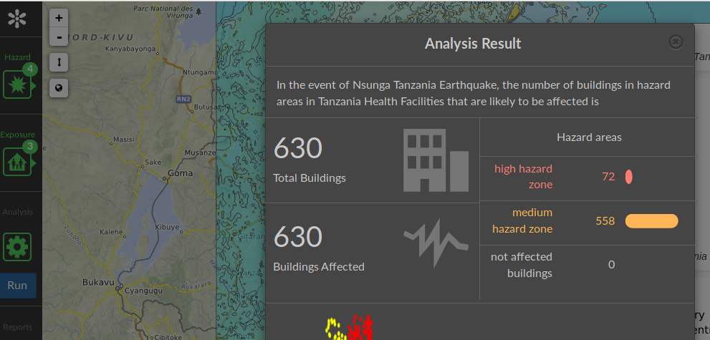
You try
Goal: To review reports and way in which to access them.
* Navigate to the analysis page of GeoSAFE
* Run the analysis using the defaults after choosing the exposure/hazard combination.
* The analysis summary is visible in the map once the process finishes.
* On the Analysis sumary visible select download option and choose the visual report in order to see the analysis results on the screen.
* For saving the analysis results choose between the options in save reports.
* You can also choose to download the analysis layer.
* Navigate to the GeoSAFE homepage and choose GeoSAFE menu and analysis list menu.
* When in the analysis list select download.
* The impact results show the hazard zone in 3 categories ie (high,medium and none) against the total affected exposure in those categories.

Name | Value
visual reports | Impact Report,  Table report,
save reports | Impact and table reports
Analysis layer | Impact layer

Check your results
After accessing the results you should see the table reports and map area with a legend showing how many features were exposed to that particual hazard. The map paints a graphic picture of where , and severity of the impact.

More about GeoSAFE
GeoSAFE produces maps and table reports. The table gives a detailed summary of how many features of the exposure has been affected by the specified hazard. The summary depends on the exposure type and the metadata that has been captured for that exposure.

Check your knowledge
- What is the significance of the reports generated after running an impact analysis?
- They produce a pretty map which everyone loves.
- It gives information and statistics about the impact analysis.
- They are not useful because they need a statistician to further interpret them.
- R?
- A1
- A2
- A3
- A4
- The reports generated from GeoSAFE and InaSAFE desktop for the same Exposure / Hazard combination is different?
- They are the same because they use InaSAFE.
- The difference would come if the version of InaSAFE used on the Desktop is newer and this would have other details in the records.
- The statisitcs would be different because the GeoSAFE is being run in the browser which is not as clever as a Desktop.

Further reading:
http://docs.inasafe.org/en/user-docs/application-help/reports.html

