

Section: Preparation
Module : Keywords and metadata conversion

InaSAFE keywords and metadata for GeoSAFE
GeoSAFE layers need InaSAFE keywords and additional metadata. You need to prepare these in QGIS with the InaSAFE plugin...
In this module we look at ways to converts metadata from one version to another so that the data can be used in GeoSAFE. This exercise assumes a user has already done GeoSAFE-layer-preparation-keywords-v4
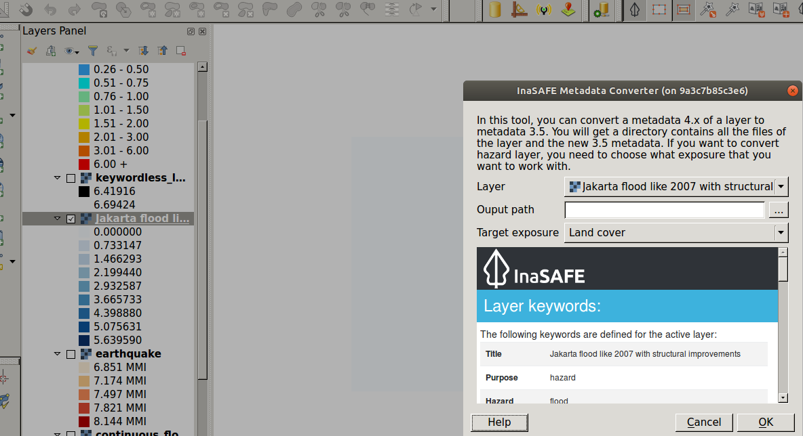
You try
Goal: To convert metadata from version 4.0 and upwards to version 3.5 which GeoSAFE currently utilises.
* Load the layer from the layer from the previous exercise.
* Choose InaSAFE from the plugin menu and select metadata conversion from the drop down available.
* Select the layer you need to convert the keywords from version 4.0 to the Geosafe version.
* Select the layer from the list specified.
* If the layer chosen is a hazard then match it to the exposure you need to expose it to.
* Select output path and run the conversion.
* Load the result to QGIS and the dock highights the Geosafe version keywords.

Name | Value
Geosafe version | 3.5
Layer type | Exposure / Hazard
Check your results
When you have done finished the conversion add the generated layer into QGIS and notice that from InaSAFE dock, the layer is no longer selectable. The dock shows a notifaction about the keywords version.

More about GeoSAFE
Geosafe is currently pinned to run InaSAFE version 3.5 which renders all metadata generated by InaSAFE versions greater than 4 unusable in GeoSAFE. The conversion of metadata allows the flexibility of running concurent analysis in the desktop and the browser using the different versions of keywords.

Check your knowledge
- What are InaSAFE keywords?
- These are letters written in bold in the metadata document.
- This describes the parameters for each hazard/exposure type.
- Keywords are a type of analysis for InaSAFE.
- When is the main difference when converting metadata with keywords 4.0 to 3.5 for hazard and vector?
- There is no difference, both do the same thing.
- When converting exposure layer you also need to specify what type of hazard the layer will be used with.
- When converting hazard layer you also need to specify what type of hazard the layer will be used with
- Can you convert metadata with keywords version 3.5 to version 4?
- Not posible at all.
- Yes if the InaSAFE guys write a new tool.
- Yes you just go through the keywords creation tool.
- I do not know.

Further reading:
http://docs.inasafe.org/en/training/old-training/intermediate/qgis-inasafe/402-preparing-data-and-keywords-for-inasafe.html
http://docs.inasafe.org/en/user-docs/application-help/keywords_wizard.html

