
Section: InaSAFE
Module : Aggregation


Aggregation in InaSAFE

“Aggregation is the process whereby we group the results of the analysis by district so that you can see how many people, roads or buildings were affected in each area.”
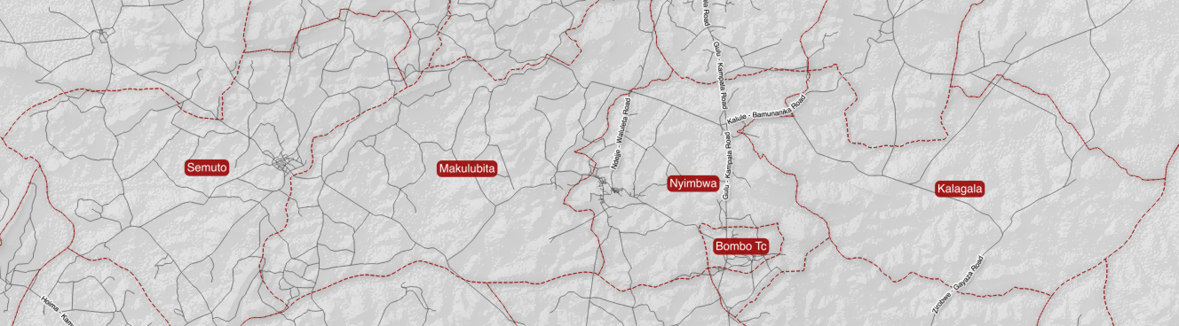
While it is not required to use aggregation areas in InaSAFE, it is recommended. Aggregation areas are typically political boundaries: wards, villages, districts, provinces etc. Generally disasters are more localised in scale, so using smaller aggregation units often makes sense. Currently InaSAFE supports only vector polygon datasets for use as aggregation layers. The aggregation layer used will also determine the analysis area when running an analysis in InaSAFE. If a QGIS selection has been made on an aggregation layer, the analysis will be constrained to only the selected areas.
You try:
Goal: To be able to understand the importance of aggregation data in InaSAFE.
Think about a disaster prone area in your community. Now think about contingency planning and post disaster support operations for that area. What aggregation area unit (ward, village, district, etc.) makes the most sense, and why? Use the space provided on the right for your answer and jot down a few keywords justifying your choice.

Check your results:
Swap your list with the person next to you and see if they had any different ideas about which constitute valid exposure data.
Aggregation Unit
Reasoning

More about aggregation
As well as demarcating regional areas, aggregation layers can play an important role in InaSAFE by driving parts of the analysis logic when dealing with population exposures. For example storing the ratio of males to females as an attribute of an aggregation layer will allow you use those areas specific ratios when producing demographic breakdowns of displaced population. Currently the following attributes can be used if present in aggregation data:
For age | Infant ratio | Child ratio | Youth ratio | Adult ratio | Elderly ratio
For gender | Male ratio | Female ratio
For age vulnerability | Under 5 years ratio | Over 60 ratio
For gender vulnerability | Child bearing age ratio | Pregnant ratio | Lactating ratio
For disability vulnerability ratio | Disabled ratio
Aggregation data can often be obtained from your local or regional government. There are also a number of free, open data sources for administrative boundaries: OpenStreetmap, gadm and others. You should be aware however that these data are somewhat subjective, for example disputed boundaries or lack of detailed boundary information may make for inconsistencies in aggregation data. For this reason it is best to obtain the aggregation area data from an official source if at all possible. In some countries (e.g. Indonesia) governments have uploaded official boundary data into OpenStreetmap, ensuring that the data is easily publicly available
InaSAFE includes a tool that will help you download aggregation data from OpenStreetmap for your area (if available).


Check your knowledge:
- Choose which exposure types are supported for aggregation ratios:
- roads (for calculating the ratio of each road type in an aggregation area)
- buildings (for calculating the ratio of each building type in an aggregation area)
- population (for calculating the ratio of each demographic group in an aggregation area)
- Mark all the correct statements:
- Aggregation areas are required for an InaSAFE analysis to work
- Aggregation areas are centrally provided and maintained by the InaSAFE project
- InaSAFE allows you to use a subset of the aggregation areas to determine the analysis area.
Answers:


Further reading:
See the aggregation section in the InaSAFE technical documentation at: http://manual.inasafe.org/en/index.html#aggregation-groups or in the application help.

