
Section: Symbology
Module: Using the Inverted Polygon Renderer


Inverted Polygon Renderer in Context
“The Inverted Polygon Renderer is used to render outside of the polygons defined in your vector polygon layer.”
In this module we will explore the inverted polygon renderer. There are two primary uses for this renderer: masking and graduated outlines which extend away from polygons rather than into them.
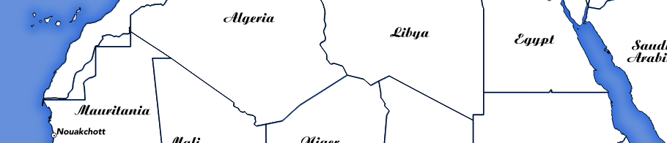

You try:
Goal: To learn how to create a coastline effect around country polygons.
* Load your countries layer and set the properties according to the table, right.
* Experiment with different options and ramps to see if you can make a nice graduated coastline effect.

Check your results:
Once you have finished, you should have the interior of your country boundaries transparent, the exterior filled with a pleasing sea colour.

Try put another layer behind the countries and verify that you can see through the interior of the countries.

Name | Value
Layer | countries
Renderer | Inverted polygons
Sub renderer | Single symbol
Symbol layer 1:
Symbol layer type | Simple fill
Fill style | no brush
Border width | 1mm
Symbol layer 2:
Sub layer type | Shapeburst fill
Gradient colours | Two colour
 | #2b6adb to #6a94db
Shading style | Shade to set distance 5mm
Blur strength | 10

More about inverted polygon renderer
One useful thing you can do with the inverted polygon render is feature masking. For example if you are trying to make a map of your country, and want to exclude surrounding territories you can create a copy of your country layer filtered to your focus country and then use the inverted polygon renderer to hide all countries except the focus country. One gotcha with this is that labels will not be masked (as of QGIS 2.14 and below). You can do some clever tricks to mask the labels which we will look at in the expressions module – see also the Mask plugin which makes it easier to manage label masking in your expressions.


Check your knowledge:
- Use the inverted renderer when:
- You need to draw outside your polygons rather than inside
- You want to switch the colour around
- You need to mask some data from other layers
- Inverted rendering can be used with:
- point layers
- line layers
- polygon layers
- raster layers
Answers: 1a&c, 2c


Further reading:
You can read more about inverted rendering here:

http://www.oslandia.com/masking-features-in-qgis-24-en.html

