
Section: Raster Analysis
Module : Multi band Satellite Imagery


Multi Spectral Images in Context
“ Multi spectral images consist of several bands of data. Each band can be viewed as a single gray band or can be visualised as a combination of different bands.” The interpretatation of the colour composites for the images can be analysed by understanding the spectral reflectance of the surface that was captured by the image.
In this module we look at ways in which we can visualise a multi band images and look at by products we can derive from the satellite image and intepret it based on the spectral signature of the image.

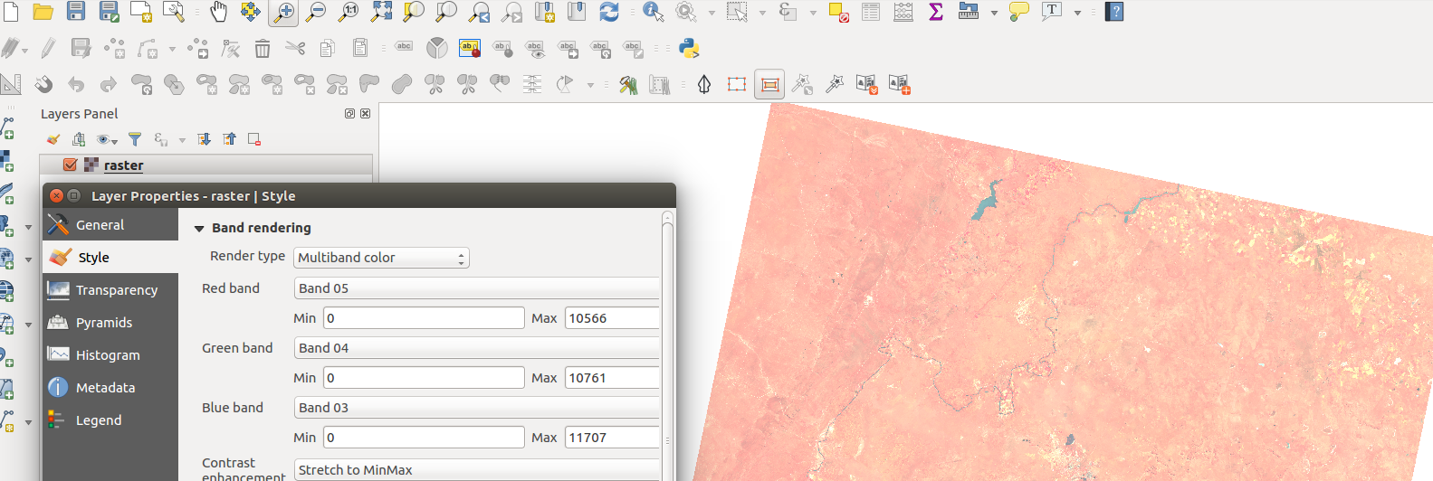
You try:
Goal: To learn how to load multi band raster and various ways to visualise the raster. To learn how to derive by products of satellite.
Check your results:
* Create a virtual raster using Landsat 8
* Make an RGB image using the band combinations specified.
* Use the following band combinations to visualise the rasters.
Colour Infrared 5,4,3
Natural Color4,3,2
False Color6,5,4 or 7,6,4 or 7,5,3
* Use the raster calculator to calculate the NDVI
* Symbolise the NDVI image generated
* Identify areas where healthy vegetation is growing and areas where vegetation is sparse

Name | Value
Data | Landsat 8
Expression | (Band 5-Band 4)/(Band5 +Band 4)
Layer | Virtual raster
RGB | 4,3,2 Bands
Process | NDVI

More about
Satellite imagery is very useful because of the large area it covers. Satellite can be programmed to captured information about a particular place at the same time of the day or revisit the same place within days. This allows covereage of the whole globe within days. When such raster become available they can then be analyzed so that we derive more information from these satellites. QGIS has got nice visualisation tools for the bands and processing capabilities. Analysis of satellite images form the basis of remote sensing.


Check your knowledge:
- What is a satellite image:
- A layer that has been downloaded from the internet
- A raster layer that has pixel values which represent natural phenomenon
- A type of GIS dataset that consist of polygon,lines and point features.
- What is the primary use of calculating NDVI :
- To make a pretty map.
- A type of raster that is used in QGIS.
- A derivitive from a satellite images showing nature of vegetation
- All satellite images have more than 1 bands:
- True
- False
Answers: 1b, 2c, 3t


Further reading:
https://landsat.usgs.gov/how-do-landsat-8-band-combinations-differ-landsat-7-or-landsat-5-satellite-data
http://www.landsatfact.com/about/project_methods
http://www.crisp.nus.edu.sg/~research/tutorial/opt_int.htm

