
Section:Analysis
Module :Population Density


Population dot density in Context
“Population distribution describes a way in which people are spread across the earth surface. Population distribution is usually shown by a dot density map where each dot represent a certain number of people. Dot density maps are useful indicators as they show the general characteristics of distribution as well as areas of high and low density”
In this module we will learn how to create a dot density map and identify areas which have high density to areas with low density.

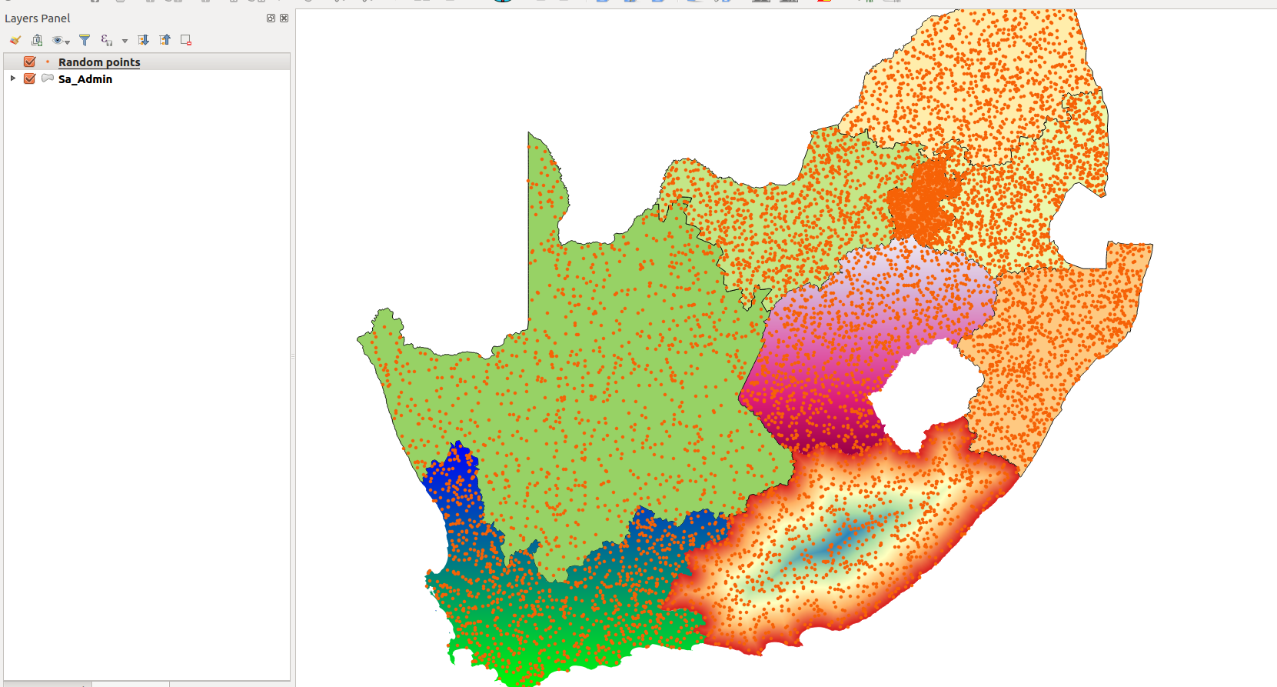
You try:
Problem: As a GIS official in your country identify the relationship between population spread and the agricultural produce from each administrative region.
Goal: To understand the relationship between agricultural produce and i population. To achieve this produce a thematic map showing agriculture productivity per region and population density
With ...
To Do:
* Load the vector layer showing administrative regions.
* Load the spreadsheet with population count for each region
* Join the layers
* Produce a dot density for each region

Name | Value
Layers | Polygon,Excel
Attribute Analysis | Table Joins
Spatial Analysis | Random Points

More about dot density maps
Dot density maps are effective at showing density variations on geographic landscapes.
Dot maps are advantageous when mapping phenomena that change smoothly over a space, as the dot maps will visually match the phenomena. There are mainly two type of dot density maps namely one-to-one and one-to-many dot maps.

Dot density maps can be used in conjunction with other thematic maps to understand phenomena that occurs across the earth surface.


Check your knowledge:
- What is it useful to know population distribution:
- Because it will interrupt human activity like a farming
- For planning purpose, resources use against people
- It does not matter as long as we know the population density
- What is population distribution and how is it represented in a GIS:
- A type of gis dataset that shows how people behave
- The spread of people across the terrain
- Spread of points in a vector layer
- Is population distribution a type of dataset:
- True
- False
Answers: 1b, 2b, 3f


Further reading:
http://docs.qgis.org/2.14/en/docs/user_manual/processing_algs/qgis/vector_creation_tools.html#random-points-inside-polygons-fixed
http://smsgis.co.za/qgis-population-density-tutorial/

